IKM Musteraufgabe

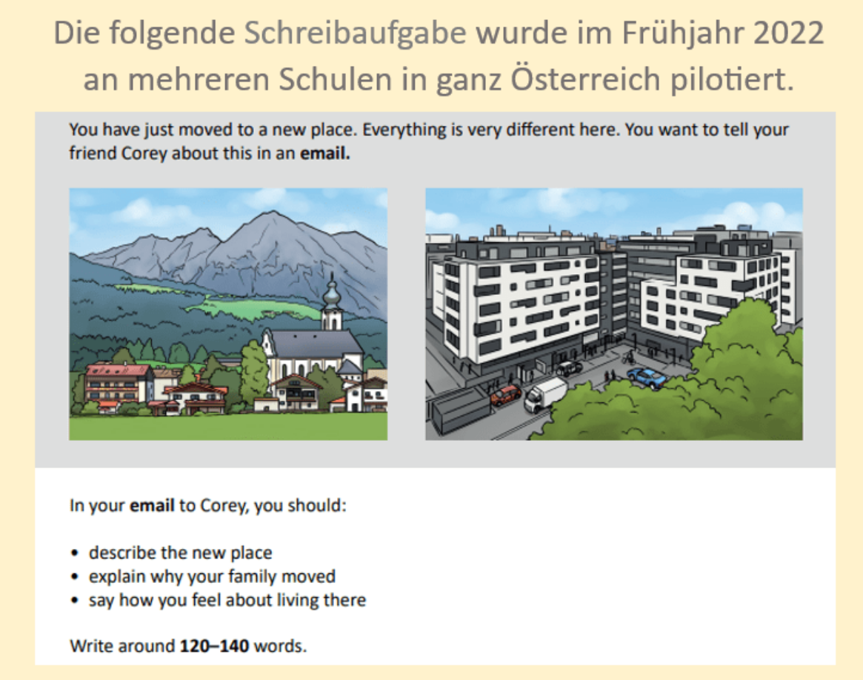

Task:
You have just moved to a new place. Everything is very different here. You want to tell your friend Corey about this in an email.
In your email to Corey, you should:
- Describe the new place
- Explain why your family moved
- Say how you feel about living there
Write around 120-140 words.

A sample performance
Dear Corey,
How are you? You asked how i like the new place. To say it in one word it’s horrible.
The new place is very diffrent to the old one. There are so many people around. The houses are much bigger and there is much more traffic. It is also very loud, our new house is near the train station and every 20 minutes a train passed. There aren’t any trees too everything is grey. You even can’t see the sky becouse there is a lot of smog around. You also asked why we had moved away. We moved because of my fathers job now he work in the bank. I don’t think i will ever like this place. The people aren’t friendly at all They don’t say “Hello” or “How are you”, they just walk away or look at you like you are an alien if you greet them.
Yours,
Helena

Rating Scale:
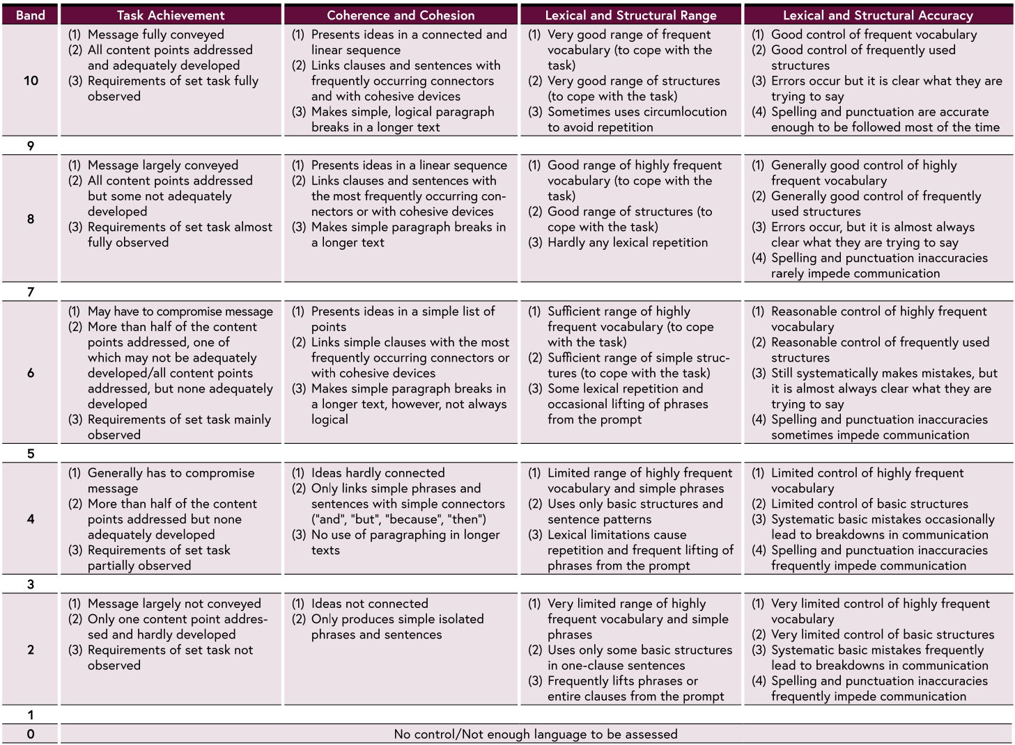

Band | Task Achievement | Coherence and Cohesion | Lexical and Structural Range | Lexical and Structural Accuracy
10 | Message fully conveyed  (1) All content points addressed and adequately developed  (2) Requirements of task fully observed | Presents ideas in a connected and logical way  (1) Links clauses and sentences with the most frequently occurring connectors  (2) Makes simple, logical paragraph breaks in longer text | Very good range of frequently used vocabulary to cope with the task  (1) Very good range of structures with occasional communication to avoid repetition | Good control of frequently used vocabulary  (1) Uses correct structures but it is clear what they are trying to say  (2) Spelling and punctuation are accurate most of the time
9 | Message largely conveyed  (1) All content points addressed but some not adequately developed  (2) Requirements of task almost fully observed | Presents ideas in a connected way  (1) Links clauses and sentences which the most frequently occurring connectors or with other cohesive devices  (2) Makes simple paragraph breaks in longer text | Good range of frequently used vocabulary to cope with the task  (1) Hardly any lexical repetition | Generally good control of frequently used vocabulary  (1) Errors occur but it is almost always clear what they are trying to say  (2) Spelling and punctuation are accurate most of the time
7 | May have to compromise message  (1) Some content points addressed, one of which adequately developed  (2) More than half all content points addressed, but none adequately developed  (3) Requirements of task mainly observed | Presents ideas in a simple list form  (1) Links simple clauses with the most frequently occurring connectors  (2) Makes simple paragraph breaks in longer text, however, not always logical | Sufficient range of highly frequent vocabulary to cope with the task  (1) Coping with simple structures  (2) Some lexical repetition and occasional lifting of phrases from the prompt | Reasonable control of frequently used vocabulary  (1) Systematically makes mistakes, but it is almost always clear what they are trying to say  (2) Spelling and punctuation inaccuracies sometimes impede communication
5 | Generally has to compromise message  (1) More than half of the content points addressed but none adequately developed  (2) Requirements of task partially observed | Ideas hardly connected  (1) Links ideas or clauses and sentences with simple connectors such as 'and,' 'but,' 'because,' 'then'  (2) No use of paragraphing in longer text | Limited range of highly frequent vocabulary to cope with the task  (1) Uses only basic structures and lexis  (2) Lexical limitations cause repetition and frequent lifting of phrases from the prompt | Limited control of frequently used vocabulary  (1) Limited control of basic structures and lexis  (2) Spelling and punctuation inaccuracies frequently impede communication
3 | Message largely not conveyed  (1) Only one content point addressed and hardly developed  (2) Requirements of task not observed | Ideas not connected  (1) Only produces simple isolated phrases and sentences | Very limited range of frequently used vocabulary and simple lexis  (1) Uses only one-clause sentences  (2) Frequently lifts phrases or sentences from the prompt | Very limited control of highly frequent vocabulary and structures  (1) Systematic mistakes frequently lead to breakdowns in communication
0 | No control/Not enough language to be assessed | No control/Not enough language to be assessed | No control/Not enough language to be assessed | No control/Not enough language to be assessed

