Prompt for ChatGPT
You are an English teacher in an ESL class.
Assess the following student text according to the criteria in the rubric uploaded here. The students are ESL learners, aged 13-14 at A2-B1 level on the CEFR scale.
Assess each of the following text samples separately and give me the following things for each text sample:
- the original text
- assessment of each category, points given as x/y
- short feedback for each category with tips for improvement
- an overall assessment of the text (sum of points in all categories, given as x/y and percentage)
- a list all the language mistakes, add the corrected version of each and explain briefly in simple language what was wrong
- Then supply the student with an improved version of the text. The level of this improved version should still be appropriate for the age group and language level (A2-B1 – CEFR).
Use this rubric: Writing Rubric English year 3-4 for AI use
Task achievement and organization: 10 pts
- 5 points: Task not predominantly satisfactorily addressed. Ideas often confused and disorganized. Illogical. Content often not understandable.
- 6 points: Predominantly satisfactory treatment of aspects. Partially fluid and structured (connectors), occasionally disorganized/illogical. Content largely understandable.
- 7 points: Task satisfactorily addressed. Some points elaborated. Sentences partially connected (simple connectors - but, because, then, first...). Paragraphs partially meaningful.
- 8 points: Task well addressed. Many points elaborated. Predominantly clear and coherent structure (simple text-grammatical means, linking words, paragraphs). Reads fluently.
- 9 points: All aspects of the topic well addressed. Good structure of the text. Content dense/complex.
- 10 points: All aspects of the topic well addressed and elaborated. Good structure of the text. Content dense/complex. Many descriptive details (adverbs, adjectives, examples).
Range:10 pts
- 5 points: Uses very few appropriate words, phrases, and structures to solve the task. Communication mostly successful with very simple issues.
- 6 points: Uses basic vocabulary and grammar to solve the task predominantly. Simple sentence patterns. Communication mostly successful with simple issues.
- 7 points: Uses sufficient vocabulary and grammar to solve the task satisfactorily, but only a portion of the learned structures is applied.
- 8 points: Uses a good range of learned vocabulary and structures appropriately. Some longer connected sentences.
- 9 points: Apt use of a wide variety of vocabulary and structures. Many longer sentences. Attempts to apply more complex structures at times.
10 points: Apt use of a very wide variety of vocabulary and structures. Many longer sentences. Attempts to apply more complex structures. Use of adjectives, adverbs, linking words and phrases, idiomatic use of vocabulary.
Accuracy:10 pts
- 5 points: Many errors hinder communication and distract the listener. Elementary errors.
- 6 points: Many errors. Communication mostly successful nonetheless. Simple structures and words often correct.
- 7 points: Errors occur even with practiced structures. Communication generally successful.
- 8 points: Few errors with familiar structures. Communication generally successful even with more complex issues. However, errors occur.
- 9 points: Few errors, secure use of familiar structures and vocabulary. Can express even more difficult/complex issues, though errors may occur.
- 10 points: Very few errors of word choice, spelling and grammar. Can express fairly difficult and complex issues sucessfully.
Task description for the students
Write a short article for the our school’s student Magazine
Artificial Intelligence: Do we still need school if we have chatGPT?
Remember to:
- follow the magazine style and format that you have learned thus far in class: Catchy title, lead sentence, clear paragraphs
- use good vocabulary and phrases
- use good facts and new information.
- Write about 150-200 words
.............................................................................................................................................................

Criteria for Fobizz Assessment
if I use the same rubric as above and enter it in the field: sample solution or scope
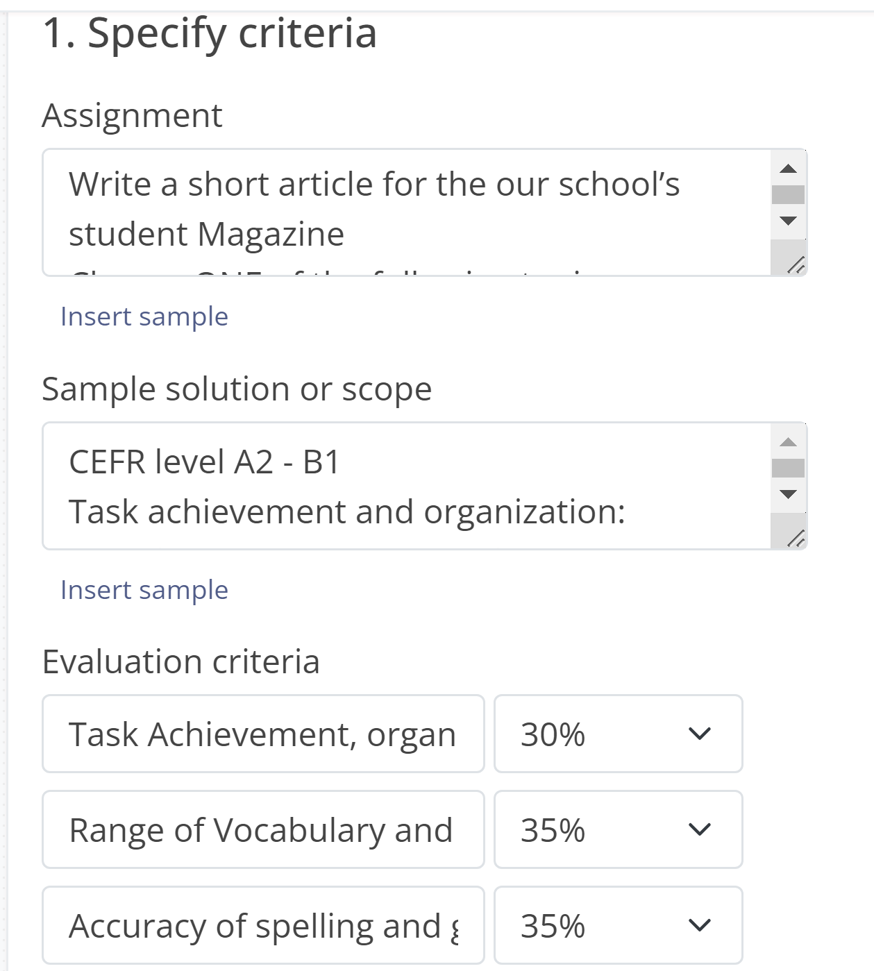
Change the given criteria to match our criteria – percentage must add up to 100
Paste the whole rubric here

...................................................................................................................................Another rubric:
Prompt for ChatGPT: A2 CEFR scale (Ministerium)
Assess the following student texts according to the criteria in the rubric below. The students are ESL learners, aged 12-13 at A2 level on the CEFR scale.
Fulfillment of the task |  | Structure and layout |  |  |  | Spectrum of  linguistic means |  |  |  | Linguistic accuracy
10 | -Type of text clearly recognizable  - Task completely fulfilled, dense content  - Word count adhered to (+/-10%) | 10 |  | Presents the content points (in the form of a simple list) clearly and comprehensibly  - Almost consistently appropriate use of the most common connectors and other text grammatical devices |  | 10 |  | Has a sufficient repertoire of linguistic means to cope well with the task  - Hardly uses parts of sentences / words from the task, hardly repeats anything |  | 10 |  | Has a good command of limited vocabulary and formulaic expressions  - Uses a repertoire of simple structures largely correctly  - Has a good command of spelling from a limited repertoire
8 |  | 8 |  |  |  | 8 |  |  |  | 8
7 | -Type of text predominantly recognizable  - Task and content adequately fulfilled  - Word count adhered to (+/-10%) | 7 |  | Presents the content points reasonably clearly and comprehensibly  - Uses simple text grammatical devices (e.g. pronouns; and, but, because) to link simple sentences together |  | 7 |  | Has sufficient elementary linguistic means (short formulaic phrases and simple sentence patterns) to cope with the task  - Takes sentences/phrases from the task, repeats them a few times |  | 7 |  | Has a limited command of vocabulary related to specific everyday needs  - Has sufficient command of some simple structures, despite systematic elementary errors4 , remains clear about what he/she wants to express.  - Has sufficient command of spelling from a limited repertoire
6 |  |  | 6 |  |  |  | 6 |  |  |  | 6
4 | Text type barely recognizable  - Task and content barely fulfilled  - Word count not adhered to (+/-10%) |  | 4 |  | Presents the content points in a disjointed and barely comprehensible way  - Strings together groups of words or sentences in a disjointed manner. |  | 4 |  | Has too few linguistic resources to be able to express him/herself meaningfully  - Almost completely takes over the text from the task or constantly repeats himself/herself |  | 4
0 | Task not fulfilled  - Not enough language for an assessment |  | 0 |  | No recognizable structure  - Not enough language for an assessment |  | 0 |  | Not enough language for an assessment |  | 0 | Text is not comprehensible at all due to linguistic errors  - Not enough language for an assessment
..................................................................................................................................................................

CHATGPT Assessment
**Text Sample 1:**
Original Text:
Do you think that we need a school when we have chatGPD?
By Sandro / 15th March
One of the most thing that people speak about is ChatGPT. But why are we go in school When there are also many apps and technology in the world. This and more you will read in this article.
First, ChatGPT can help everyone and it answers all questions, but how we know if it's right? There are many fake news too. So you don't can trust. ChatGPT complete.
In school, the teachers answer us the questions till we understand it. But chatGPT explain it not so easy. School. We study languages with some activities. But on chatGPD you just read it and still don’t know anything in the language. You can't solve a math problem without knowing how. So teachers are very important to us. Also in sport. ChatGPT. Don't tell you which sport exercise you can do. It can give you some tips, but it will not present you what to do. There are many subjects where you really need teachers who can explain it to you. Not all questions will be solved with ChatGPD.

Assessment: with Flexi Rubric
- Task Achievement and Organization: 5/10
- Feedback: The ideas are somewhat disorganized and lack coherence.
- Range: 5/10
- Feedback: Basic vocabulary and grammar are used, but there are several errors.
- Accuracy: 4/10
- Feedback: Many errors hinder communication. Attention should be paid to elementary errors.
Overall Assessment: 14/30 (46.7%)
Language Mistakes:
- "ChatGPD" should be "ChatGPT."
- "One of the most thing" should be "One of the most discussed things."
- "But why are we go in school When there are also many apps and technology in the world" should be "But why do we go to school when there are also many apps and technologies in the world?"
- "This and more you will read in this article" is redundant.
- "So you don't can trust" should be "So you can't trust."
- "ChatGPT complete" is unclear. It should be rephrased.
- "But chatGPT explain it not so easy" should be "But ChatGPT doesn't explain it so easily."
- "In school, the teachers answer us the questions till we understand it" is awkward. It should be rephrased.
- "But on chatGPD you just read it and still don’t know anything in the language" is unclear. It should be rephrased.
- "ChatGPT. Don't tell you which sport exercise you can do" is incomplete. It should be rephrased.
- "Not all questions will be solved with ChatGPD" should be "Not all questions can be solved with ChatGPT."
Improved Version:
**Title: The Role of ChatGPT in Modern Education**
By Sandro | 15th March
In the era of ChatGPT, the question arises: Do we still need traditional schooling? While ChatGPT offers vast information, it presents challenges in educational settings.
ChatGPT can provide answers, but discerning their accuracy amidst the prevalence of fake news is crucial. Moreover, the interactive learning experience provided by teachers cannot be replaced by ChatGPT's passive delivery of information. Subjects like language learning and mathematics require hands-on explanations, which ChatGPT lacks. Furthermore, personalized guidance in activities such as sports is essential, which ChatGPT cannot provide.
In conclusion, while ChatGPT is a valuable tool, it cannot fully substitute the essential role of teachers and interactive learning in traditional schooling. Therefore, traditional schooling remains indispensable for comprehensive education and skill development.

Text 1 assessed by ChatGPT + A2 scale Ministerium
Fulfillment of the task (x/y = 7/10):
The type of text is recognizable, but the task is not completely fulfilled. The content is somewhat relevant, but it lacks depth and coherence.
Feedback: Try to elaborate more on the topic provided. Discuss both the advantages and limitations of relying solely on ChatGPT compared to traditional schooling.
Structure and layout (x/y = 4/10):
The text lacks a clear structure and organization. It jumps between ideas without smooth transitions.
Feedback: Organize your ideas into paragraphs. Start with an introduction, then present your arguments in separate paragraphs, and conclude with a summary.
Spectrum of linguistic means (x/y = 4/10):
The text demonstrates limited linguistic variety. It relies heavily on simple sentence patterns and lacks diversity in vocabulary and sentence structures.
Feedback: Try to use a wider range of vocabulary and sentence structures. Experiment with different connectors to link ideas together more effectively.
Linguistic accuracy (x/y = 4/10):
There are numerous grammatical errors throughout the text, including verb tense inconsistencies, missing articles, and unclear expressions.
Feedback: Pay attention to verb tense consistency and use appropriate articles (a, an, the) where necessary. Work on clarity in expression to convey your ideas more effectively.
Overall grade: 19/40 (47.5%)

Fobizz Assessment of Text 1

Error Table for text 1
Error | Correction | Error type
One of the most thing | One of the most common things | Grammar
But why are we go in school | But why do we go to school | Grammar
This and more you will read | You will read about this and more | Sentence Structure
So you don't can trust | So you can't trust | Grammar
ChatGPT complete | ChatGPT completely | Grammar
But chatGPT explain it not so easy | But chatGPT doesn't explain it so easily | Grammar
But on chatGPD you just read it | But on chatGPT you just read it | Spelling
Don't tell you which sport exercise | Doesn't tell you which sport exercise | Grammar
It will not present you what to do | It will not show you what to do | Word Choice
Not all questions will be solved with ChatGPD | Not all questions can be solved with ChatGPT | Grammar

What you did well
- You chose a relevant and interesting topic that engages the reader.
- You made good use of paragraphs to structure your text.

What you can improve
- Pay attention to your grammar and sentence structure. There are several errors that make the text difficult to understand.
- Be consistent with your spelling. You have spelled "ChatGPT" as "ChatGPD" in some places.

Evaluation Table
Category | Evaluation | Feedback
Task Achievement and Organization | 60% | You addressed the topic and organized your text into paragraphs. However, your ideas were sometimes confused and disorganized.
Range of Vocabulary and Grammar | 50% | You used a basic range of vocabulary and grammar, but there were many errors and inconsistencies.
Accuracy of Spelling and Grammar | 40% | There were many spelling and grammar errors that hindered communication and distracted the reader.

Final grade: 49.50
Text 1 Gradingly
(the task that you can us for trying the tool is not exactly the same, but close enough)

The allowed topic is: How will Artificial Intelligence (AI) impact the education industry?

Write your answer in min. 100 words within 20 minutes. Recommended word count: 150.
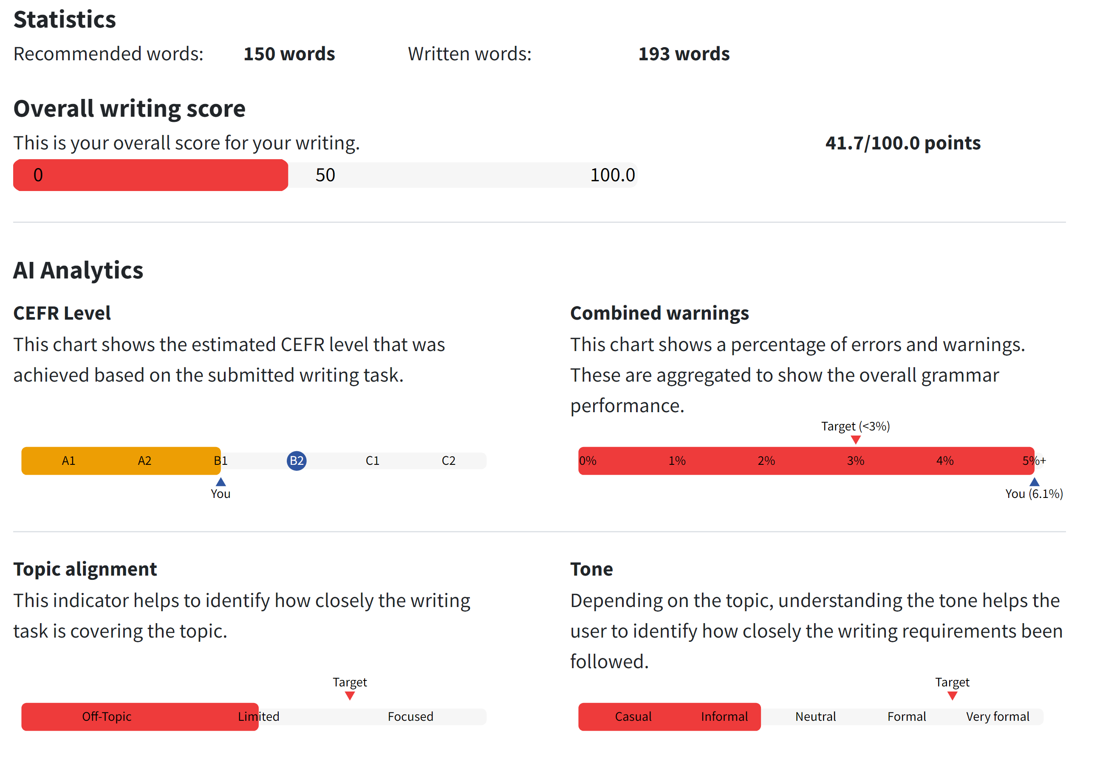

Essay Grader Text 1:
Evaluation:
Organization: D
The essay lacks a clear organizational structure. The introduction is vague and does not clearly state the purpose of the essay. The body paragraphs lack coherence and do not present a clear argument or counterargument. The conclusion is also missing, leaving the essay feeling incomplete and disorganized.
Progression: D
The progression of ideas is weak. The essay jumps from one point to another without clear transitions or logical flow. The ideas are not developed in a coherent manner, making it difficult for the reader to follow the argument.
Development of Ideas: D
The development of ideas is lacking. The essay presents some points about the limitations of ChatGPT and the importance of teachers, but these points are not well-developed or supported with evidence or examples. The essay would benefit from more specific and detailed examples to strengthen the argument.
Conventions: D
The essay has numerous grammatical and punctuation errors, making it difficult to understand the writer's intended meaning. The use of informal language and lack of proper sentence structure detract from the overall quality of the writing.
Language and Vocabulary: D
The language and vocabulary used in the essay are not appropriate for academic writing. There are numerous instances of awkward phrasing, unclear expression, and misuse of words. The essay would benefit from a more sophisticated and precise use of language and vocabulary.
Suggestions for Improvement:
Organization: The essay would benefit from a clear and concise introduction that outlines the main points to be discussed. Each body paragraph should focus on a specific aspect of the argument and include clear topic sentences and transitions to guide the reader through the essay. A strong conclusion that summarizes the main points and provides a final thought on the topic is also essential.
Progression: To improve the progression of ideas, the writer should consider outlining the main points before writing and ensuring that each paragraph builds on the previous one. Clear transitions between ideas and paragraphs will help to create a more coherent and logical flow of information.
Development of Ideas: To strengthen the development of ideas, the writer should provide specific examples and evidence to support their points. This could include real-life examples, statistics, or expert opinions to add credibility to the argument. Each point should be fully developed and explained to provide a comprehensive understanding for the reader.
Conventions: The writer should focus on improving grammar, punctuation, and sentence structure. Proofreading the essay for errors and revising for clarity and coherence will help to improve the overall quality of the writing.
Language and Vocabulary: To enhance the language and vocabulary, the writer should aim for more precise and formal language. Avoiding slang and colloquial expressions, and using a wider range of vocabulary will help to elevate the writing to a more academic level.
Overall Grade: D
Conclusion:
The overall grade for this essay is a D. The essay demonstrates below-average performance in all criteria. The lack of organization, weak progression of ideas, underdeveloped arguments, and numerous language and convention errors contribute to this low grade. To achieve a higher grade, the student should focus on improving the structure and coherence of the essay, providing more specific and detailed examples, and refining their language and vocabulary to create a more polished and academic writing style.
**Text Sample 2:**
ChatGPT Assessment
Original Text:
ChatGPT instead of brains?
Is school still important if we have ChatGPT?
By Alfred
ChatGPT is an artifishal intelligence that you can chat with and that will tell you almost eveything. Many people use it for work, school, projekts and much more.
But why do we still need school if the AI will tell us everything anyway? That is because a computer can't replace our brains. Even though ChatGPT can write essays or do maths, umans still need the ability to think logical and do things on their own. Another disadvantage is that technology may be won't last forever. As an example. A blackout could happen. In that case, we would have to think on our own. On top of that, people would all be pretty stupid in generall.
I still think that AI is really helpful and should be used in school and work. Another advantage of ChatGPT is that it can give you creative ideas and can help in daily activities.
Assessment:
- Task Achievement and Organization: 7/10
- Feedback: The ideas are mostly coherent and connected.
- Range: 6/10
- Feedback: Basic vocabulary and grammar are used, but there are some errors.
- Accuracy: 6/10
- Feedback: Many errors detract from clarity. Attention should be paid to accuracy.
Overall Assessment: 19/30 (63.3%)

Text 2: ChatGPT + A2 scale Ministerium
Let's assess Text 2 based on the provided rubric:
Fulfillment of the task (x/y = 8/10):
The type of text is recognizable, and the task is adequately fulfilled. The content addresses the topic of ChatGPT and its role in education, though it could delve deeper into the discussion.
Feedback: Expand on your arguments to provide a more comprehensive analysis of the role of ChatGPT compared to traditional schooling.
Structure and layout (x/y = 7/10):
The text has a recognizable structure with an introduction, body paragraphs, and a conclusion. However, there are some issues with coherence and organization.
Feedback: Ensure smoother transitions between ideas to improve the flow of your writing. Consider breaking down longer sentences into shorter ones for clarity.
Spectrum of linguistic means (x/y = 6/10):
The text demonstrates a limited range of linguistic means, relying mainly on simple sentence structures and vocabulary.
Feedback: Try to vary your sentence structures and use a wider range of vocabulary to make your writing more engaging and expressive.
Linguistic accuracy (x/y = 6/10):
There are several grammatical errors throughout the text, including misspellings, tense inconsistencies, and unclear expressions.
Feedback: Pay attention to spelling and grammar to improve clarity and coherence in your writing. Proofreading your work before submission can help you catch and correct these errors.
Overall grade: 27/40 (67.5%)
Language Mistakes:
- "artifishal" should be "artificial."
- "eveything" should be "everything."
- "projekts" should be "projects."
- "that is because a computer can't replace our brains" is a run-on sentence and should be rephrased.
- "umans" should be "humans."
- "think logical" should be "think logically."
- "Another disadvantage is that technology may be won't last forever" is awkwardly phrased. It should be rephrased.
- "In that case, we would have to think on our own" is redundant and awkward. It should be rephrased.
- "people would all be pretty stupid in generall" is inappropriate and should be rephrased.
- "I still think that AI is really helpful and should be used in school and work" lacks clarity and specificity.
- "Another advantage of ChatGPT is that it can give you creative ideas and can help in daily activities" is vague and could be more specific.
Improved Version:
**Title: The Coexistence of ChatGPT and Human Intelligence**
By Alfred
In today's digital age, ChatGPT, an artificial intelligence capable of vast information retrieval, is widely utilized across various domains, including work and education.
While ChatGPT offers unprecedented convenience, its integration into education raises questions about the relevance of traditional schooling. However, the limitations of AI become evident when considering the irreplaceable role of human intellect. Despite ChatGPT's proficiency in tasks like essay writing and mathematics, human cognition, characterized by logical thinking and independent problem-solving, remains indispensable.
Moreover, the impermanence of technology poses a potential threat. Instances like blackouts necessitate human intervention, highlighting the need for human intellectual capacity.
In conclusion, while AI like ChatGPT enhances efficiency, it cannot supplant the unique capabilities of human intelligence. Therefore, traditional schooling remains essential for nurturing human intellect and critical thinking skills, complementing the benefits of AI integration in education and beyond.

Fobizz Assessment of text 2

Error Table
Error | Correction | Error Type
artifishal | artificial | Spelling
eveything | everything | Spelling
projekts | projects | Spelling
umans | humans | Spelling
won't last forever | might not last forever | Grammar
generall | general | Spelling

What you did well
- You chose a relevant and interesting topic that engages the reader.
- You presented both sides of the argument, discussing the benefits and drawbacks of AI in education.

What you can improve
- Pay attention to spelling and grammar. There were several spelling mistakes in your text.
- Try to use more complex sentence structures and a wider range of vocabulary to make your writing more engaging.

Evaluation Table
Category | Evaluation | Feedback
Task Achievement and Organization | 70% | You addressed the topic and presented your ideas in a clear and organized manner. However, some points could have been elaborated more.
Range of Vocabulary and Grammar | 60% | You used a basic range of vocabulary and grammar. Try to use a wider range of vocabulary and more complex sentence structures.
Accuracy of Spelling and Grammar | 50% | There were several spelling mistakes in your text. Make sure to proofread your work before submitting it.

Final grade: 59.50

Gradingly Text 2
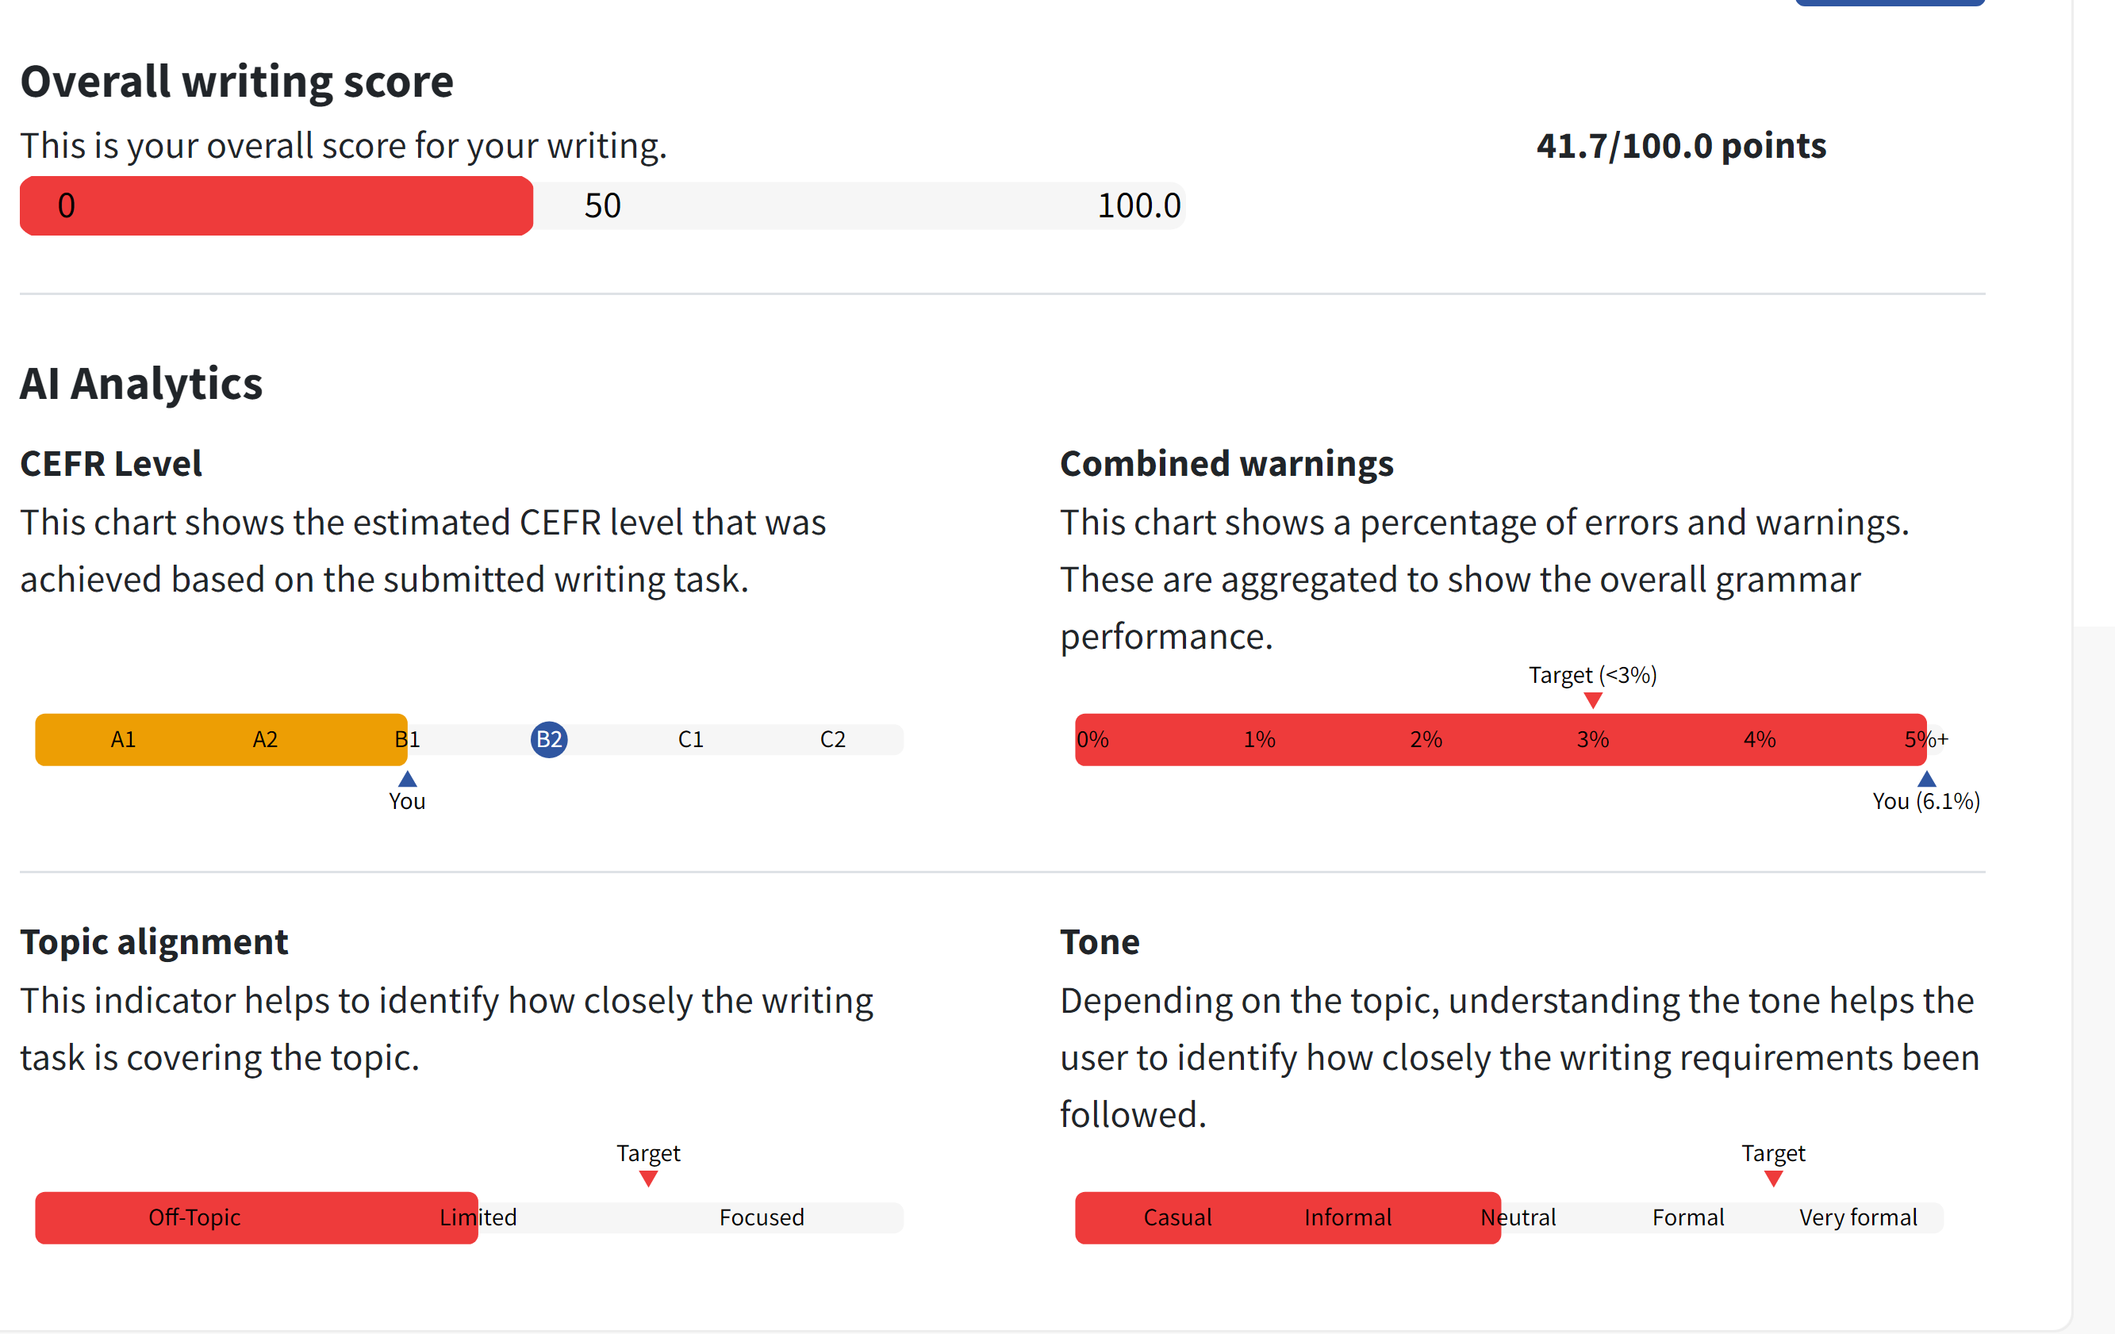
Essay Grader: Text 2
Evaluation:
Organization: D
The essay lacks a clear introduction and conclusion. The ideas are presented in a disjointed manner, making it difficult for the reader to follow the argument.
Progression: D
The essay lacks a clear progression of ideas. The points are not developed in a logical order, and there is no clear transition between them.
Development of Ideas: C
The essay presents some relevant points about the advantages and disadvantages of ChatGPT, but the ideas are not fully developed. There is a lack of specific examples or evidence to support the claims.
Conventions: C
The essay contains numerous spelling and grammatical errors, such as "artifishal," "eveything," "projekts," "umans," "won't," and "generall." Additionally, the use of informal language detracts from the overall quality of the writing.
Language and Vocabulary: C
The language and vocabulary used in the essay are basic and lack sophistication. There is a need for more varied and precise language to convey the ideas effectively.
Suggestions for Improvement:
Organization: The essay would benefit from a clear introduction that presents the main argument and a conclusion that summarizes the key points. Additionally, organizing the ideas in a logical manner with clear transitions between them would improve the overall organization.
Progression: To improve the progression of ideas, the writer should consider presenting the points in a logical order, with each paragraph building upon the previous one. Clear transitions between ideas will help the reader follow the argument more effectively.
Development of Ideas: To improve the development of ideas, the writer should provide specific examples and evidence to support the claims made about the advantages and disadvantages of ChatGPT. This will add depth and credibility to the argument.
Conventions: The writer should carefully proofread the essay to correct spelling and grammatical errors. Additionally, using formal language and avoiding informal expressions will enhance the overall quality of the writing.
Language and Vocabulary: To improve the language and vocabulary, the writer should consider using more varied and precise language to convey the ideas effectively. This will enhance the sophistication of the writing and engage the reader more effectively.
Overall Grade: C-
Conclusion:
The overall grade for the essay is a C-. The essay presents some relevant points about the advantages and disadvantages of ChatGPT, but it lacks organization, progression, and development of ideas. Additionally, the numerous spelling and grammatical errors, as well as the use of informal language, detract from the overall quality of the writing. To achieve a higher grade, the writer should focus on improving the organization, progression, development of ideas, and language and vocabulary, as outlined in the suggestions for improvement.

**Text Sample 3:**
ChatGPT Assessment
Original Text:
Do we still need school if we have Chat GPT?
Written by Musafa
Many students are asking themselves thies question. Why are we still going to school if we have chat GPT? With ChatGPD you can get in less than two seconds all the informations you want.
That's true, but not everything that ChatGPT says, is true. Chat GPT gives you sometimes wrong informations. Above all these reasons you should Not ask Jet GPT every single time, because its a computer and you should not trust it. You can ask ChatGPT one or at least two times, but not every single time.
Above all the reasons, many students are using ChatGPT whenever they want. The Problem is that thies students believes everything and they get wrong informations which can be very dangerous if students only use ChatGPT. They would not learn anything from using it and the will have no job where they can make money. Can ChatGPT really help students? Yes it can, but only sometimes.
You still have to go to school to get a job. You can use chat she pity, but you have to go to school Without school you will not have money.
Assessment with Flexi scale:
- Task Achievement and Organization: 6/10
- Feedback: Ideas are presented, but the structure could be improved for better clarity and organization.
- Range: 6/10
- Feedback: Basic vocabulary and grammar are used, but there are some errors.
- Accuracy: 6/10
- Feedback: Many errors detract from clarity. Attention should be paid to accuracy.
Overall Assessment: 18/30 (60%)

ChatGPT + A2 scale Ministerium
Fulfillment of the task (x/y = 7/10):
The type of text is recognizable, and the task is adequately addressed. The content discusses the role of ChatGPT in education, but it lacks depth and coherence.
Feedback: Provide more comprehensive insights into the advantages and limitations of using ChatGPT compared to traditional schooling.
Structure and layout (x/y = 6/10):
The text has a recognizable structure with an introduction, body paragraphs, and a conclusion. However, there are issues with coherence and organization, leading to disjointedness.
Feedback: Work on organizing your ideas more effectively to improve the flow of your writing. Use clear transitions between sentences and paragraphs.
Spectrum of linguistic means (x/y = 6/10):
The text demonstrates a limited range of linguistic means, relying mainly on simple sentence structures and vocabulary. However, there are some attempts to use connectors.
Feedback: Expand your linguistic repertoire by using a wider range of vocabulary and sentence structures. Incorporate more connectors to improve coherence and clarity.
Linguistic accuracy (x/y = 6/10):
There are several grammatical errors throughout the text, including misspellings, tense inconsistencies, and unclear expressions.
Feedback: Pay attention to spelling, grammar, and sentence structure to enhance the clarity and accuracy of your writing. Proofread your work carefully before submission.
Overall grade: 25/40 (62.5%)
Language Mistakes:
- "thies" should be "this."
- "informations" should be "information."
- "ChatGPD" should be "ChatGPT."
- "Jet GPT" should be "ChatGPT."
- "thies students" should be "these students."
- "believes" should be "believe."
- "informations" should be "information."
- "chat she pity" is unclear and should be rephrased.
- "Without school you will not have money" lacks clarity and specificity.
Improved Version:
**Title: The Role of School in the Era of ChatGPT**
Written by Musafa
In today's digital era, many students ponder the necessity of traditional schooling in the presence of ChatGPT. While this AI offers instant access to vast information, its reliability remains questionable.
Indeed, ChatGPT provides rapid information retrieval, yet it is crucial to acknowledge its limitations. Notably, ChatGPT is prone to occasional inaccuracies, rendering blind trust imprudent. It is advisable to use ChatGPT sparingly, verifying its responses independently.
Despite its benefits, over-reliance on ChatGPT poses risks. Students may overlook critical thinking and analytical skills development, essential for future employment. Therefore, while ChatGPT can be a valuable resource, it should complement rather than replace traditional education.
In conclusion, while ChatGPT aids information access, traditional schooling remains indispensable for fostering critical skills vital for future success. Therefore, striking a balance between technology and traditional education is imperative in preparing students for the challenges of tomorrow.
Fobizz Assessment of text 3

Error Table
Error | Correction | Error Type
thies question | this question | Spelling
ChatGPD | ChatGPT | Spelling
informations | information | Incorrect plural form
Not ask Jet GPT | not ask ChatGPT | Spelling
thies students | these students | Spelling
the will have | they will have | Typo
chat she pity | ChatGPT | Spelling

What you did well
- You chose a relevant and interesting topic that engages the reader.
- You presented both sides of the argument, showing the benefits and drawbacks of using ChatGPT.

What you can improve
- Pay attention to spelling and grammar. There were several errors that could have been avoided with careful proofreading.
- Try to structure your arguments more clearly. It was sometimes difficult to follow your line of reasoning.

Evaluation Table
Category | Evaluation | Feedback
Task Achievement and Organization | 60% | The topic was addressed and there was an attempt to structure the text, but the arguments were not always clear or logically organized.
Range of Vocabulary and Grammar | 70% | The vocabulary and grammar used were generally appropriate, but there was a lack of variety and complexity.
Accuracy of Spelling and Grammar | 40% | There were numerous spelling and grammar errors, which sometimes made the text difficult to understand.

Final grade: 56.50

Gradingly for text 3
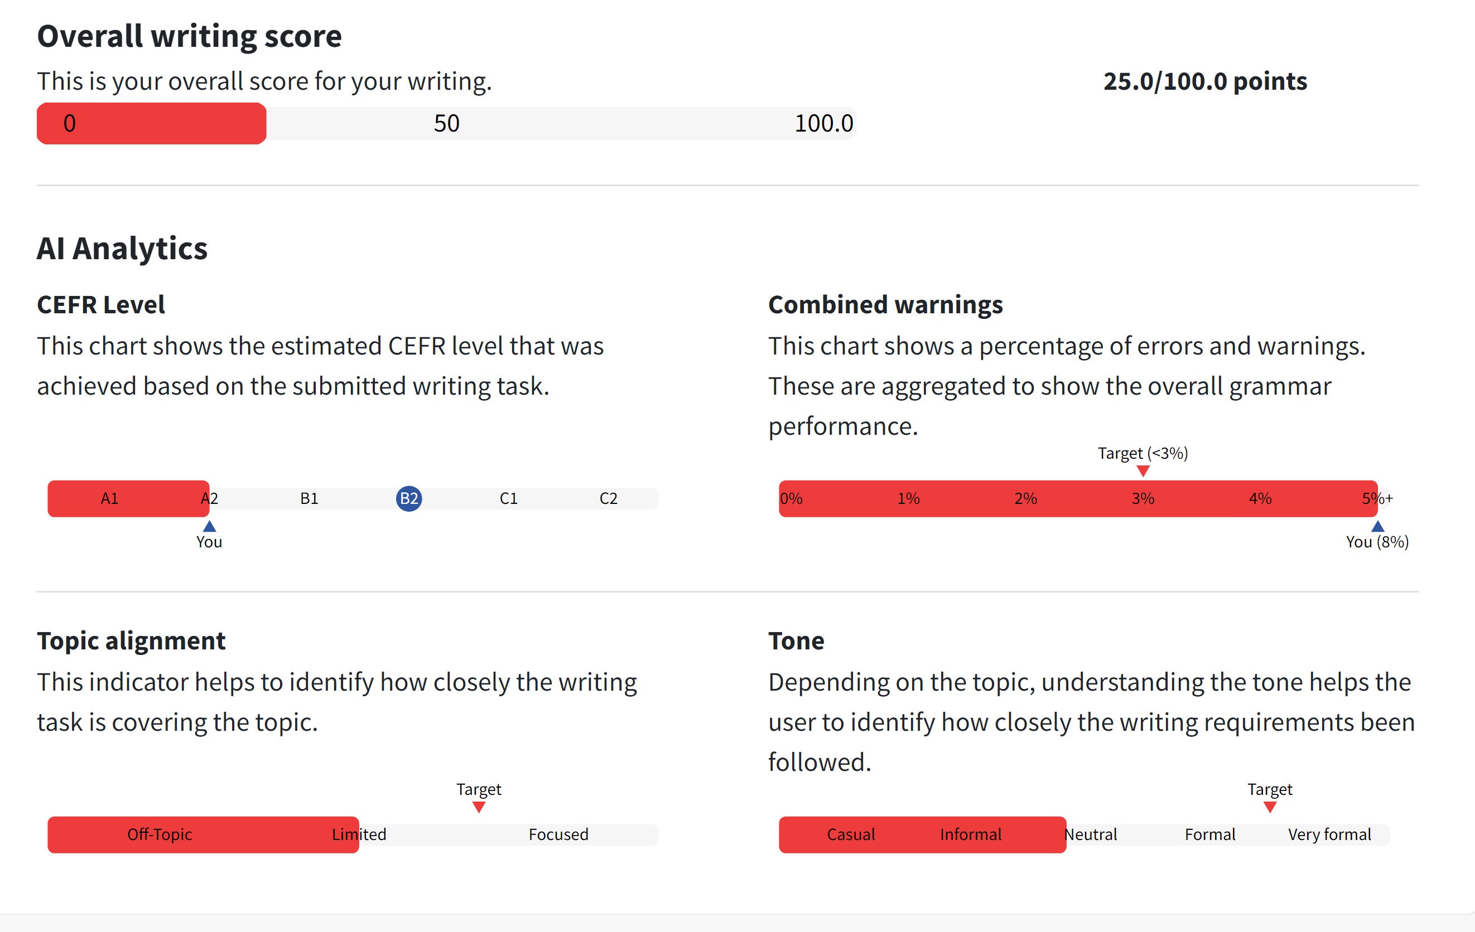
Essay Grader: Text 3
Evaluation:
Organization: D
The essay lacks a clear and logical structure. The ideas are presented in a disjointed manner, making it difficult for the reader to follow the argument.
Progression: D
The essay lacks coherence and flow. The ideas are not connected in a logical sequence, and the transitions between paragraphs are abrupt.
Development of Ideas: D
The essay lacks depth and development of ideas. The arguments are presented in a superficial and repetitive manner, and there is a lack of evidence or examples to support the claims.
Conventions: D
The essay contains numerous grammatical and spelling errors. The use of language is informal and lacks clarity, and there are inconsistencies in punctuation and capitalization.
Language and Vocabulary: D
The language used in the essay is informal and lacks sophistication. There is a lack of variety in vocabulary, and the sentence structures are often awkward and unclear.
Suggestions for Improvement:
Organization: - Create a clear introduction that presents the main argument and provides an overview of the points to be discussed.
- Use topic sentences to introduce each paragraph and ensure that the ideas are presented in a logical order.
- Conclude the essay by summarizing the main points and restating the thesis.
Progression: - Use transition words and phrases to connect the ideas and create a smooth flow between paragraphs.
- Ensure that each paragraph builds upon the previous one and contributes to the overall argument.
Development of Ideas: - Provide specific examples and evidence to support the claims made in the essay.
- Avoid repeating the same points and strive for depth and complexity in the discussion of ideas.
Conventions: - Proofread the essay carefully to correct grammatical and spelling errors.
- Use formal language and adhere to standard conventions of punctuation and capitalization.
Language and Vocabulary: - Use a more formal and academic tone throughout the essay.
- Expand the vocabulary and use varied sentence structures to enhance clarity and sophistication.
Overall Grade: D
Conclusion: The overall grade for this essay is a D due to the lack of organization, coherence, and development of ideas, as well as numerous grammatical and language errors. To achieve a higher grade, the student should focus on improving the structure and flow of the essay, providing more depth and evidence to support their arguments, and using formal language and correct conventions. Additionally, careful proofreading and attention to language and vocabulary will enhance the overall quality of the writing.

**Text Sample 4:**
ChatGPT Assessment
Original Text:
Does AI end school?
A I destroys school system!!!
Written by Nina
Is Artificial Intelligence really better than school? Well, technically it is. But how does this end for the kids?
Learn almost everything from a computer these days, But you still have to learn everything about social interactions and behaviour, because this is humanity. Even the best of the best AI's can't teach humanity, and they never will because they aren't able to learn anything about it. Every kid needs school, To find friends to learn about emotions or depression. Also, kids can't evolve without human contact and nobody to speak.
So in conclusion, we don't have evidence, but we can only imagine what would happen without human teachers. So a I would just destroy a world. Even worse is the brain chip that Elon Musk is developing and testing right now. This chip instantly transports every information online in your brain and this would destroy humanity because you would have no human contact at all.
AI is evolving and humanity is eliminating itself. Live your life as good as possible.
Assessment with Flexi scale:
- Task Achievement and Organization: 7/10
- Feedback: Ideas are presented with some coherence, but the structure could be improved for better flow.
- Range: 7/10
- Feedback: Sufficient vocabulary and grammar are used, but there are errors and room for improvement.
- Accuracy: 7/10
- Feedback: Several errors affect clarity. Attention should be paid to accuracy and word choice.
Overall Assessment: 21/30 (70%)

ChatGPT + A2 scale (Ministerium)
Fulfillment of the task (x/y = 8/10):
The type of text is recognizable, and the task is adequately addressed. The content discusses the impact of artificial intelligence on the education system, but it lacks depth in analysis.
Feedback: Provide more detailed insights into the potential consequences of relying solely on artificial intelligence for education compared to traditional schooling.
Structure and layout (x/y = 7/10):
The text has a recognizable structure with an introduction, body paragraphs, and a conclusion. However, there are some issues with coherence and organization.
Feedback: Ensure smoother transitions between ideas to improve the flow of your writing. Consider breaking down longer sentences into shorter ones for clarity.
Spectrum of linguistic means (x/y = 7/10):
The text demonstrates a moderate range of linguistic means, with attempts to use connectors and varied sentence structures.
Feedback: Continue to diversify your vocabulary and sentence structures to make your writing more engaging and expressive.
Linguistic accuracy (x/y = 7/10):
There are a few grammatical errors throughout the text, including tense inconsistencies and unclear expressions.
Feedback: Pay attention to verb tense consistency and clarity in expression to enhance the coherence and accuracy of your writing.
Overall grade: 29/40 (72.5%)
Language Mistakes:
- "A I" should be "AI."
- "technically it is" could be clearer.
- "Learn almost everything from a computer these days" lacks clarity.
- "But you still have to learn everything about social interactions and behaviour, because this is humanity" is confusing.
- "To find friends to learn about emotions or depression" lacks clarity and coherence.
- "So a I would just destroy a world" lacks clarity and coherence.
- "brain chip" should be "brain implant."
- "transports every information" should be "transports all information."
- "Live your life as good as possible" could be clearer and more coherent.
Improved Version:
**Title: The Impact of AI on Education**
Written by Nina
The question arises: Is Artificial Intelligence (AI) superior to traditional schooling? While AI undoubtedly offers vast knowledge, it cannot replace the essence of human interaction.
Although AI provides extensive information, the importance of social interactions and human behavior remains paramount. AI lacks the capacity to instill essential human qualities. Therefore, traditional schooling, with its focus on emotional intelligence and social skills, remains indispensable.
In conclusion, while AI continues to evolve, it cannot replicate the multifaceted experiences offered by traditional schooling. Human teachers play a pivotal role in nurturing empathy, critical thinking, and social skills essential for personal and professional success. Thus, embracing the synergy between AI and traditional education ensures a holistic approach to learning and development.
Fobizz Assessment of text 4

Error Table
Error | Correction | Error Type
A I destroys school system!!! | AI Destroys School System!!! | Spelling
Learn almost everything from a computer these days, | You can learn almost everything from a computer these days, | Incomplete sentence
But you still have to learn everything about social interactions and behaviour, because this is humanity. | However, you still need to learn about social interactions and behavior, as this is a crucial part of being human. | Clarity
Every kid needs school, To find friends to learn about emotions or depression. | Every kid needs school to make friends and learn about emotions and mental health issues like depression. | Punctuation and clarity
Also, kids can't evolve without human contact and nobody to speak. | Also, kids can't develop properly without human interaction and communication. | Clarity
So a I would just destroy a world. | So AI could potentially disrupt our world. | Clarity
AI is evolving and humanity is eliminating itself. | AI is evolving, and it seems like humanity is gradually eliminating its own importance. | Clarity

What You Did Well
- You chose a relevant and interesting topic that engages the reader.
- You presented a clear argument and supported it with examples.

What You Can Improve
- Work on sentence structure and clarity to make your points more effectively.
- Use more varied vocabulary and complex sentence structures to enhance your writing.

Evaluation Table
Category | Evaluation | Feedback
Task Achievement and Organization | 70% | You addressed the topic and organized your thoughts reasonably well, but there were some areas where your argument could have been clearer.
Range of Vocabulary and Grammar | 60% | You used a basic range of vocabulary and grammar. Try to incorporate more varied vocabulary and complex sentence structures in your writing.
Accuracy of Spelling and Grammar | 70% | There were several spelling and grammar errors that affected the clarity of your writing. Be sure to proofread your work carefully.

Final grade: 66.50
Gradingly for text 4
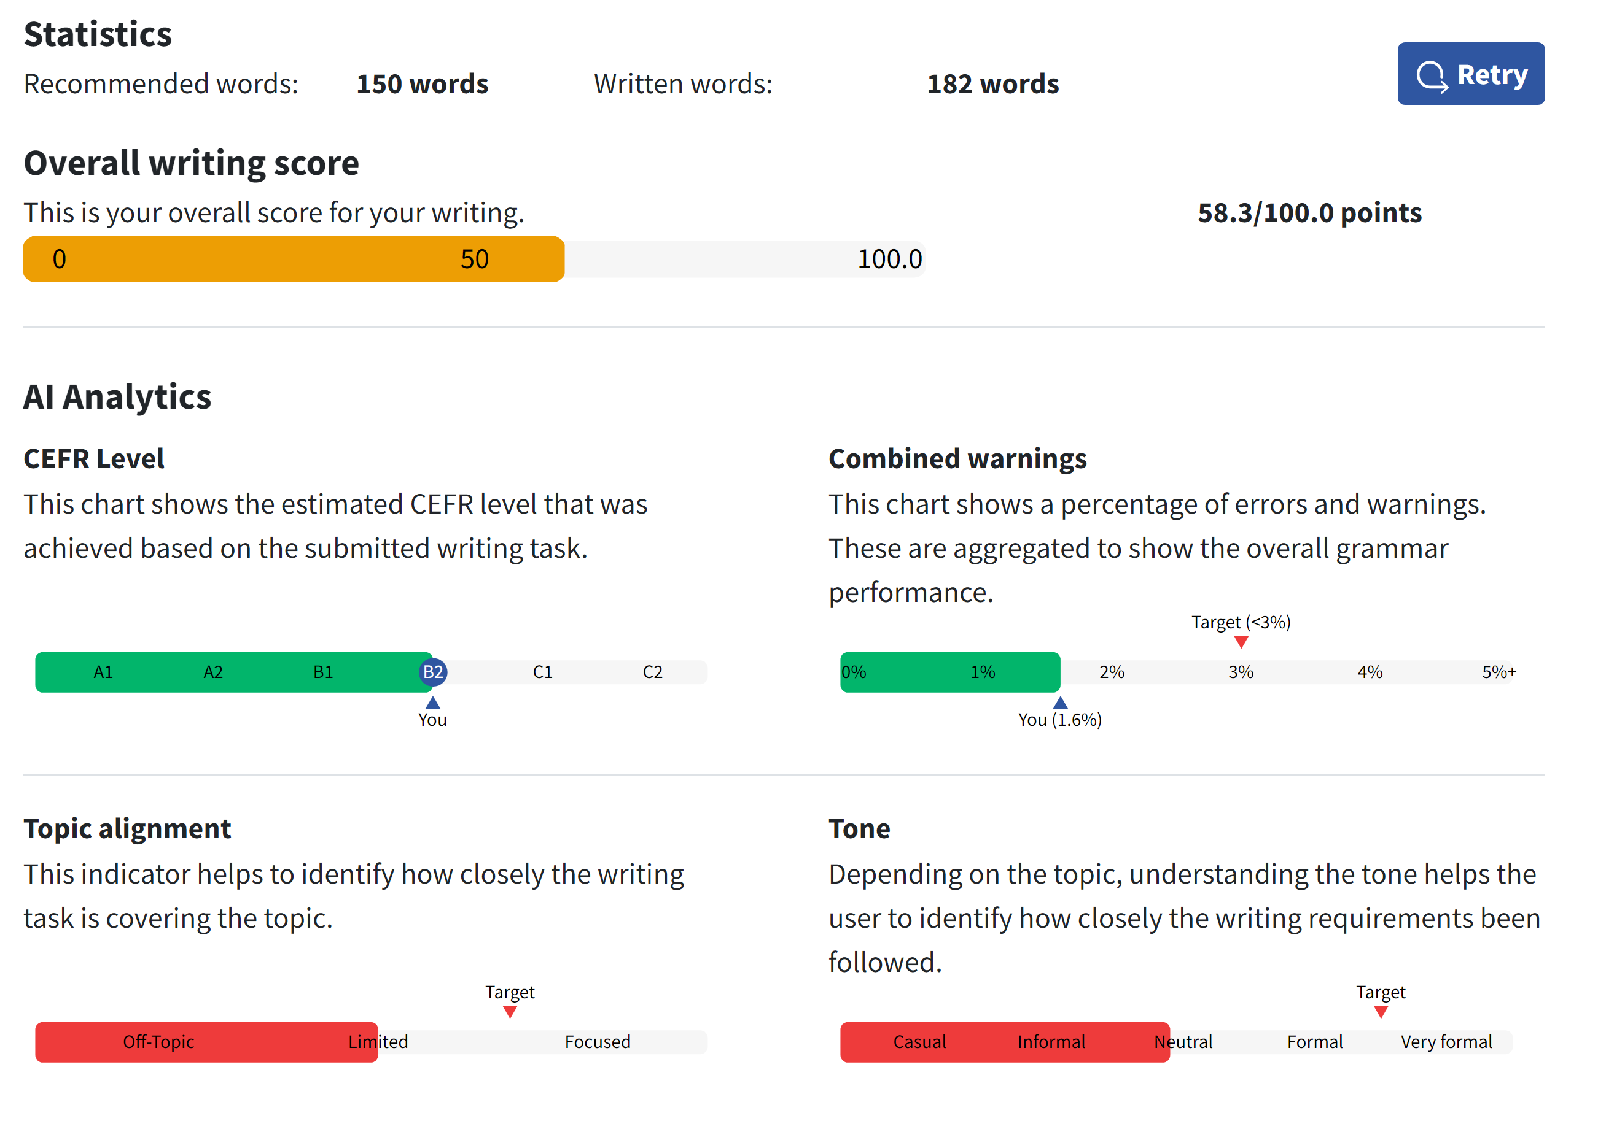
Essay Grader: Text 4
Evaluation:
Organization: The essay lacks a clear organizational structure. The ideas are presented in a disjointed manner, making it difficult for the reader to follow the argument. The introduction does not effectively introduce the topic, and the conclusion does not effectively summarize the main points. Grade: D
Progression: The essay lacks a logical progression of ideas. The ideas are presented in a random order, and there is no clear development of the argument. Transitions between ideas are lacking, making the essay feel disjointed. Grade: D
Development of Ideas: The essay lacks development of ideas. The points made are not supported with evidence or examples, and there is a lack of depth in the exploration of the topic. The argument is not well-developed and lacks coherence. Grade: D
Conventions: The essay contains numerous grammatical and punctuation errors, making it difficult to read. There are also issues with capitalization and sentence structure. Additionally, the essay lacks proper formatting and does not adhere to standard conventions of academic writing. Grade: D
Language and Vocabulary: The language and vocabulary used in the essay are informal and lack sophistication. There is a lack of precision in the choice of words, and the essay would benefit from a more varied and precise vocabulary. Grade: D
Suggestions for Improvement:
Organization: To improve the organization, the essay should begin with a clear introduction that introduces the topic and provides an overview of the main points to be discussed. Each paragraph should focus on a single main idea and be connected to the previous and following paragraphs through clear transitions.
Progression: To improve the progression of ideas, the essay should follow a logical sequence of ideas, with each paragraph building on the previous one. Clear transitions should be used to guide the reader through the argument.
Development of Ideas: To improve the development of ideas, the essay should provide specific examples and evidence to support the points being made. Each point should be explored in depth, and the argument should be well-supported with evidence and reasoning.
Conventions: To improve conventions, the essay should be carefully proofread for grammatical and punctuation errors. Attention should be paid to capitalization, sentence structure, and overall formatting to ensure that the essay adheres to standard conventions of academic writing.
Language and Vocabulary: To improve the language and vocabulary, the essay should use more formal and precise language. The vocabulary should be varied and sophisticated, and the language should be clear and concise.
Overall Grade: D
Conclusion:
The overall grade for this essay is a D due to the lack of organization, progression, development of ideas, and issues with conventions and language. The essay would benefit from a clear organizational structure, logical progression of ideas, well-developed arguments supported by evidence, adherence to standard conventions of academic writing, and the use of more formal and precise language. With these improvements, the essay could achieve a higher grade.

**Text Sample 5:**
ChatGPT Assessment of text 5
Original Text:
Is it an option to just not go to school and just ask ChatGPT it if you need something?
In the last few years, artificial intelligence or Short a I was getting a big topic and there was also the question if we still need to learn in school. If you can just ask ChatGPT.
By Leopold
In fact, you can't have your smart phon all the time. Four example, sometimes the battery is low. Or you forget it at home. Many people forget also looking all the on your phone is bat for your eyes. Almoust 30% of all teens in Austria can't see in a long distance.
Another disadwanschet of AI Is that one in houndert answers of ChatGPT is wrong. This may sounds less but if you think that you got about 3 fail informations (What would be if you asking KI all the time) Per day this could be a big problem.
A way to use ChatGPT in school is to recherche And not just ask AI what is the solution of this math homework? It is also an opinion to say ChatGPT that It should give you examples to learn so maby next time before you have a math test, try to learn with AI but remember: Never say chatGPT that it should slove your exercises.
Assessment with Flexi scale:
- Task Achievement and Organization: 6/10
- Feedback: Ideas are presented, but the structure could be improved for better coherence.
- Range: 6/10
- Feedback: Basic vocabulary and grammar are used, but there are errors and lack of clarity.
- Accuracy: 6/10
- Feedback: Many errors affect clarity and coherence. Attention should be paid to accuracy and word choice.
Overall Assessment: 18/30 (60%)

ChatGPT + A2 scale Ministerium
Fulfillment of the task (x/y = 7/10):
The type of text is recognizable, and the task is adequately addressed. The content discusses the idea of relying on ChatGPT instead of attending school, but it lacks depth in analysis.
Feedback: Provide more detailed insights into the advantages and disadvantages of using ChatGPT as a substitute for traditional schooling.
Structure and layout (x/y = 6/10):
The text has a recognizable structure with an introduction, body paragraphs, and a conclusion. However, there are issues with coherence and organization.
Feedback: Ensure smoother transitions between ideas to improve the flow of your writing. Consider breaking down longer sentences into shorter ones for clarity.
Spectrum of linguistic means (x/y = 6/10):
The text demonstrates a moderate range of linguistic means, with attempts to use connectors and varied sentence structures.
Feedback: Continue to diversify your vocabulary and sentence structures to make your writing more engaging and expressive.
Linguistic accuracy (x/y = 6/10):
There are several grammatical errors throughout the text, including misspellings, tense inconsistencies, and unclear expressions.
Feedback: Pay attention to spelling, grammar, and clarity in expression to enhance the coherence and accuracy of your writing.
Overall grade: 25/40 (62.5%)
Language Mistakes:
- "Short a I" should be "AI."
- "Four example" should be "For example."
- "phon" should be "phone."
- "all the on your phone is bat for your eyes" lacks clarity.
- "Almoust" should be "Almost."
- "teens in Austria can't see in a long distance" lacks clarity.
- "disadwanschet" should be "disadvantage."
- "houndert" should be "hundred."
- "fail informations" should be "incorrect information."
- "What would be if you asking KI all the time" lacks clarity.
- "recherche" should be "research."
- "It is also an opinion to say ChatGPT" lacks clarity and coherence.
- "so maby next time" should be "so maybe next time."
- "try to learn with AI" could be clearer.
Improved Version:
**Title: The Role of ChatGPT in Education**
Written by Leopold
In recent years, artificial intelligence (AI) has become a significant topic of discussion, raising questions about the necessity of traditional schooling. Can ChatGPT replace the classroom experience?
However, relying solely on ChatGPT presents challenges. Technical issues, such as low battery or forgetfulness, hinder constant access to information. Moreover, prolonged screen time poses risks to eye health, affecting a significant portion of teens.
Furthermore, AI is not infallible; approximately one in a hundred responses from ChatGPT may be incorrect, potentially leading to misinformation. Therefore, it is essential to use ChatGPT critically, supplementing its responses with independent research.
In conclusion, while ChatGPT offers valuable assistance, it cannot replace the holistic learning experience provided by traditional schooling. Embracing a balanced approach, incorporating both AI and traditional education, ensures comprehensive learning and skill development for students.

Fobizz Assessment of text 5

Error Table
Error | Correction | Error Type
Short a I | AI (Artificial Intelligence) | Spelling
phon | phone | Spelling
Four example | For example | Wrong word
bat for your eyes | bad for your eyes | Spelling
Almoust | Almost | Spelling
disadwanschet | disadvantage | Spelling
houndert | hundred | Spelling
fail informations | false information | Wrong word
KI | AI | Wrong abbreviation
recherche | research | Wrong word
opinion | option | Wrong word
slove | solve | Spelling

What you did well
- You chose an interesting topic and presented a balanced view, discussing both the advantages and disadvantages of using AI for learning.
- You used some good vocabulary and phrases, such as "artificial intelligence", "smart phone", "battery is low", "long distance", etc.

What you can improve
- Pay more attention to spelling and grammar. There are several spelling mistakes and grammatical errors in your text.
- Try to structure your text more clearly. Use paragraphs to separate different ideas and make your text easier to read.

Evaluation Table
Category | Evaluation | Feedback
Task Achievement and Organization | 60% | You addressed the task and presented some good points. However, your text could be better organized. Use paragraphs to separate different ideas.
Range of Vocabulary and Grammar | 70% | You used a good range of vocabulary and some complex sentences. However, there are several grammatical errors in your text.
Accuracy of Spelling and Grammar | 40% | There are many spelling and grammatical errors in your text. These errors make your text difficult to understand at times.

Final grade. 56.50
Gradingly Response to text 5
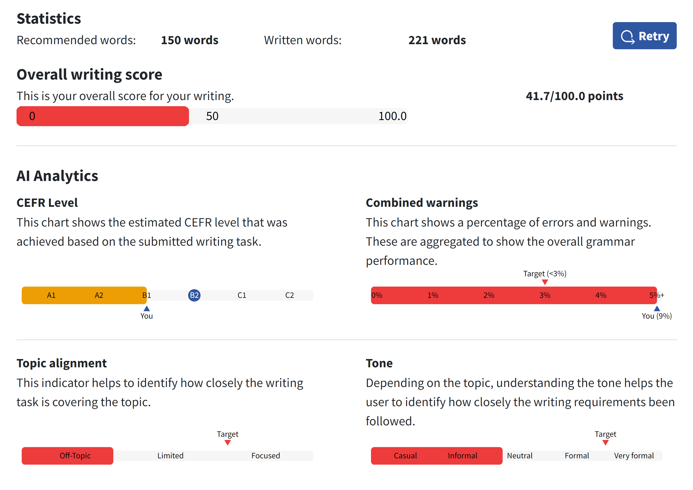
Essay Grader: Text 5
Evaluation:
Organization: D
The essay lacks a clear introduction, body, and conclusion. The ideas are presented in a disorganized manner, making it difficult for the reader to follow the writer's train of thought.
Progression: D
The essay lacks a logical progression of ideas. The writer jumps from one point to another without providing smooth transitions or connections between them.
Development of Ideas: D
The essay lacks depth and development of ideas. The points made are not well-explained or supported with evidence or examples. The writer needs to provide more detailed and coherent explanations to strengthen their arguments.
Conventions: D
The essay contains numerous grammatical and spelling errors, making it difficult to understand. The use of informal language and lack of proper punctuation further detract from the overall quality of the writing.
Language and Vocabulary: D
The language used is informal and lacks sophistication. The vocabulary is limited, and the sentence structure is often unclear, leading to confusion for the reader.
Suggestions for Improvement:
Organization: The essay needs a clear introduction, body, and conclusion. Each paragraph should focus on a specific point and provide smooth transitions between them to create a coherent flow of ideas.
Progression: The writer should work on creating a logical progression of ideas. Each point should build upon the previous one, and the connections between them should be clearly articulated to guide the reader through the essay.
Development of Ideas: The writer should provide more detailed explanations and support their ideas with evidence or examples. This will help to strengthen the arguments and provide a more convincing case for the points being made.
Conventions: The writer needs to pay closer attention to grammar, spelling, and punctuation. Using formal language and adhering to proper writing conventions will enhance the clarity and professionalism of the essay.
Language and Vocabulary: The writer should aim to use more sophisticated language and varied sentence structures to improve the overall quality of the writing.
Overall Grade: D
Conclusion:
The overall grade for this essay is a D due to the lack of organization, progression, development of ideas, and the presence of numerous grammatical and language errors. To achieve a higher grade, the writer needs to focus on improving the structure and coherence of the essay, providing more detailed and supported ideas, adhering to proper writing conventions, and using more sophisticated language and vocabulary.

Comparison of Results
 | Text 1 | Text 2 | Text 3 | Text 4 | Text 5
ChatGPT Flexi Scale | 46,7 | 63,3 | 60 | 70 | 60
Chat GPT  A2 Scale | 47,5 | 67,5 | 62,5 | 72,5 | 62,5
Fobizz | 49,5 | 59,5 | 56,5 | 66,5 | 56,5
Gradingly | 41,7 | 41,7 | 25 | 58,3 | 41,7/100
Essay Grader | D | C | D | D | D
Teacher | 60 | 90 | 50 | 83 | 73
 | 7-6-5 | 9-9-9 | 5-6-4 | 8-9-8 | 9-7-6

