
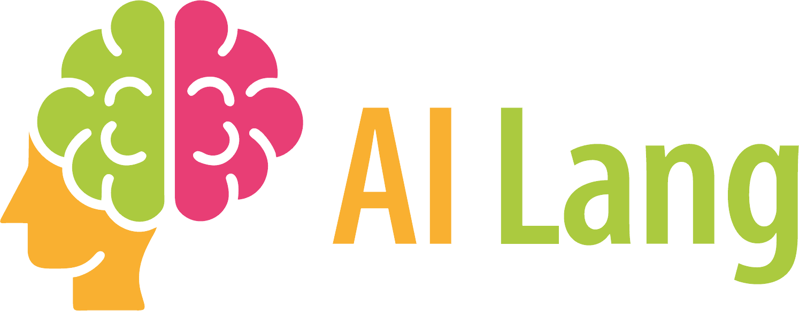
Join us!
BarCamp: AI for Language Education

We would like to invite you to our first BarCamp on AI for Language Education.
What is a BarCamp?
A BarCamp, also known as an unconference, is a gathering of experts who want to share and learn in an informal, open environment. In a BarCamp, all participants actively contribute and share their experience and know-how in a short presentation or demonstration.
In our first AI-Lang BarCamp we invite language teachers, teacher educators and language students to share their experiences with AI technology.
In this first meeting we would like to discuss the following questions:
 | - How can AI help language teachers plan lessons and create materials? How useful, effective and creative are the activities generated by different AI tools?  - How can AI help language learners improve their writing, speaking, listening or reading skills?
Join our online event and share a very concrete experience with a specific skill, task or tool that you have tried out. Your presentation should not exceed 20 minutes and will be followed by 10 minutes of discussion.
The BarCamp will be held online (on Zoom) on November 5th from 5 – 7 p.m. (Central European Standard Time: GMT+1)
If you would like to participate, please register here: xxxxxxxx

(I would then produce a google form for registration:
Your name and institution
Title of your presentation:
50 word abstract:
(e-mails will be collected automatically)
We will send you a link to the meeting a few days before the event.

