The True Cost of Fast Fashion
In this project you will explore the true cost of fast fashion. What are the consequences of cheap and trendy fashion items on the environment?
Step 1: Collect information
Watch the two videos and take detailed notes. You can watch the videos as many times as you want and pause them to note important facts.
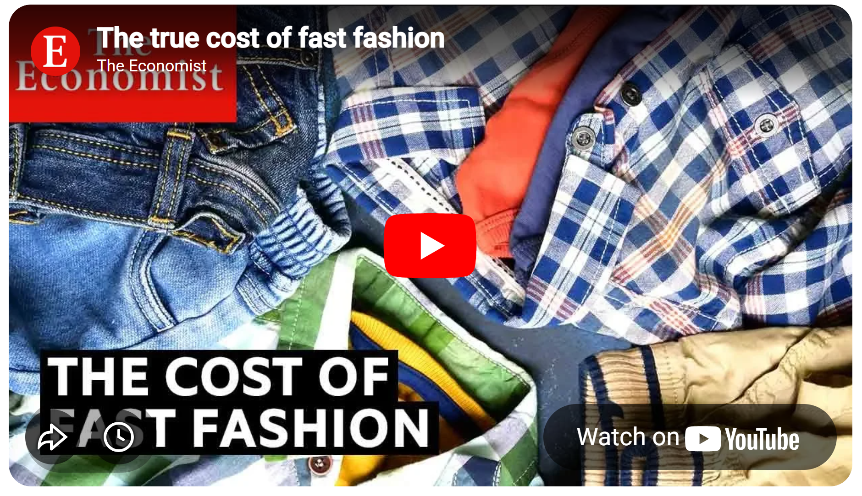 |   https://youtu.be/tLfNUD0-8ts?si=GqZXKvFbaIbuQzcu
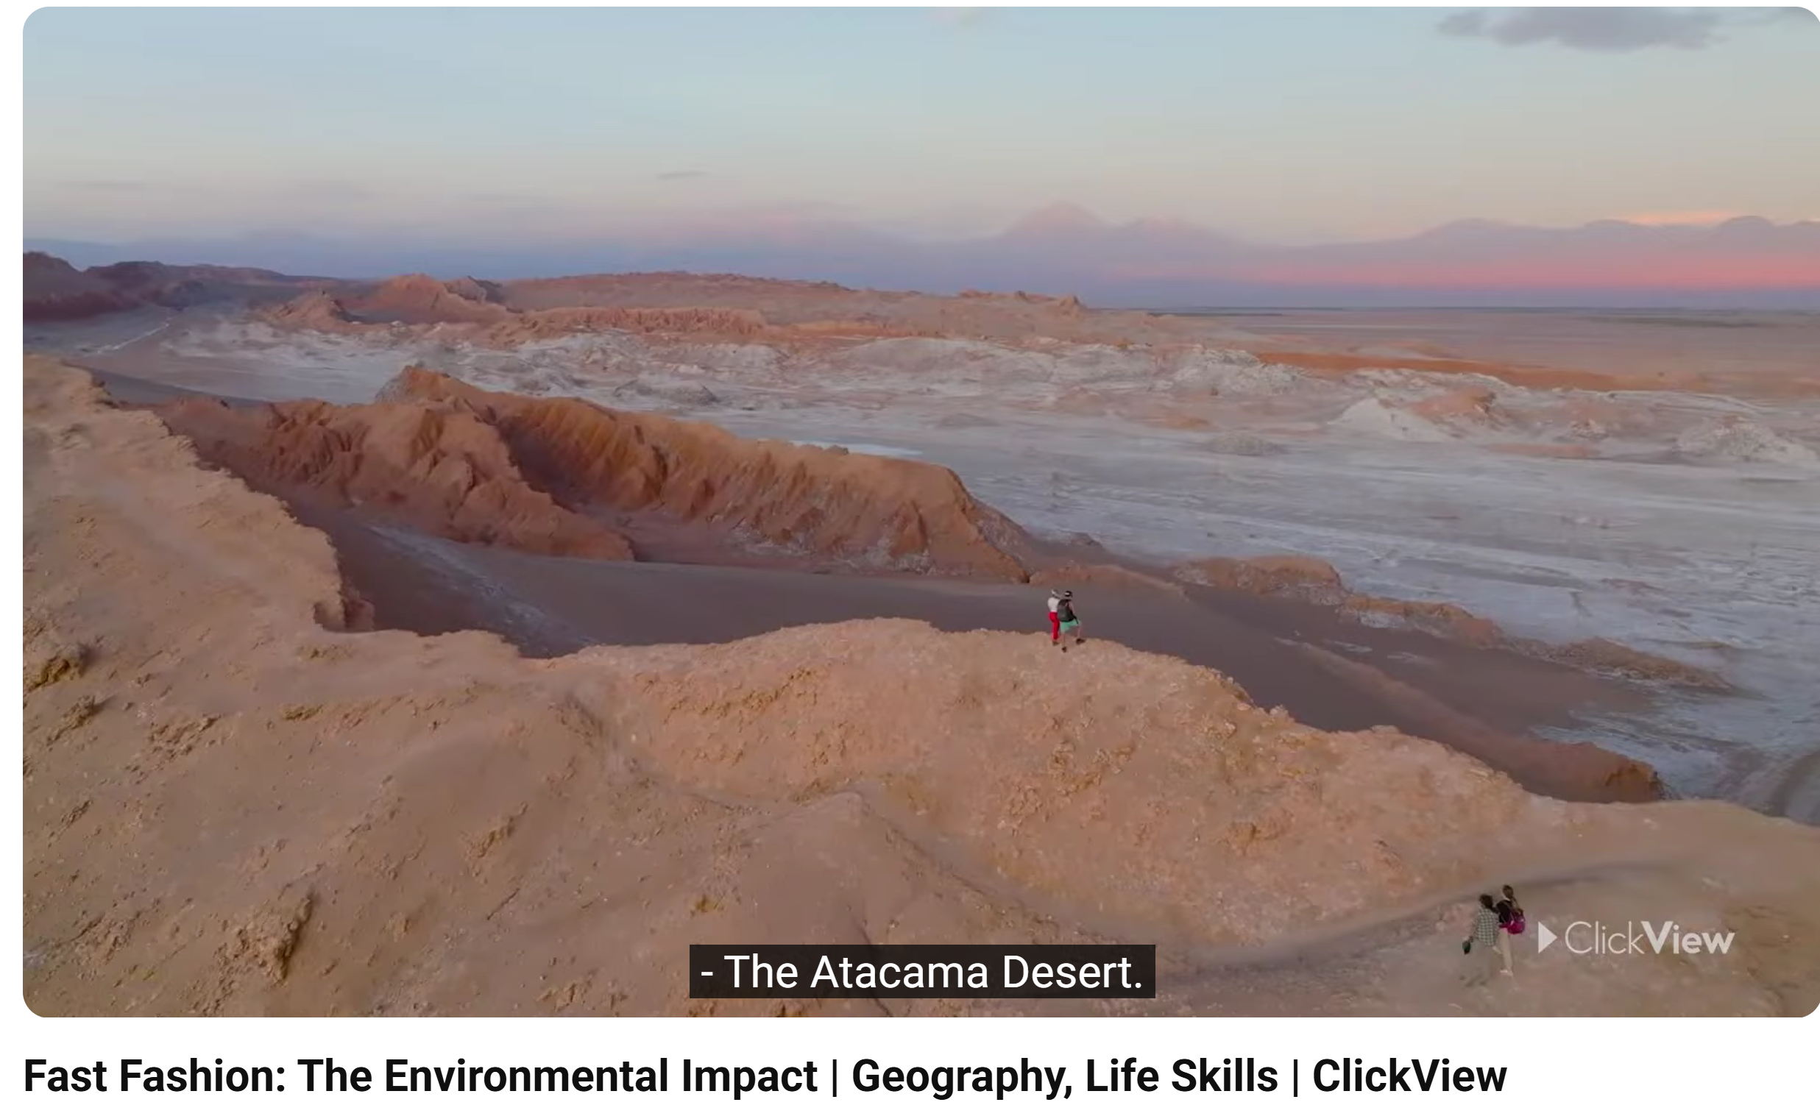 |   https://youtu.be/oqCQTtemR_k?si=QRtzz4D_xcg672QE

Step 2: Take Action
Your task: Our school wants to take action to reduce its environmental footprint. Write an article for our school website to inform your peers about the environmental impact of fast fashion and help raise their awareness about the consequences of their shopping habits. Include tips for more sustainable behavior focusing specifically on things that students can do. The article should be about 500 words long. Add one or two fitting images from pixabay.com

Step 3: Look at a Pro-version
Now, go to Notebook LM. Create a new notebook and label it: “The True Cost of Fast Fashion.”
Upload the two video links as sources.
Then ask Notebook LM to create an article for our school website. Use the following prompt:
Use the information from the sources to write an article for a secondary school website. The article should raise readers' awareness and encourage them to rethink their shopping habits and buy more sustainable items. The article should be about 500 words long and at B2 level on the CEFR. Target group: ESL students, teen readers.

Then use Notebook LM to create an infographic on this topic. Click on the pencil icon and enter
the following prompt:
The infographic should be used together with the article and inform teenagers about the problems with fast fashion, inviting them to rethink their shopping habit.s

Copy the AI generated text and infographic in a file and print it.

Step 4: What can you learn from the AI version?
Compare your own article with the version produced by Notebook LM.
What are the differences?
- What topics or aspects are included in the two versions?
- Look at the structure and organization of the texts? In what way are they different?
- Look at the language: Are the level and register appropriate for your teenage readers? Do you understand all the words and phrases? Can you use them yourself?
Collect a few useful phrases or expressions that you would like to include in your version.

Step 5: The best of two worlds:
What can you learn from the AI version? Decide what you would like to change in your text and produce a final version of your article.
Remember: The final article should still be YOUR work. 

Step 6: Hand in your work:
Save all three versions of your article in one file and hand it in for evaluation.

