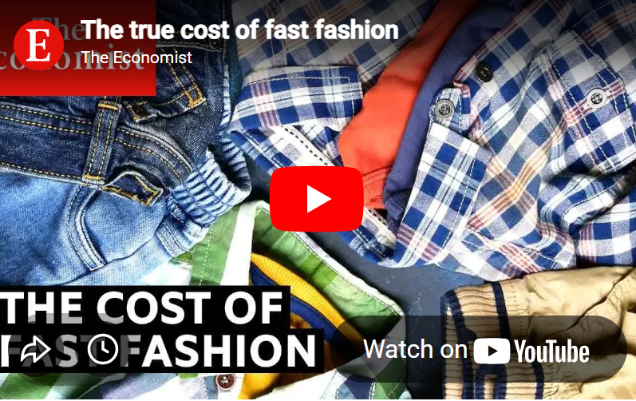 | Fast Fashion  Before watching: What do you know about fast fashion? Write down some keywords or phrases.  

Link: https://www.youtube.com/watch?v=tLfNUD0-8ts
Scan the QR code or click the link to watch the video 'The true cost of fast fashion'

My Video Notes
As you watch the video, write down 4-5 main ideas or interesting facts that you understood.

Now watch the interactive version of the video and answer the questions.


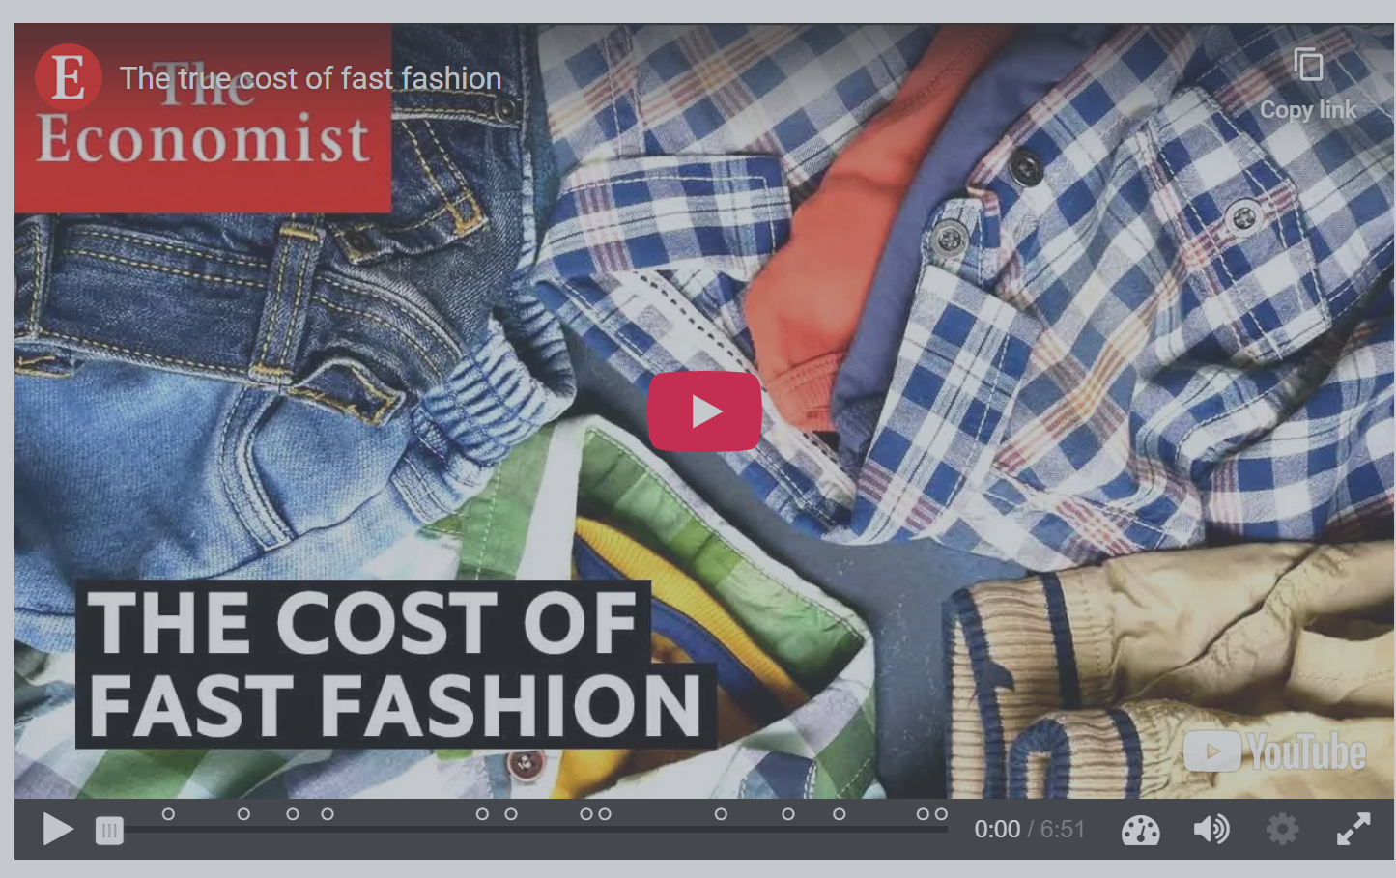

 Vocabulary: Review key vocabulary words from the reading.
landfills
Places where trash is buried in the ground. Many old clothes end up in huge landfills.
trendy
Fashionable or popular at a particular time. She likes to buy trendy clothes that are popular right now.
affordable
Cheap enough for most people to buy. The store sells affordable clothes that don't cost too much money.
impact
The powerful effect that something has on a situation or person.The environmental impact of throwing away clothes is very big.
sustainable
Able to be maintained at a certain rate or level; not harmful to the environment.
Buying fewer clothes is a more sustainable way to live.
trash
Discarded matter; rubbish. A lot of these clothes end up in landfills, which are places where trash is buried.
inexpensive
Cheap. Fast fashion clothes are often inexpensive, which lets people buy more of them.

Let's look more closely: The Impact of Fast Fashion
Read the summary text and highlight all the information that is new for you.
What is Fast Fashion?
Fast fashion refers to cheap, trendy clothes produced quickly by mass-market retailers. Because these items are inexpensive, consumers often buy more than they need, leading to a cycle of constant shopping.
The Environmental Cost
This industry creates a massive environmental problem. Approximately 80 billion pieces of clothing are made every year. Unfortunately, millions of tons of these garments end up in landfills. In Britain alone, 300,000 tons of clothes are thrown away annually. Globally, only 25% of clothing is recycled, meaning the majority of our fashion choices become waste.
Challenges in Recycling
Recycling centers like Savannah Rags work hard to process our old clothes. However, Mohammed Patel from the center notes that clothing quality is decreasing. Because modern clothes are often made from cheaper, lower-quality materials, it is becoming much harder for workers to sort and resell them.
The Power of Social Media
Social media significantly influences our shopping habits. Ijeoma Kola explains the concept of "Instagram pressure," where people feel they can never wear the same outfit twice in photos. This social pressure encourages people to buy new clothes constantly just for a single post.
Sustainable Solutions
There are better ways to enjoy fashion without harming the planet:
- Rent the Runway: This service allows people to share or rent clothes. This increases the lifespan of a garment because many different people wear it.
- Patagonia: This company encourages customers to buy durable goods. They want people to repair their items and keep them for a long time rather than replacing them.
Looking to the Future
The demand for affordable fashion is growing worldwide. Experts warn that clothing sales could triple by 2050. To protect the environment, we must find ways to make the fashion industry more sustainable.
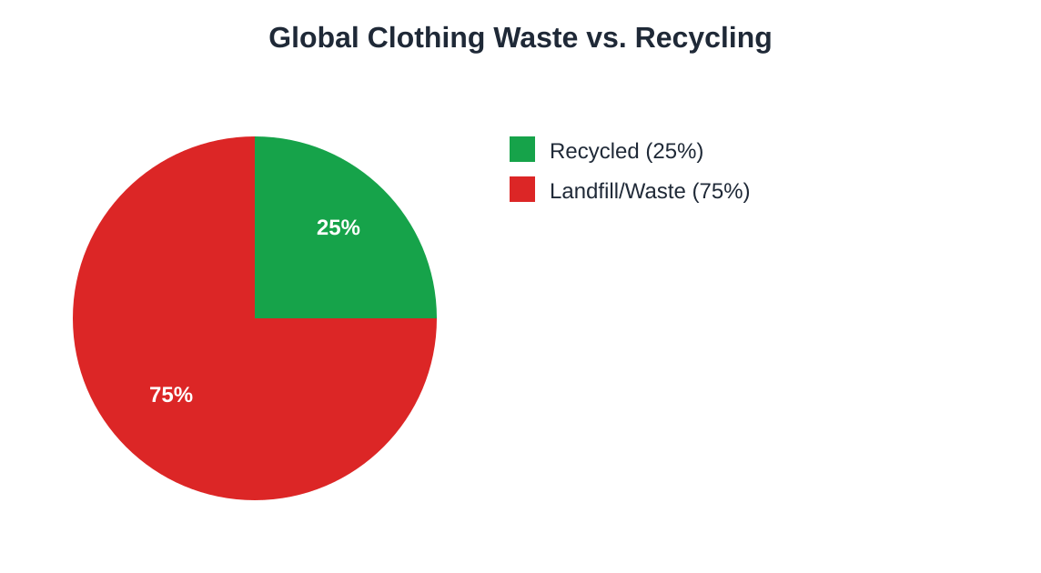
Only a small portion of the world's clothing is currently recycled.

The Impact of Fast Fashion
1. Labor Conditions: Workers in a large-scale textile factory
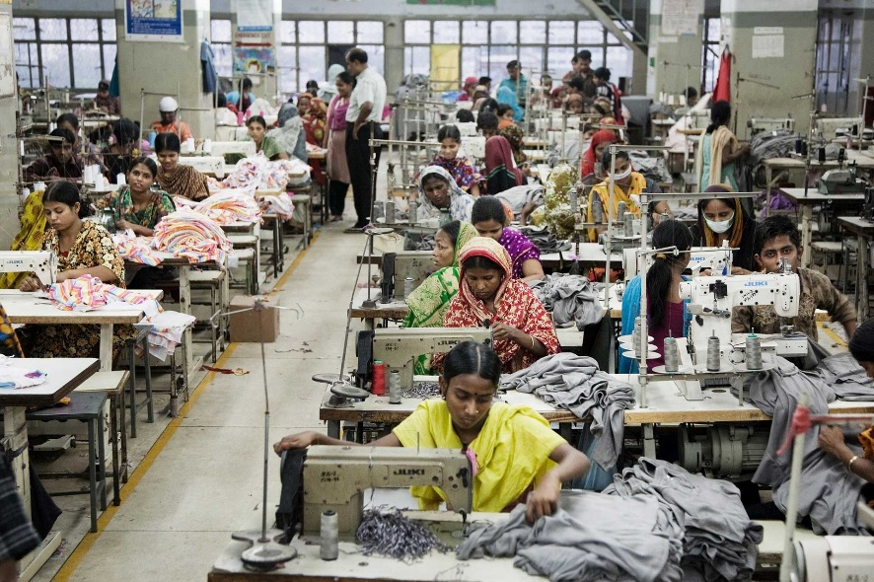
Many fast fashion items are made in factories with poor working conditions and low wages. What do you notice about the conditions in this image?
2. Environmental Waste: Massive piles of discarded clothing in a landfill
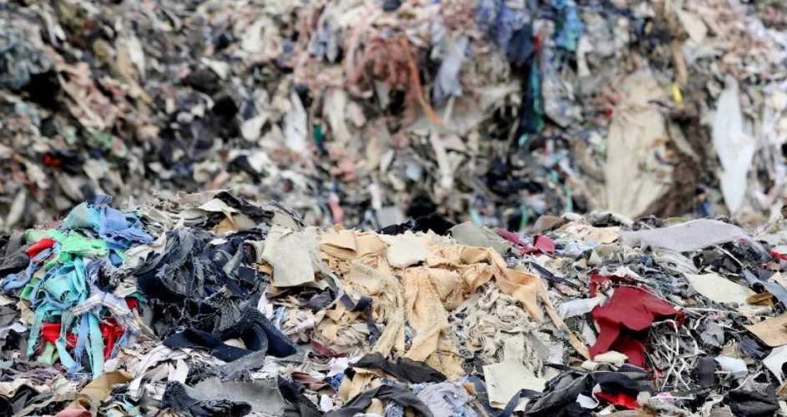
Billions of garments end up in landfills every year. What happens to clothes that are thrown away? Where do your old clothes end up?

3. Textile Pollution: A river colored by chemical dyes from a nearby factory
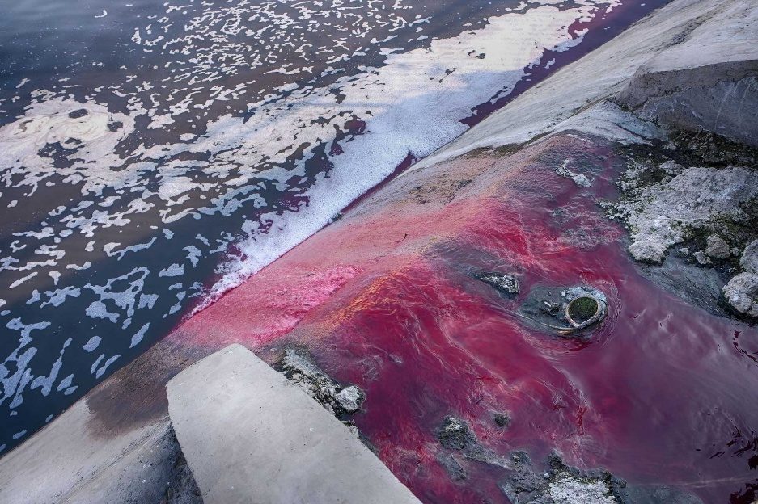
The fashion industry is one of the world's largest polluters of fresh water. What impact might this have on local communities?

4. Sustainable Alternatives:
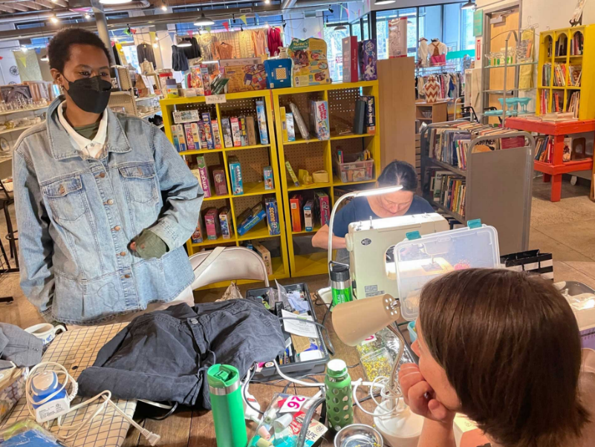
Which of these alternatives (repairing, thrifting, or recycling) would you be most likely to try? Explain why you chose that option.

 Reading for more details
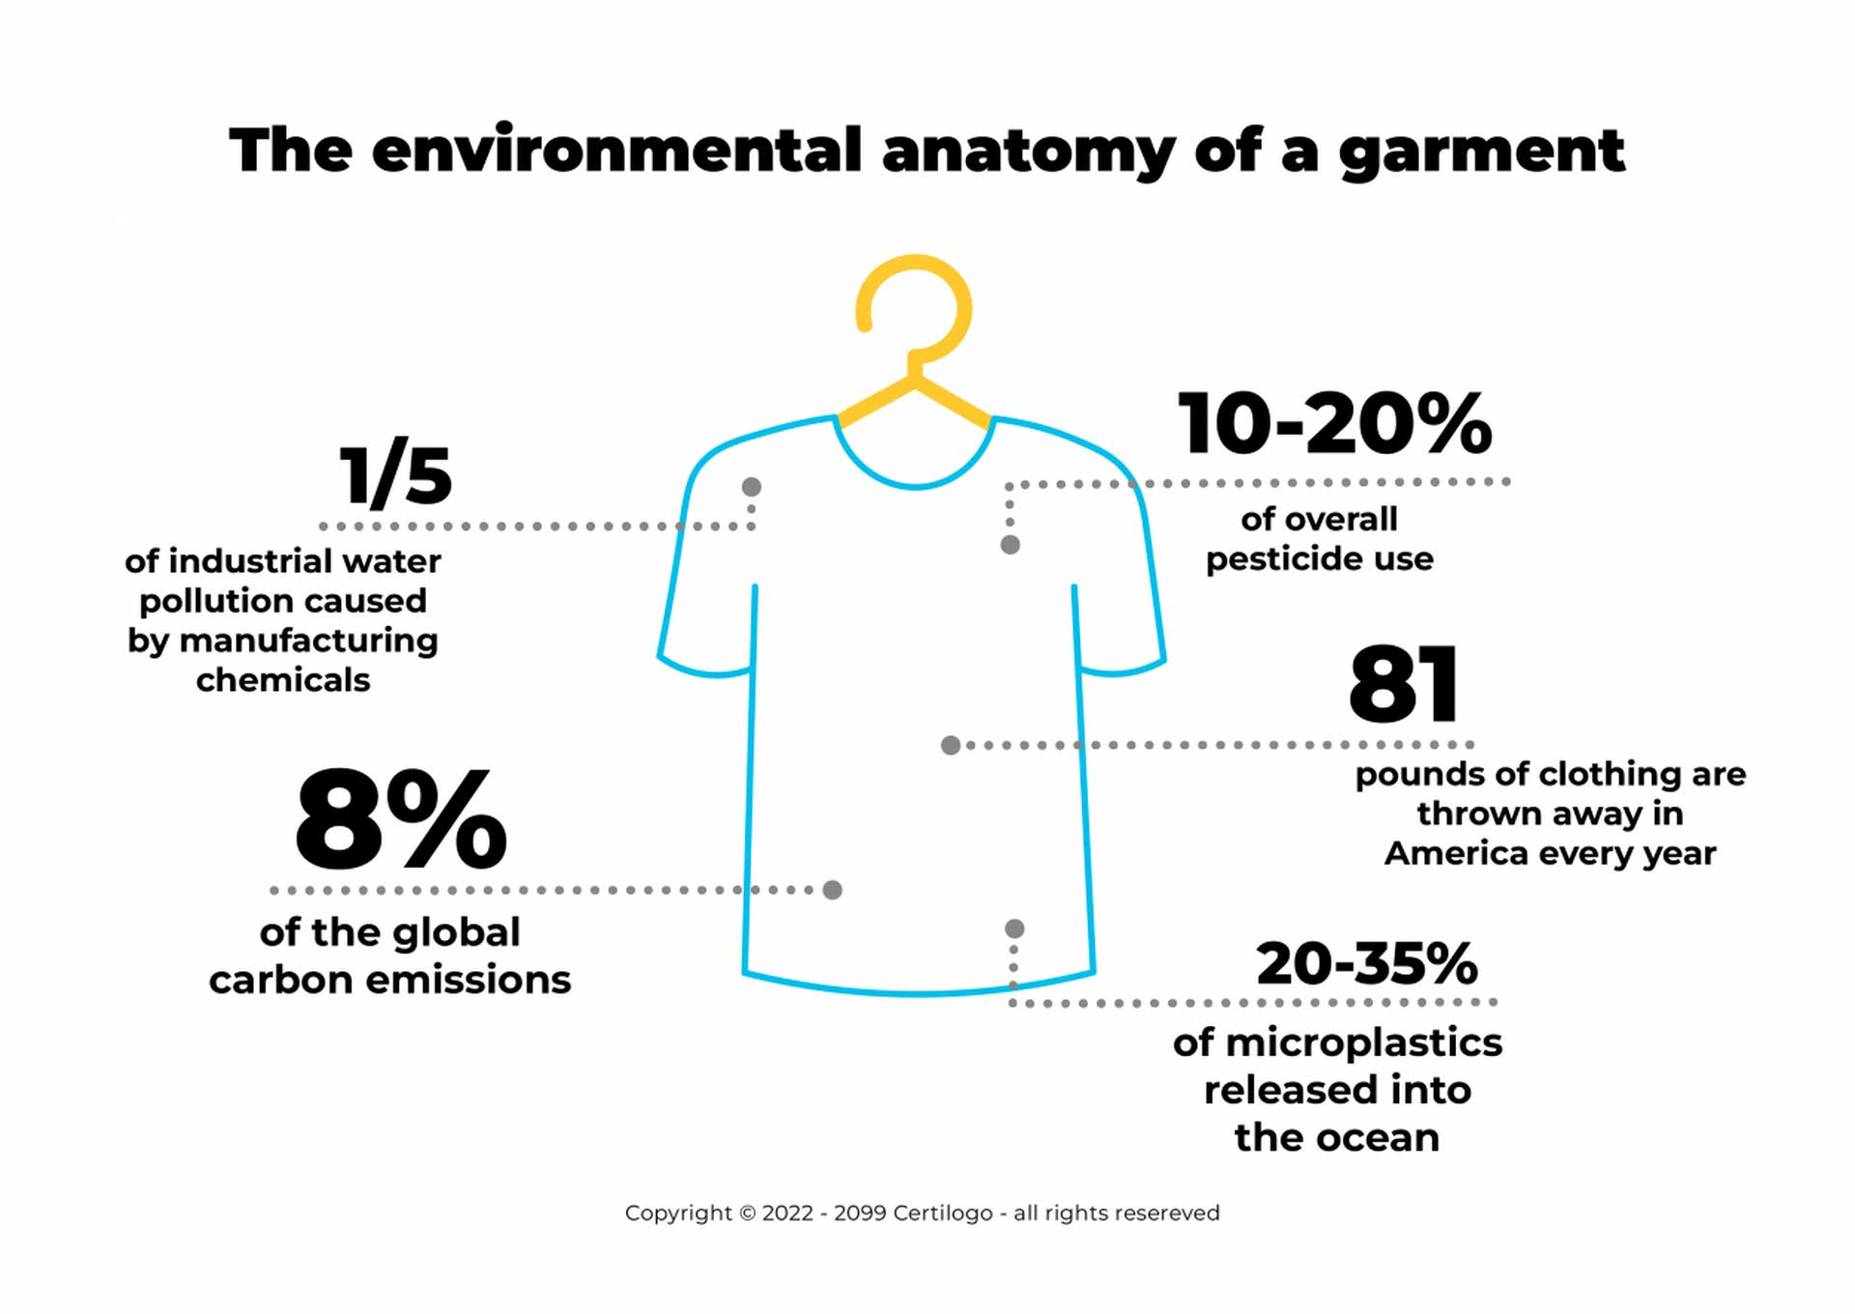
Read the text carefully and find a fitting title for each section:

..........................................................................................................................................................................................................................
It is now very easy to buy clothes. Every year, about 80 billion pieces of clothing are made. But we are making too many clothes. A lot of these clothes end up in landfills, which are places where trash is buried.
"Fast fashion" means clothes that are cheap and new in style. This lets people buy more clothes. But people wear these clothes less often and throw them away faster than before.
So, where do old clothes go? A company called "Savannah Rags" in England recycles clothes. They sort through clothes that people have thrown away from recycling bins all over the country.
Mohammed Patel has run this recycling center for 12 years. He says, "Most of it will go to Africa and Dubai."
Around the world, places like this only recycle about 25% of the clothes that are thrown away. In Britain, over 300,000 tons of clothes go into landfills every year. This is the fastest-growing type of trash in the country.
This is a problem everywhere. As more people in other countries get richer, they want to buy more clothes. They want cheaper clothes. Experts think that by the year 2050, the amount of clothing sold could become more than three times bigger.
Mohammed says, "We've seen that the quality of the materials used has gotten worse. We have to sort through many more clothes to find the same quality of items we can sell."
But how can the clothing business keep growing and also help the planet? We need people to buy fewer clothes.

Find a title for this section:

............................................................................................................................................................................................................................
Ijeoma Kola is a fashion blogger from New York. She cares more about the newest styles than old clothes. She says, "Because I post often on Instagram, there's some pressure to have a new outfit."
Ijeoma is a fashion blogger. Her stylish posts and tips about clothes get many people to follow her online. She used to buy many clothes from stores like H&M, Zara, and ASOS. "They have trendy items, and they are quite cheap," she says. Today, she is looking for a new outfit for a special event. But this store does not sell clothes. It rents them out.
Ijeoma has been telling people about "Rent the Runway." It is a new way to get nice clothes. Rent the Runway lets you rent clothes for four or eight days at a time. Ijeoma explains, "You are using clothes quickly, but you are sharing them with other people. So other people get to wear the same things you are wearing."
Usually, clothes are only worn about 20% of the time. Rent the Runway's goal is to change how people think about the clothes they wear. "Instead of buying something and only wearing it maybe three or four times before you give it away or throw it away," Ijeoma says, "an item is worn much more when it is shared by different people."
Rent the Runway has only a few physical stores, but they are very popular online. They are changing the fashion world. The company has 10 million members, which means they have a lot of laundry to do! The company says they have the biggest dry-cleaning service in the world.
Rent the Runway helps clothes be used more. It also helps fight the problem of throwing away too much. But clothing brands usually do not want people to buy less.

Find a title for this section:

............................................................................................................................................................................................................................
One exception might be Patagonia. They are an outdoor clothing company. They surprised the fashion world with an advertisement in The New York Times on Black Friday in 2011. The ad said, "DON'T BUY THIS JACKET."
In Amsterdam, Ryan Gellert leads Patagonia's work in Europe and the Middle East. He explains, "The clothing industry has become one of the most polluting in the world. We make products that people do not need by making them want them. We create a feeling that if you do not buy it now, it will not be available later."
He says there is a "race to the bottom on price and quality" that cannot continue.
Patagonia's ideas are very different from fast fashion. Their main idea is: buy once, buy good quality, and fix clothes so they last longer.
Ryan says, "So maybe doing that in Amsterdam and then finding out how to share it elsewhere."
With one repair shop in North America and repair services that can travel around Europe and America, Patagonia's message against fast fashion is reaching people. They want people to believe in their ideas.
"Helping our customers keep their product in use longer was also one of Patagonia's first big ideas," Ryan says.
Between 2008 and 2014, Patagonia's profits reportedly became three times bigger. Patagonia says they make almost $1 billion a year.
They hope to inspire other brands to think about how fast fashion affects the environment. Ryan says, "If I could talk to leaders from some of the bigger fast fashion companies in the world, I would really tell them to understand the full effect of their supply chains."
Patagonia shows a smarter way to approach fashion. But they are a rare example.
For Mohammed at the recycling center, the rise of fast fashion has been good for his business. But this habit of throwing things away makes him feel sad. He says, "Sometimes it's very upsetting. You come to work and you think, 'Is this what we have become? That humans only think about throwing things away?'"
He adds, "The effect on the planet's environment is huge. And I don't think we, as humans, understand what we are doing, just to wear a pair of jeans."
To fix the problem of throwing things away, brands and customers need to change their habits. Companies that are showing the way prove that there are good business ideas in selling less. Others need to follow their example.

Vocabulary: Collect 5 new words from the text that you would like to study. Write the word and a part of the sentence from the text where you found it. Then add a translation into German or your first language.

 Multiple Choice Questions
1. What is 'fast fashion' primarily described as in the passage?
A.Clothes that are very expensive and last a long time.
B.Clothes that are cheap and new in style.
C.Clothes made from recycled materials.
D.Clothes designed for special events.
2. What is the main idea behind Rent the Runway?
A.To sell clothes at lower prices than traditional stores.
B.To allow people to rent clothes for a short time instead of buying them.
C.To encourage people to buy more clothes from online retailers.
D.To create new clothing designs using sustainable materials.
3. What is Patagonia's main philosophy regarding clothing consumption?
A.To focus on selling as many products as possible at competitive prices.
B.To partner with fast fashion brands to improve their environmental practices.
C.To constantly introduce new fashion trends to keep customers engaged.
D.To encourage customers to buy durable products, repair them, and use them for a long time.
Short Answer Questions
1. What is Mohammed Patel's main concern about the amount of clothing waste he sees at Savannah Rags?
2. How does Ijeoma Kola's use of Rent the Runway differ from buying clothes from fast fashion stores?
3. What does Patagonia do to help customers use their products for a longer time?

 Think Pair Share
Instructions: Read and answer the question independently. Compare your answer with your partners. Work together to prepare what you will share.
The article talks about different ways people are trying to make fashion more sustainable, like renting clothes or buying from companies that encourage repairs. Thinking about your own shopping habits, what is one change you could make to help reduce clothing waste, and why do you think that change would be important?
I think...
Before talking to your partner, answer the question using what you learned from the reading and your own background knowledge.
My partner thinks...
Take notes on your partners response. How is it different from yours? How is it the same?
We will share...
Decide together what you will share aloud with others.

 Answer and Explain
Instructions: For each question, answer the question and explain why you picked the answer you did using specific evidence from the text.
Question: What is a main reason why many clothes end up in landfills?
Answer: | Explain: Where did you find this information in the text? Copy the exact phrase here.
A.People buy clothes that are cheap and new in style, then throw them away quickly.
B.People do not have enough places to recycle their old clothes.
C.The clothes made today are not good quality and break easily.
D.There are too many clothes made each year for people to wear them all.

Question: Which company tells people not to buy new clothes and instead fix their old ones?
Answer: | Explain:
A.H&M
B.Patagonia
C.Savannah Rags
D.Rent the Runway
Answer and Explain
Question: How does Rent the Runway try to stop clothes from being thrown away?
Answer: | Explain:
A.They make clothes that last a very long time.
B.They let people borrow clothes for a short time so more people can wear them.
C.They sell clothes that are made from old, recycled materials.
D.They have shops where you can get your broken clothes fixed.

Exit Ticket: Fast Fashion & Sustainability
1. Explain the “True Cost of Fast Fashion”
Explain the “true cost” of a pair of jeans in 1-2 sentences. What does it include?

2. Environmental Impact Check
According to the text, what percentage of thrown-away clothes are actually managed to be recycled worldwide?
A) 10% B) 25% C) 50% D) 75%

3. 3-2-1 Reflection
Three things I learned about the clothing industry:
Two things consumers can do to help:
One remaining question I have:
4. Personal Action: What is one sustainable change you can make in your own life regarding how you buy or use clothes?

One change I can make is...

Now go to the online activities to practice and use the new vocabulary about fast fashion.
https://app.redmenta.com/en/solve?ks_id=60216592&utm_source=redmenta&utm_medium=worksheet&utm_campaign=worksheet_share

