Our First Storywriting Project

Create your own origami storybook in 10 steps

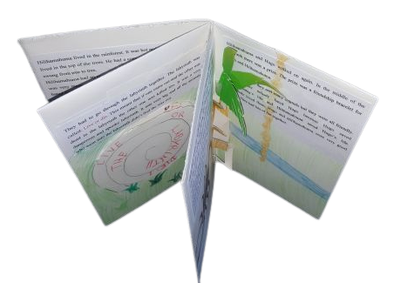
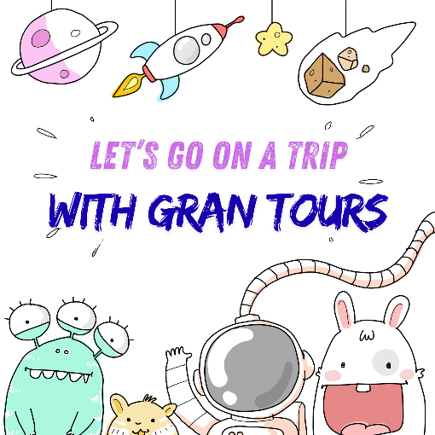

Step 1. Read the story “The Trouble with Gran".
If your school does not have the storybook, watch the video below.
Then travel to a cool place with Gran's travel agency and write a story about your adventure.
Use the story-planning worksheet on the next page and follow all the steps.
Start your story like this:
You won't believe what happened to me last week. I went on a trip with "Gran Tours"….
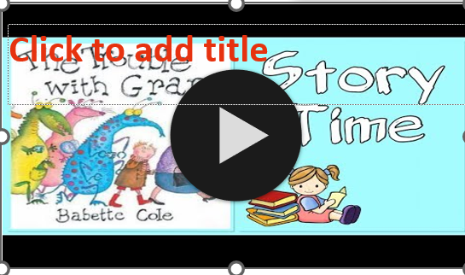



Travel with GRAN TOURS
- Gran’s cool Travel Agency.
- Go to the best places.
- Meet the coolest creatures.
- See the strangest things.
- Eat the most delicious foods.
- Do the craziest things.

Now, write your own story about an exciting trip with Gran’s travel agency.

Step 2: Plan your story – Take notes!

Do you need more ideas? Ask Groovy, the story-writing assistant, for help.

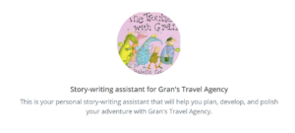

https://app.fobizz.com/ai/chats/public_assistants/136635a9-2880-48cd-bc67-4e454799da47?token=428bc313d81b99dbf64768d71534d002

Where did you go? | A place on Earth? The jungle, the ocean, a snowy mountain?  To the Moon? To another star?
Who came with you? | Take a friend or a family member with you.
How did you travel? | Did you go by airplane, by train, by car, by bus, by bike,  Or did you take a spaceship, a magic broom, a time capsule…
What did you see?  What was the place like? | Did you go to a village, a town, a large city, a forest, a mountain, a beach, a playground, a garden. Were there trees, flowers, houses, streets….
Who else was there? | What were the people, animals and other creatures like? Were they friendly / dangerous / weird / cool…?
What did you eat there?
What did you do? What happened?
How did you feel about it? |         Was it fun, scary, boring, exciting, exhausting …  This Photo by Unknown Author is licensed under CC BY-SA  This Photo by Unknown Author is licensed under CC BY-SA

Step 3: Write a first draft
Write your adventure story on a piece of paper in your spiral notebook. Start like this: You won't believe what happened to me last week. I went on a trip with "Gran Tours"

Step 4: Get some help
Ask a friend for more ideas. Then discuss the story with your teacher.

Step 5: Revise your story.
Use the tips you got from your teacher and a friend. Add more details to make your
story really interesting.
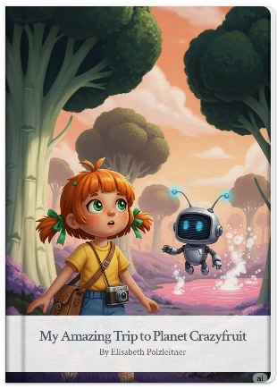
Step 6: Produce a storybook
Use your story to make a digital storybook with the help of AI.
- Type your story into a Word file and save it on your desktop.
- Go to Google Gemini in your Chrome browser.
- Open the sidebar on the left and click on Gems.
- Select Storybook in the Gem manager.
- Write the following prompt into the “Ask Gemini” box:
Use my story about about my trip to ….(put the setting of your story here) and turn it into a storybook. Write the story from a first-person perspective. The main character has just returned from a crazy adventure trip with Gran Tours and shares their experience in the storybook.
- Then paste in your story from the Word file.
- Wait for Gemini to create your storybook.

Step 7: How do you like the AI version of the story?
What is different? What can you learn from the AI version? Is there anything you don’t like?

Step 8: What I want to keep
Collect about 10 vocabulary items (short phrases or sentences) that you would like to use in your own story.

Step 9: Create your own masterpiece

Revise your own story one more time. Use the new vocabulary that you have learned from Gemini. You can also add other details or make other changes if you want. Then write your story into an origami book and illustrate the pages.
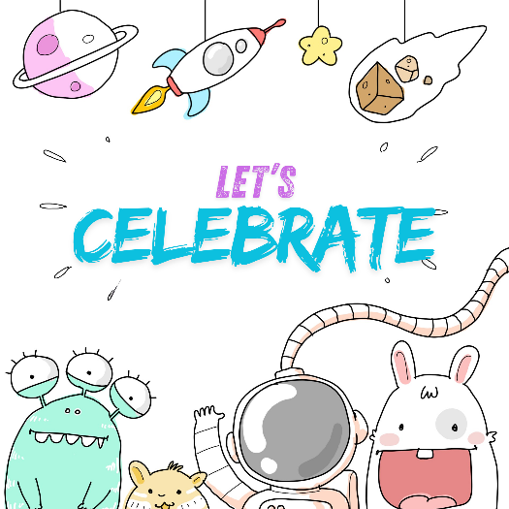
Make a real masterpiece. Follow the QR code to find out how to fold your origami book from an A3 sheet.

Step 10: Let’s celebrate:
When all the storybooks are finished, we will have a story reading party in class.
Bring your polished storybooks and read your classmates’ adventures. Drinks and cookies will be supplied by “Gran Tours”.

