Name: ____________________ Date: ____________________
Invention Evaluation: Dragons' Den vs. Chindogu

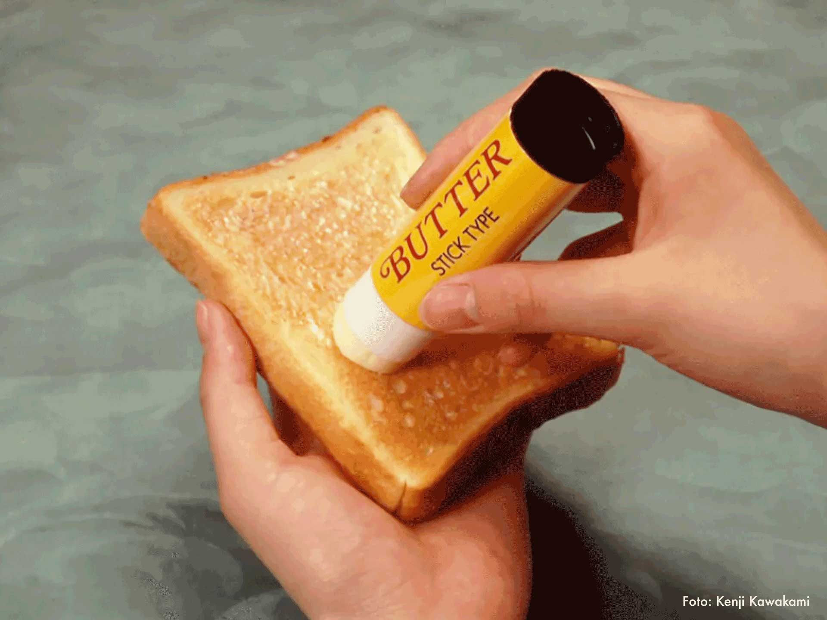
Have you ever watched a show like Dragons' Den and wondered why some inventions get funded while others don't? It's interesting to see what investors think will be a hit. But what about inventions that are meant to be useless? That's where Chindogu comes in.
Chindogu is a Japanese idea that means "unusual tool" or even "weird tool". These inventions look like they could solve everyday problems, but they usually end up causing more trouble. The person who came up with Chindogu, Kenji Kawakami, says they're "invention dropouts" because they're not meant to be sold.
Think of a baby mop, which is a suit for babies that cleans the floor as they crawl. Or how about an alarm clock in a cage that you have to unlock to turn off? These are funny ideas, but not exactly practical. Dan Papia helped spread the word about Chindogu in English-speaking countries. He even wrote a book called 101 Unuseless Japanese Inventions with Kawakami.
Now, let's compare this to Dragons' Den, a show where inventors pitch their ideas to wealthy investors. The "Dragons" decide if they want to invest money in the invention to help the inventor start a business. Sometimes, the Dragons turn down ideas that later become very successful.
For example, the Tangle Teezer, a hair comb that easily detangles hair, was rejected on Dragons' Den. The Dragons thought it was a "waste of time," but the inventor proved them wrong. The Tangle Teezer became a huge hit and is now used by famous people. Another example is the Trunki, a ride-on suitcase for kids. One of the Dragons even broke it during the show! But the Trunki went on to sell millions.

So, what's the difference between a Chindogu invention and one that succeeds after being rejected on Dragons' Den? Chindogu are meant to be useless and funny. They're not designed to make money or solve problems efficiently. Inventions on Dragons' Den, however, are meant to be useful and profitable. The Dragons are looking for ideas that can make them money, even though they sometimes miss out on good ones.
In conclusion, while Dragons' Den focuses on inventions with the potential for commercial success, Chindogu celebrates the art of uselessness. Both offer unique perspectives on invention, highlighting the importance of practicality and humor in different ways. One seeks to solve real-world problems with profitable solutions, while the other finds joy in creating impractical solutions that make us laugh.
‏
Research
Look up the Trunki and the Tangle Teezer on the internet. Have you seen people use these inventions? Would you buy one of these items? Why / Why not?

Vocabulary
Review key vocabulary words from the reading.

To be funded by
verb / passive
Someone gave money so that it could be done/built
The school was funded by donations from the town.
investors
noun
people who give money to a company, business, or project in order to make a profit
The investors hoped the new store would be successful.
practical
adjective
useful and sensible
Wearing a helmet while biking is a practical way to
stay safe.
pitch
verb
to try to persuade someone to do something
The inventor will pitch their idea to the Dragons.
commercial
adjective
related to buying and selling things
The commercial showed a new toy that everyone wanted.
profitable
adjective
making money
The lemonade stand was very profitable on the hot day.

Name: ____________________ Date: ____________________
Multiple Choice Questions
Answer the following multiple choice questions about the reading.
Argumentative Claim
1. Which of the following statements best describes the primary difference between inventions featured on and Chindogu inventions?
A. Chindogu inventions are judged by wealthy investors, while inventions on Dragon’s Den are not.
B. Inventions on Dragon’s Den are intended to be useful and profitable, while Chindogu are meant to be useless and humorous.
C. Inventions on Dragon’s Den are created in Japan, while Chindogu inventions are created in English-speaking countries.
D. Chindogu inventions are always successful, whereas inventions on Dragon’s Den are often rejected.
Argumentative Claim
2. Based on the passage, what is Kenji Kawakami's perspective on Chindogu inventions?
A. He believes they are highly practical solutions to everyday problems.
B. He thinks they should be pitched to investors on Dragon’s Den.
C. He considers them a waste of time and resources.
D. He sees them as funny inventions that are not intended for sale.
Argumentative Claim
3. Which of the following claims is best supported by the examples of the Tangle Teezer and the Trunki in the passage?
A. Inventions that solve complex problems are more likely to be funded on Dragon’s Den.
B. Inventions rejected on Dragon’s Den are Chindogu inventions.
C. Investors on Dragon’s Den always make correct predictions about the success of inventions.
D. Investors on Dragon’s Den sometimes do not see the potential of an invention.
Name: ____________________ Date: ____________________
Short Answer Questions
Answer the following short answer questions about the reading.
Argumentative Claim
1. Explain the main goal of inventors who present their ideas on Dragon’s Den. Use examples from the text to support your answer.
‏
‏
‏
‏
‏
‏
Argumentative Claim
2. What is the central claim about Chindogu? Use details from the text to support your answer.
‏
‏
‏
‏
‏
‏
Argumentative Claim
3. Compare and contrast the purpose of inventions on with the purpose of Chindogu inventions. Provide examples from the text to support your comparison.
‏
‏
‏
‏
‏
‏
Name: ____________________ Date: ____________________
Think Pair Share
Instructions: Read and answer the question independently. Compare your answer with your partners. Work together to prepare what you will share.
After reading about Chindogu and inventions on Dragon’s Den, can you think of a creative idea that others might think silly or impractical? Can you think of a creative idea that others might think useful?
I think...  Before talking to your partner, answer the question using what you learned from the reading and your own background knowledge. | ‏  ‏  ‏  ‏  ‏  ‏  ‏  ‏
My partner thinks...  Take notes on your partners response. How is it different from yours? How is it the same? | ‏  ‏  ‏  ‏  ‏  ‏  ‏  ‏
We will share...  Decide together what you will share aloud with others. | ‏  ‏  ‏  ‏  ‏  ‏  ‏  ‏

Language Focus – the passive

Grammar book page 68 / 69
Do the two pages on the passive voice. You will need it to talk about your invention.
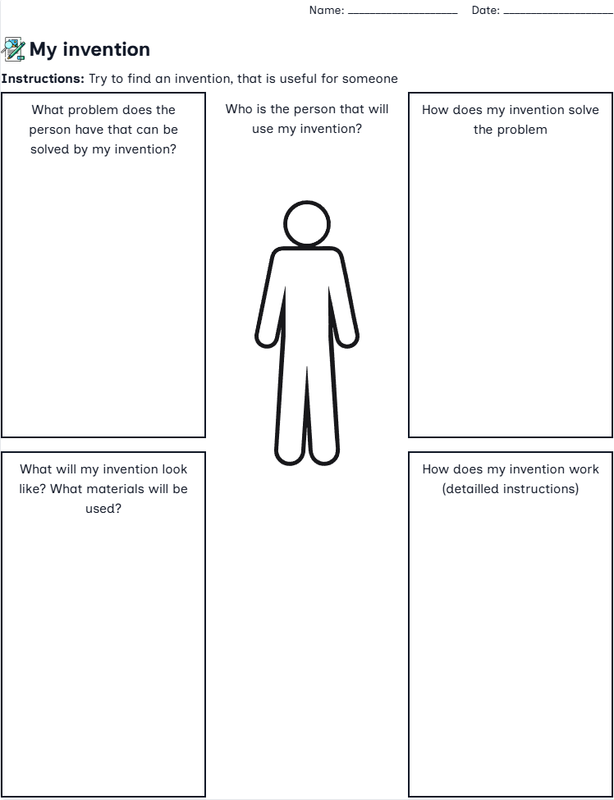

Your online business partner
When you have finished your collections of ideas, go to FOBIZZ and discuss them with your online business partner
https://app.fobizz.com/ai/chats/public_assistants/8f426460-05ab-4cc1-bc09-8fc1ba0768ce?token=a9fb0cda0b2803fdbfe0028d22127d70

1 4f Dragon’s Den Application Form

Name of my invention: _________________________________________________

You want to follow the footsteps of Steve Jobs, Thomas Edison, Grace Hopper and many more great inventors? You want to make your crazy ideas come true?
Then join the 4f Dragon’s Den and present your invention in front of the Dragons.

You will present your invention
to the rest of the class and the Dragons at the end of the project.

Guidelines for your presentation in the Dragon’s Den •
- Your presentation should last 2-5 minutes.
- The dragons need to know everything about your invention, but are very busy and have little time! •
  - Your presentation should contain the name of your invention,
  - your target group,
  - what your invention can do and how it works,
  - which problem it solves
  - and what your USP (unique selling proposition) is. •

- Use good language (vocabulary) to show that you are a professional. •

You want to sell your invention! Be a businessperson and show the dragons why they have to invest in your product! Get creative and have fun!

Additional questions you should be able to answer
- How does your invention make life easier/better for the people who use it
- What materials are used to make your invention?
- How is your invention used?
- What does your invention look like? (Draw a small sketch!) 5
- optional: your slogan

