A beautiful scene in my summer holidays
Step 1: Where will you be in the holidays?
Think of all the things you are planning to do in the upcoming holidays. Choose a beautiful place where you will go this summer and imagine the scene in a lot of detail. Try to see and feel it and take a mental picture.
Where will you be? What is going on around you? What do you see?
Describe this scene in detail – write about 80 to 100 words.
Step 2: Create an AI picture of your beautiful scene
Now go to Fobizz (use your teacher's link) and ask one of the AI picture tools to create a photo or a painting of your scene. Try all three image generators (DALL E2, DALL E3, Stable Diffusion XL) and choose the picture(s) that you like best. Here is an example:
I am really looking forward to the summer holidays. In my dreams I am sitting in a comfortable deckchair, under an old olive tree and looking down at the sea, about 50m below me. All around me there are lush green trees , pink and white oleander bushes and two beautiful palm trees. There is a little round table next to me, with a glass of orange-juice and a good book.
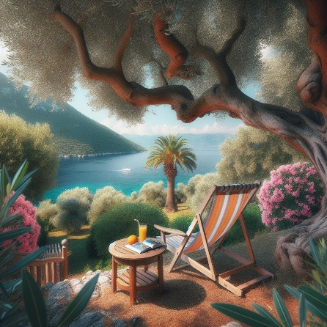 | 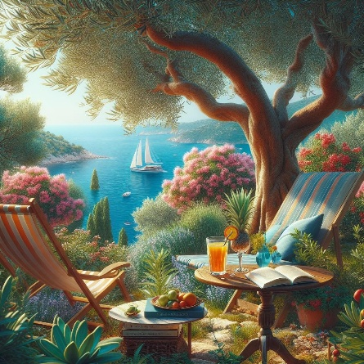 | 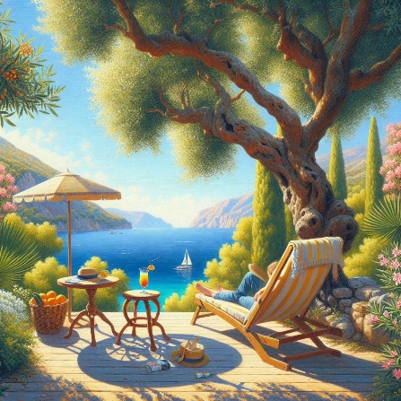

Step 3: During the holidays
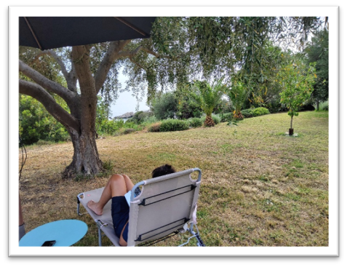
When you are actually visiting this place, take a few photos on your mobile phone and bring them to school in the fall. How close is your dream picture to your real photo? Here is an example:

Step 4: Back in school
Now let's ask ChatGPT to write a description of the scene.
Just go to ChatGPT, upload your photo and ask: “Describe this picture in detail.”

This is what ChatGPT says about the picture above:

The image shows a serene outdoor setting. In the foreground, a person is lying on a lounge chair, positioned under a large tree that provides shade. The person is relaxing with their legs crossed, wearing dark shorts and a light-colored shirt.
To the left of the lounge chair is a small, round table with a blue top. A mobile phone rests on the table. The edge of a black umbrella is visible at the top of the image, providing additional shade.
The background features a well-maintained garden with lush greenery, including various types of trees and bushes. Notably, there are two small palm trees and another tree to the right of the person. The grass appears to be a bit dry in some areas but overall, the garden looks peaceful and inviting. In the distance, partially visible through the foliage, is a glimpse of the sea, adding to the tranquil atmosphere.

Step 5: What can you learn from ChatGPT?
Read the new description carefully and highlight five good phrases that you would like to remember and use in the future.
Then copy them into your vocabulary collection (vocab book or on vocab cards) and study them.

Step 6: Sharing and Caring

Meet with 2 or 3 other students. In your group share your photos and talk about these beautiful places.
Try to use all the new vocabulary phrases that you have just learnt from ChatGPT.

