skills practiced | Minimum CEFR level | Topic/Content area | Objectives | AI tools used | SAMR  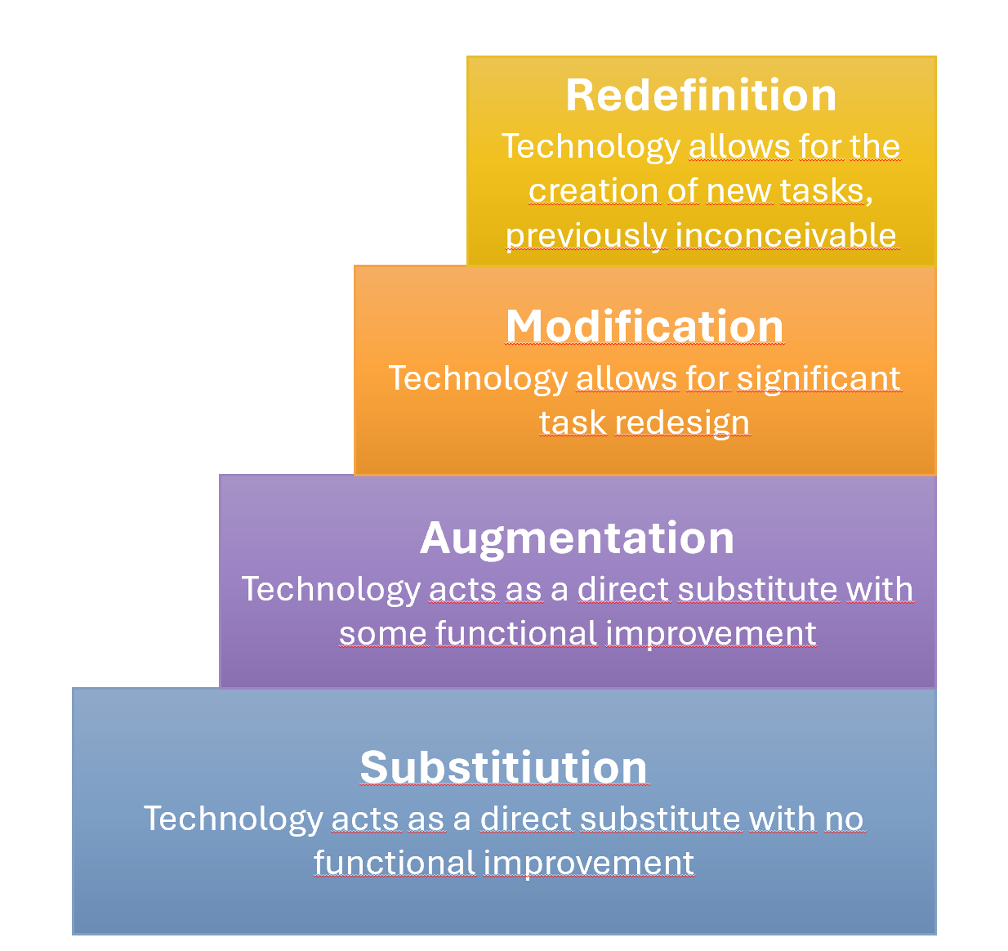
- writing  - speaking | B1-B2 | Crazy Inventions—but any other controversial topic will work. | stating one's opinion  writing a well-structured opinion article  giving a presentation, convincing the audience with good arguments | corrected.ai or any AI for correcting language mistakes and giving feedback  Gamma.app for generating presentation slides based on the student's article | Modification  These steps could be completed without AI, but the teacher's feedback on language corrections would not be as immediate. AI feedback is helpful and saves the teacher time.  Generating the presentation slides would also be time-consuming with minimal language learning benefits.  Professional-looking slides generated by AI motivate students and lead to better presentations in class.

Writing convincing articles and presenting the key arguments orally
In this example we are again using the topic of Crazy Inventions. In this case the language level of the students is a little higher (B1 to B2).
Step 1: Warm-up: The students explore a collection of crazy inventions online or in a PowerPoint presentation prepared by the teacher. In class they discuss how useful or how silly these inventions might be.
Step 2: Writing an article: The students then choose one of these inventions and write a persuasive article for a consumer magazine, where they either advertise the product and describe its useful and extraordinary features or criticize the product as being useless or even harmful. Find the task instructions below.
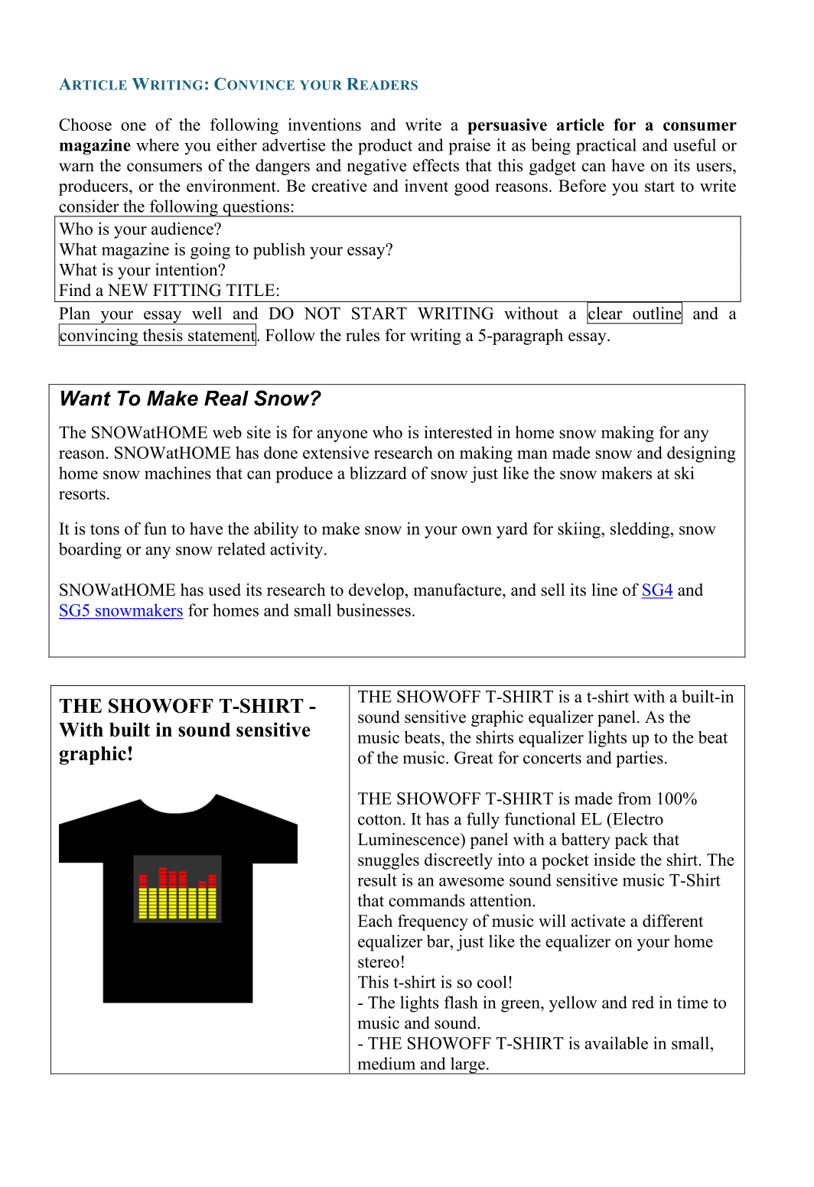
Step 3: Peer Feedback, Revising, and Editing with AI: The students meet with a partner and give each other feedback on their article. Then the students get feedback and corrections from AI. They can use corrected.ai, the Fobizz Feedback assistant, or any other feedback and correction AI that is available to them. If the students are using Gemini Gem, ChatGPT, Euria.ai, Perplexity, or any other general platform, you might want to share a helpful prompt with the students.

Step 4: Creating presentation slides with AI: The students then use Gamma.app to create a PowerPoint presentation based on their essay. Gamma.app allows users to upload a text document (in our case, the pro or con article for the consumer magazine) and will create a presentation based on this input. Using AI for this step seems meaningful, because creating the presentation and finding suitable images and a layout is usually quite time-consuming, while little language learning is happening during this stage. The free version of Gamma.app offers enough credits so the students can generate and adapt the presentation based on their text input.
Step 5: Presenting in class: The students use the PowerPoint slides and practice presenting them in their own words. It is important that the students do not just read off the words and phrases but speak freely, addressing their audience. Then each student delivers their presentation to the class, followed by a short discussion and feedback on the language and presentation skills (free speaking, rather than reading)
This sequence leaves the creative work and critical thinking with the students and uses AI to assist with language feedback and the technical steps of creating a presentation.
Below, find an article written by a student at upper secondary level and the resulting PowerPoint slides generated by Gamma.app.

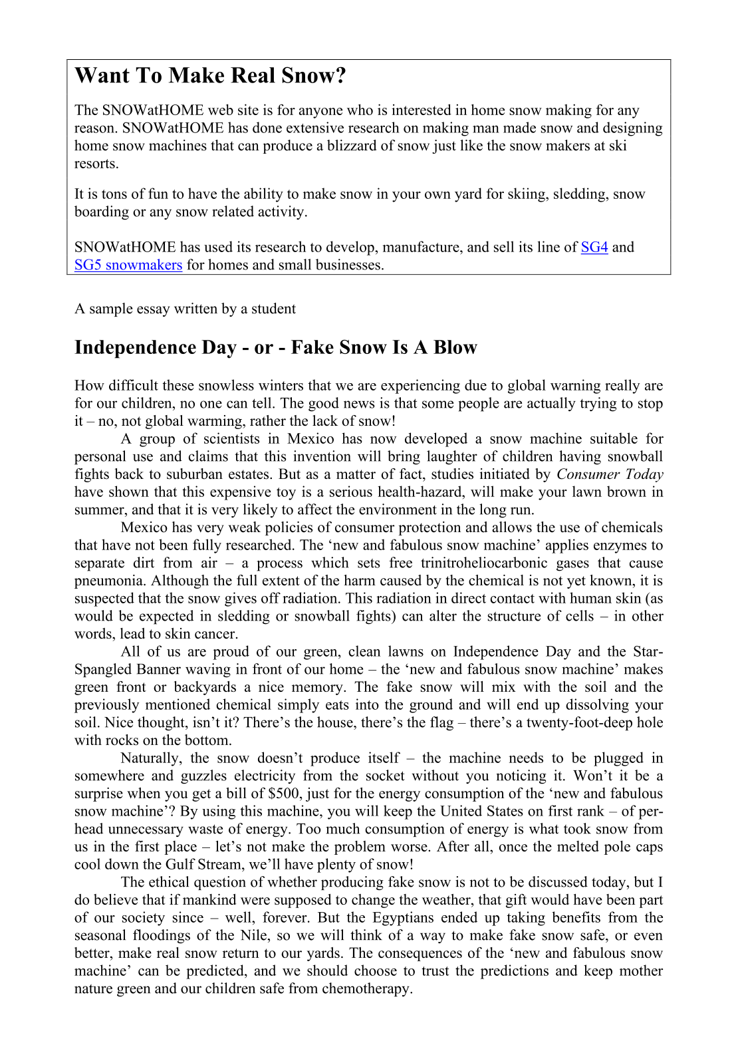
Presentation generated by Gamma.app based on the student’s article.

To view the presentation follow the link
https://gamma.app/docs/The-Hidden-Dangers-of-Home-Snow-Machines-ovmzjqdnjpseplt

The following sales presentation was generated by Gamma.app based on the short ad for the snow machine.

https://gamma.app/docs/Make-Real-Snow-at-Home-wkm5p3rlvb4pgvz

Can you think of a similar project for your students?
What topic would be suitable?
How can you make sure that the creative steps and the language learning are done by the students?

