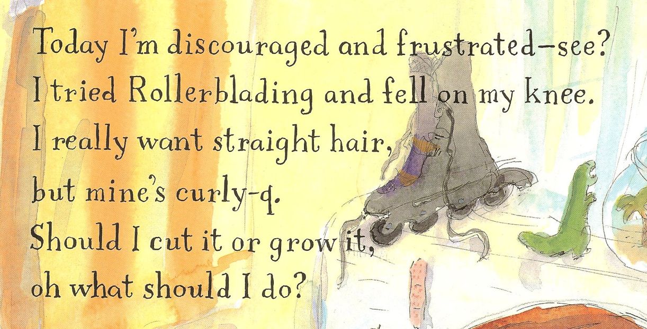
New version
give up or study harder
I make too many mistakes
to pass it
but I failed terribly
another FOF test

