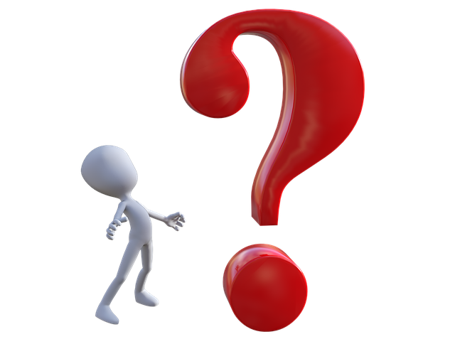
Specific events
Past tense
(2nd form)
General question
Have you ever…
= present perfect tense (3rd form)
Yes, I have.
When was that? Tell me more about it.
Have you ever felt really …………………?

