Travelling across Europe



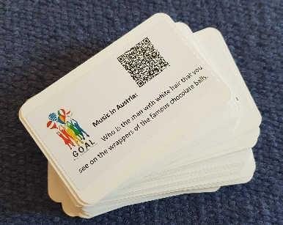
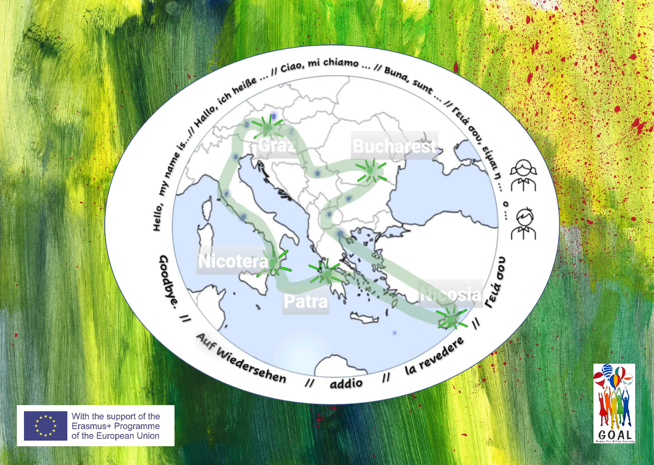
You need:
- a gameboard
- a set of tickets
- a counter for each player
- a smartphone or tablet with a QR-code reader
Goal of the game:
Travel around Europe along the marked route until you come back to your starting point.
How to play the game:
Each player chooses a starting point and puts their counter in this place.
The youngest player starts and picks up a ticket and reads out the question.
If the player can answer the question without any help, he/she moves to the next stop and may pick up another ticket.
Always check your answers by scanning the QR code on the ticket.
If the player cannot answer the question immediately (without help), scan the QR code on the ticket. Read the text or watch the video. If the player can now answer the question, he/she may move to the next stop (but is not allowed to pick up a 2nd ticket).
The next player may pick up a ticket …
Greetings:
Whenever a player enters one of the 5 countries in our project, he/she must greet the others in the language of this country. When a player leaves one of these countries, he/she must say “good bye” in the language of the country.

If a player cannot say the correct greeting, he/she cannot move on.
This Photo by Unknown Author is licensed under CC BY-NC
The Winner:
The player who returns to his/her starting point first, wins the game.

