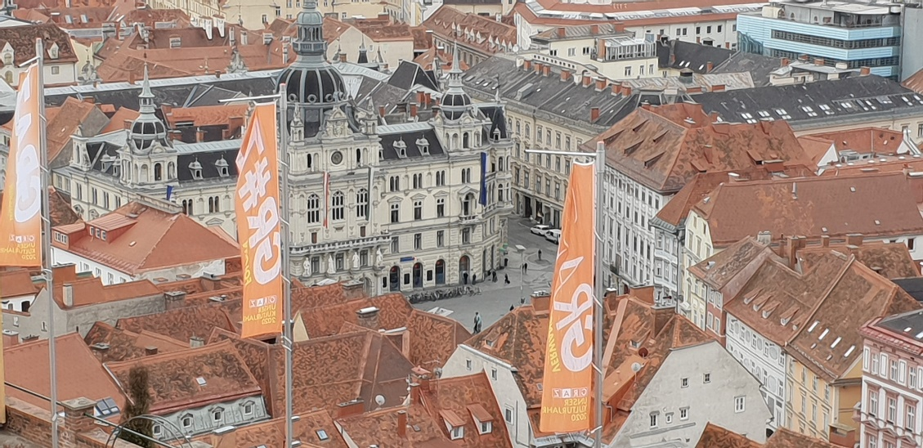
GOAL Games Workshop, May 12th, 2022:
Group: “Hauptplatz” – Main Square

 | Names | Boardgame Travelling across Europe | Cardgame:  Happy Families of Graz | Cardgame:  Happy Families of Cyprus | 4 online games:  How we Live and Work in Graz | Online game:  Archeological Museum in Nicosia: (Reading)  What are these very old stone people doing? | Online game:  Archeological Museum in Nicosia (Listening)  What are these very old people doing?
Guest
Year 1
Year 2
Year 3
any other

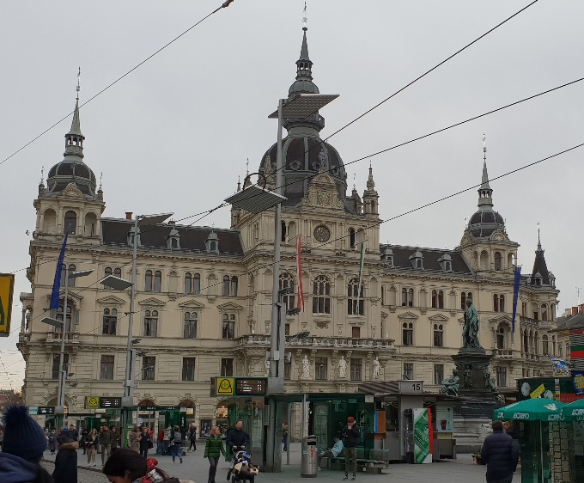
GOAL Games Workshop, May 12th, 2022:
Group: “City Hall (Rathaus)”

 | Names | Boardgame Travelling across Europe | Cardgame:  Happy Families of Graz | Cardgame:  Happy Families of Cyprus | 4 online games:  How we Live and Work in Graz | Online game:  Archeological Museum in Nicosia: (Reading)  What are these very old stone people doing? | Online game:  Archeological Museum in Nicosia (Listening)  What are these very old people doing?
Guest
Year 1
Year 2
Year 3
any other

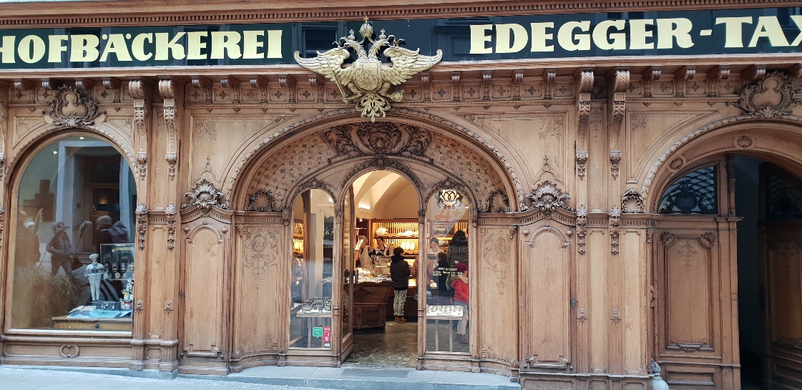
GOAL Games Workshop, May 12th, 2022:
Group: “Bakery Edegger-Tax”

 | Names | Boardgame Travelling across Europe | Cardgame:  Happy Families of Graz | Cardgame:  Happy Families of Cyprus | 4 online games:  How we Live and Work in Graz | Online game:  Archeological Museum in Nicosia: (Reading)  What are these very old stone people doing? | Online game:  Archeological Museum in Nicosia (Listening)  What are these very old people doing?
Guest
Year 1
Year 2
Year 3
any other

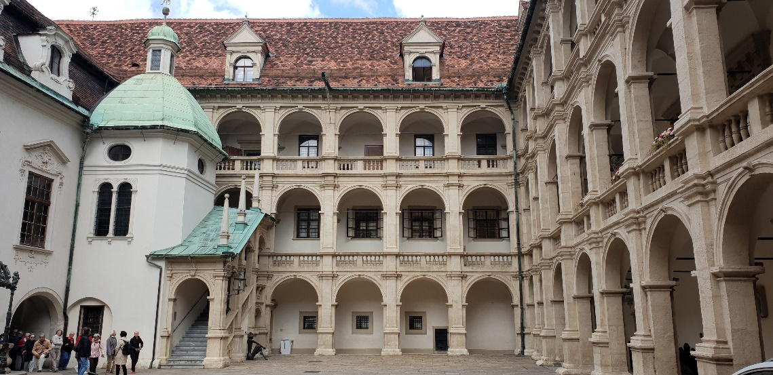
GOAL Games Workshop, May 12th, 2022:
Group: “Landhaushof – Herrengasse”

 | Names | Boardgame Travelling across Europe | Cardgame:  Happy Families of Graz | Cardgame:  Happy Families of Cyprus | 4 online games:  How we Live and Work in Graz | Online game:  Archeological Museum in Nicosia: (Reading)  What are these very old stone people doing? | Online game:  Archeological Museum in Nicosia (Listening)  What are these very old people doing?
Guest
Year 1
Year 2
Year 3
any other

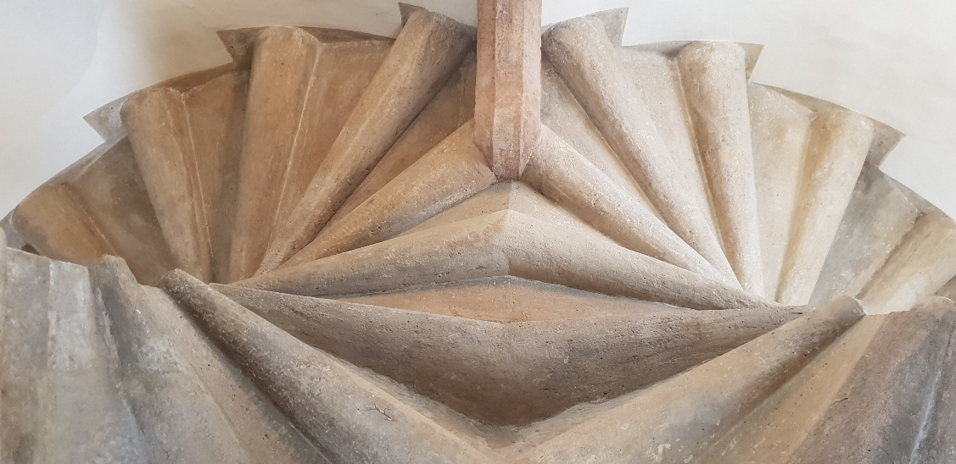
GOAL Games Workshop, May 12th, 2022:
Group: “Double Spiral Staircase” (Doppelwendeltreppe)

 | Names | Boardgame Travelling across Europe | Cardgame:  Happy Families of Graz | Cardgame:  Happy Families of Cyprus | 4 online games:  How we Live and Work in Graz | Online game:  Archeological Museum in Nicosia: (Reading)  What are these very old stone people doing? | Online game:  Archeological Museum in Nicosia (Listening)  What are these very old people doing?
Guest
Year 1
Year 2
Year 3
any other

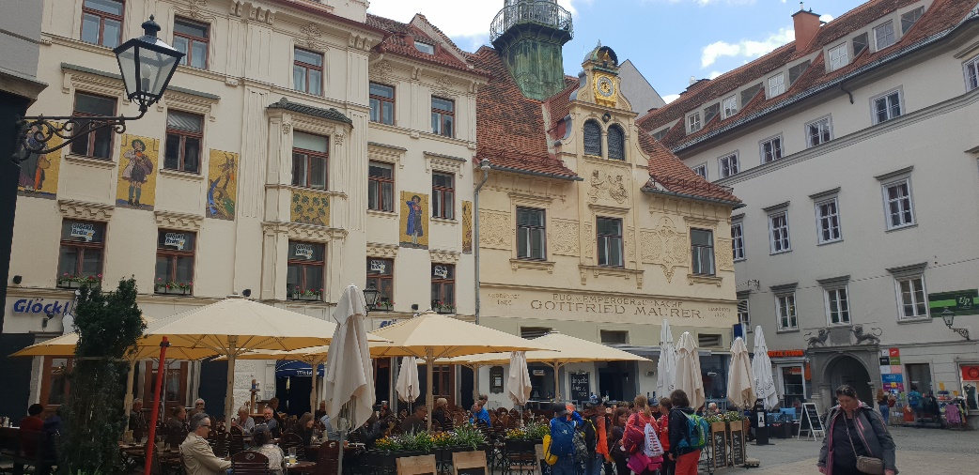
GOAL Games Workshop, May 12th, 2022:
Group: “Glockenspielplatz”

 | Names | Boardgame Travelling across Europe | Cardgame:  Happy Families of Graz | Cardgame:  Happy Families of Cyprus | 4 online games:  How we Live and Work in Graz | Online game:  Archeological Museum in Nicosia: (Reading)  What are these very old stone people doing? | Online game:  Archeological Museum in Nicosia (Listening)  What are these very old people doing?
Guest
Year 1
Year 2
Year 3
any other

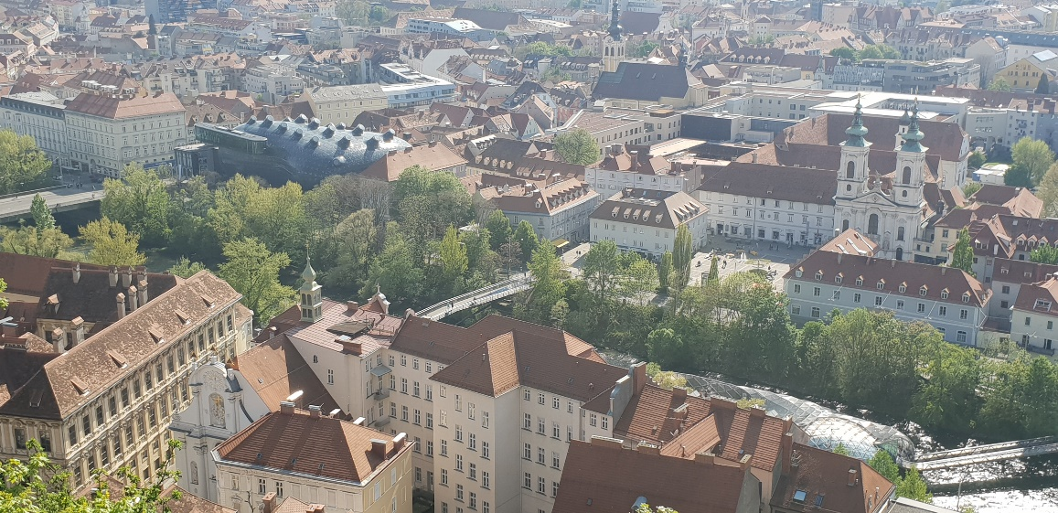
GOAL Games Workshop, May 12th, 2022:
Group: “View from Schlossberg”

 | Names | Boardgame Travelling across Europe | Cardgame:  Happy Families of Graz | Cardgame:  Happy Families of Cyprus | 4 online games:  How we Live and Work in Graz | Online game:  Archeological Museum in Nicosia: (Reading)  What are these very old stone people doing? | Online game:  Archeological Museum in Nicosia (Listening)  What are these very old people doing?
Guest
Year 1
Year 2
Year 3
any other

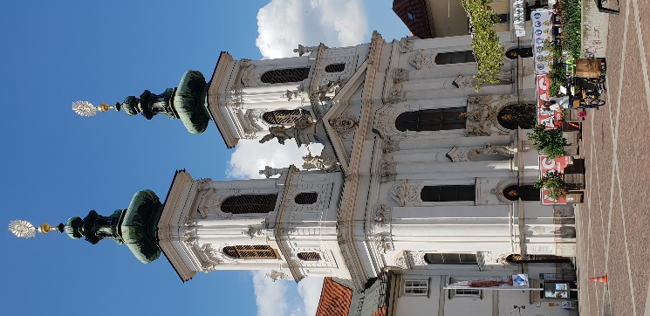
GOAL Games Workshop, May 12th, 2022:
Group: “Mariahilferkirche”

 | Names | Boardgame Travelling across Europe | Cardgame:  Happy Families of Graz | Cardgame:  Happy Families of Cyprus | 4 online games:  How we Live and Work in Graz | Online game:  Archeological Museum in Nicosia: (Reading)  What are these very old stone people doing? | Online game:  Archeological Museum in Nicosia (Listening)  What are these very old people doing?
Guest
Year 1
Year 2
Year 3
any other

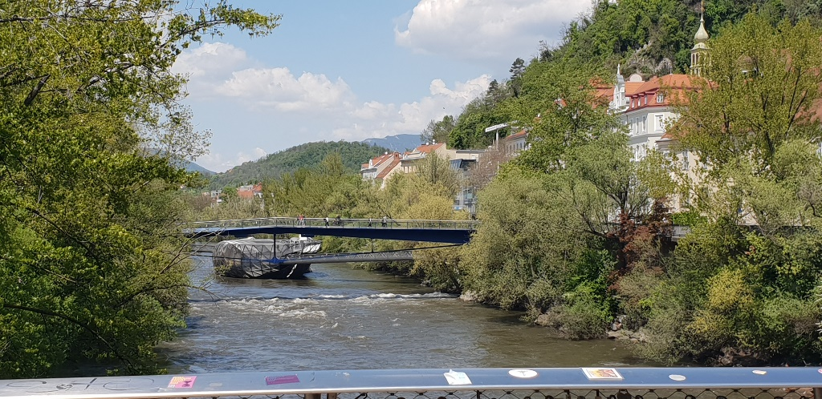
GOAL Games Workshop, May 12th, 2022:
Group: “The river Mur”

 | Names | Boardgame Travelling across Europe | Cardgame:  Happy Families of Graz | Cardgame:  Happy Families of Cyprus | 4 online games:  How we Live and Work in Graz | Online game:  Archeological Museum in Nicosia: (Reading)  What are these very old stone people doing? | Online game:  Archeological Museum in Nicosia (Listening)  What are these very old people doing?
Guest
Year 1
Year 2
Year 3
any other

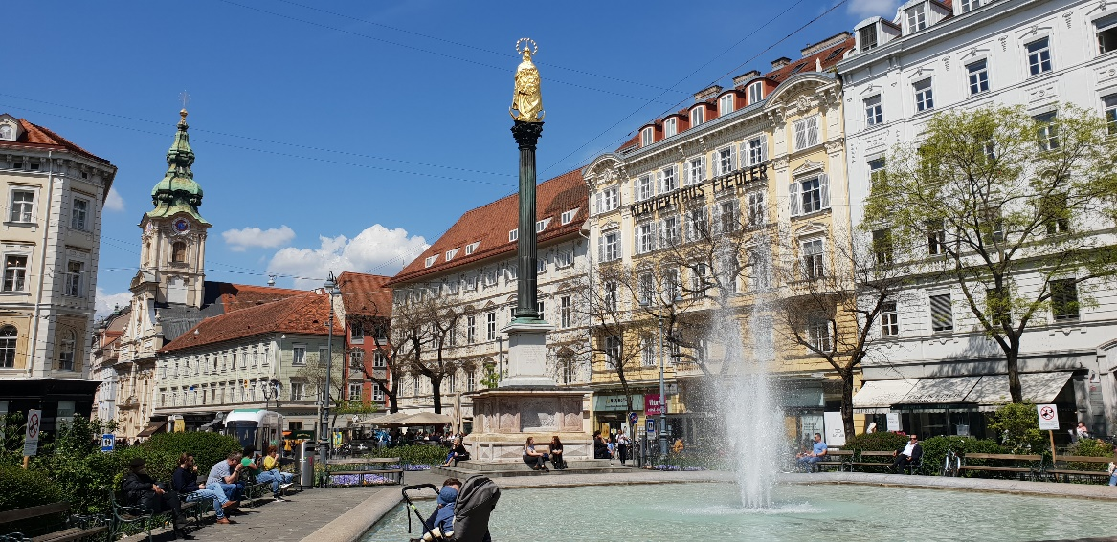
GOAL Games Workshop, May 12th, 2022:
Group: “Eisernes Tor, Pestsäule, Stadtpfarrkirche“

 | Names | Boardgame Travelling across Europe | Cardgame:  Happy Families of Graz | Cardgame:  Happy Families of Cyprus | 4 online games:  How we Live and Work in Graz | Online game:  Archeological Museum in Nicosia: (Reading)  What are these very old stone people doing? | Online game:  Archeological Museum in Nicosia (Listening)  What are these very old people doing?
Guest
Year 1
Year 2
Year 3
any other

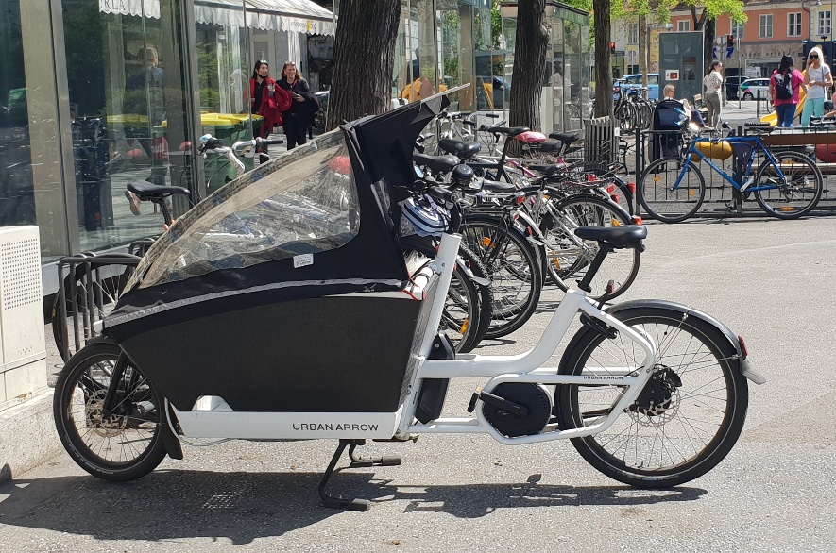
GOAL Games Workshop, May 12th, 2022:
Group: “Sustainable Traffic solutions – Cargo bikes”

 | Names | Boardgame Travelling across Europe | Cardgame:  Happy Families of Graz | Cardgame:  Happy Families of Cyprus | 4 online games:  How we Live and Work in Graz | Online game:  Archeological Museum in Nicosia: (Reading)  What are these very old stone people doing? | Online game:  Archeological Museum in Nicosia (Listening)  What are these very old people doing?
Guest
Year 1
Year 2
Year 3
any other

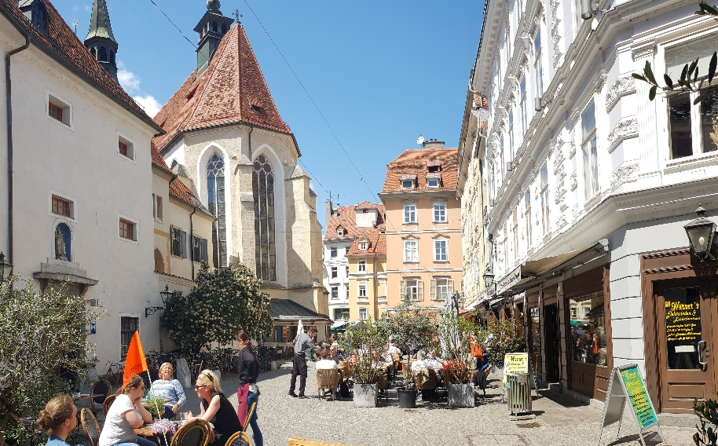
GOAL Games Workshop, May 12th, 2022:
Group: “Franziskanerplatz”

 | Names | Boardgame Travelling across Europe | Cardgame:  Happy Families of Graz | Cardgame:  Happy Families of Cyprus | 4 online games:  How we Live and Work in Graz | Online game:  Archeological Museum in Nicosia: (Reading)  What are these very old stone people doing? | Online game:  Archeological Museum in Nicosia (Listening)  What are these very old people doing?
Guest
Year 1
Year 2
Year 3
any other

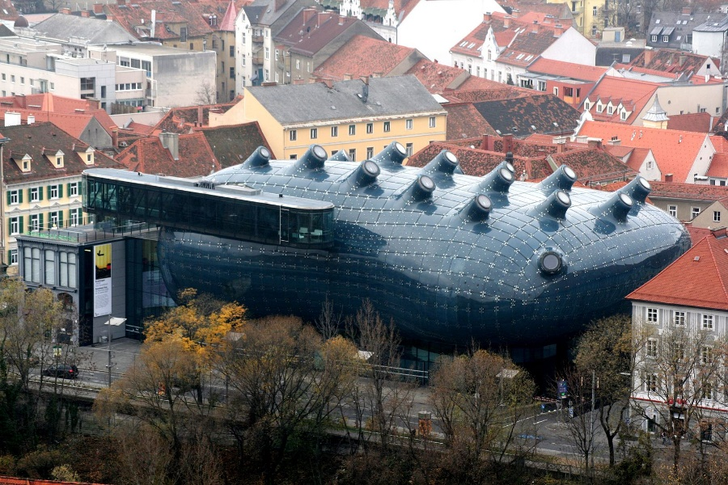
GOAL Games Workshop, May 12th, 2022:
Group: “Kunsthaus: The friendly alien”

 | Names | Boardgame Travelling across Europe | Cardgame:  Happy Families of Graz | Cardgame:  Happy Families of Cyprus | 4 online games:  How we Live and Work in Graz | Online game:  Archeological Museum in Nicosia: (Reading)  What are these very old stone people doing? | Online game:  Archeological Museum in Nicosia (Listening)  What are these very old people doing?
Guest
Year 1
Year 2
Year 3
any other

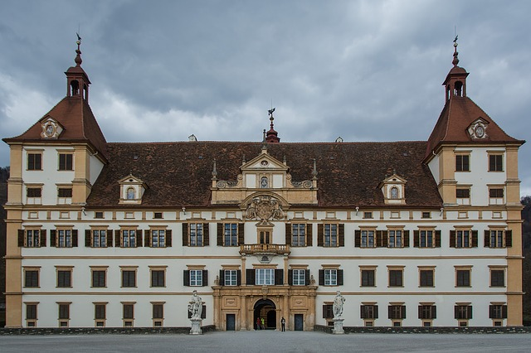
GOAL Games Workshop, May 12th, 2022:
Group: “Eggenberg Castle”

 | Names | Boardgame Travelling across Europe | Cardgame:  Happy Families of Graz | Cardgame:  Happy Families of Cyprus | 4 online games:  How we Live and Work in Graz | Online game:  Archeological Museum in Nicosia: (Reading)  What are these very old stone people doing? | Online game:  Archeological Museum in Nicosia (Listening)  What are these very old people doing?
Guest
Year 1
Year 2
Year 3
any other

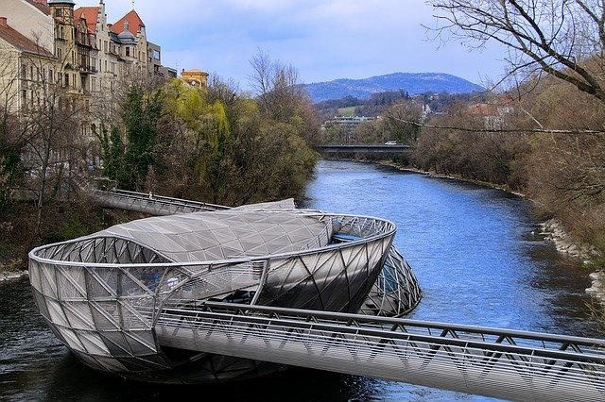
GOAL Games Workshop, May 12th, 2022:
Group: “Murinsel: Island in the Mur”

 | Names | Boardgame Travelling across Europe | Cardgame:  Happy Families of Graz | Cardgame:  Happy Families of Cyprus | 4 online games:  How we Live and Work in Graz | Online game:  Archeological Museum in Nicosia: (Reading)  What are these very old stone people doing? | Online game:  Archeological Museum in Nicosia (Listening)  What are these very old people doing?
Guest
Year 1
Year 2
Year 3
any other

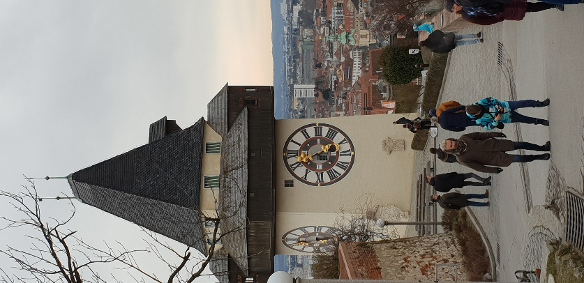
GOAL Games Workshop, May 12th, 2022:
Group: “The Clocktower”

 | Names | Boardgame Travelling across Europe | Cardgame:  Happy Families of Graz | Cardgame:  Happy Families of Cyprus | 4 online games:  How we Live and Work in Graz | Online game:  Archeological Museum in Nicosia: (Reading)  What are these very old stone people doing? | Online game:  Archeological Museum in Nicosia (Listening)  What are these very old people doing?
Guest
Year 1
Year 2
Year 3
any other

Games Workshop GOAL:

16 groups --- 5 players per group

Prepare 16 group tables:
- Lernumgebung
- Flexi blue
- Flexi green
- Flexi red (3f)
Charge all available tablets (at least 10)

Put one game on each table – so the groups can start.

Groups fill in their names and start with the first game. This is NOT about SPEED, but about finding out as much as possible about Graz.
All other games will be available at the teacher’s desk (in each classroom). Groups can bring back their first game and get another one.
1-2 teachers per room: please help with the games, rules …
Bring dice and counters
Each group should play all the games.

