Transportation in Graz
Why is it not a good idea to go by car in Graz?
Question: How do most teachers and students of PraxisNMS go to school?

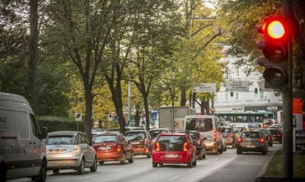
Graz is an old city with fairly narrow streets. They are not made for lots of cars. Therefore, people who go by car are often stuck in traffic jams. It is also very difficult to find a parking space for your car.

Therefore, most of the teachers and students of our school come by tram, by bus, or they ride their bikes to school.
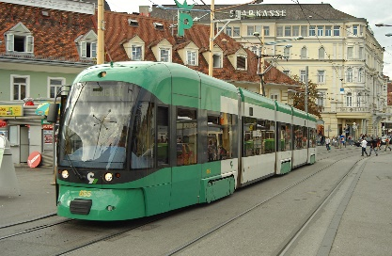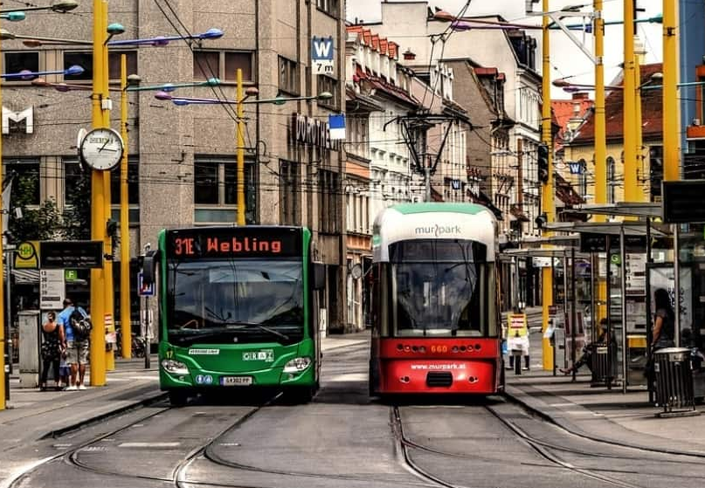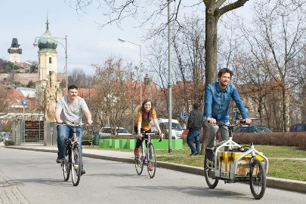
The tram stops right in front of our school,
and for bikes we have a special parking area with a roof, so the bikes do not get wet in the rain.

