Christmas in Austria
Does Santa Claus bring the presents in Austria?
How do people in Austria celebrate Christmas?

The Christmas holidays in Austria start on the 24th of December and end after Epiphany.
On Christmas Eve families are always together. Many families go to church and then they eat delicious food. Many eat pork or duck with delicious sauces.
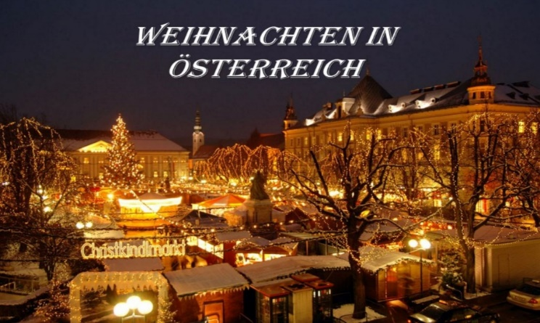
After the delicious meal, the families light the candles on the Christmas tree and the children get their presents.
Christmas is the event of love – people share love but the stress of buying presents is never absent…
The children in Austria do not believe in Santa Claus, but for us Christkind (that is Christchild) brings the presents. We think that Christchild looks like an angel and can fly through keyholes, but nobody has ever seen it.
When the children grow up they find out that this is not true because the parents buy presents for them.
THIS IS HOW WE CELEBRATE CHRISTMAS IN AUSTRIA!!!!!!

