What do people eat on All Saints’ Day?
Do all people celebrate Halloween in Austria?

Halloween

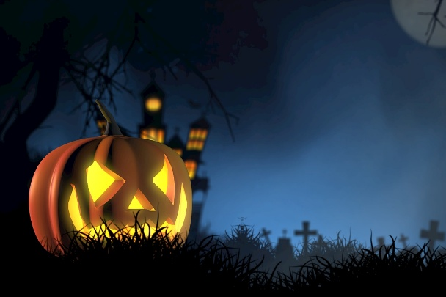
In Austria more and more children like to celebrate Halloween. They like Halloween because it is fun to dress up as witches, ghosts and other scary figures. The children walk around the neighborhood and say “Süßes oder Saures” – that’s trick or treat in German.
Many children go to Halloween parties and celebrate with their friends.
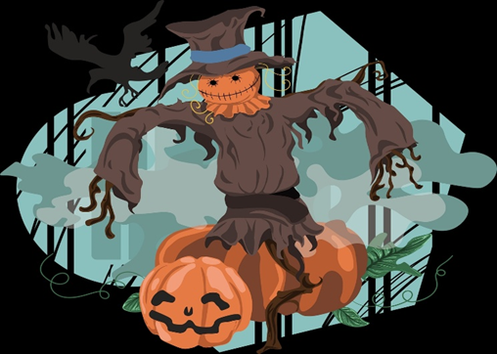
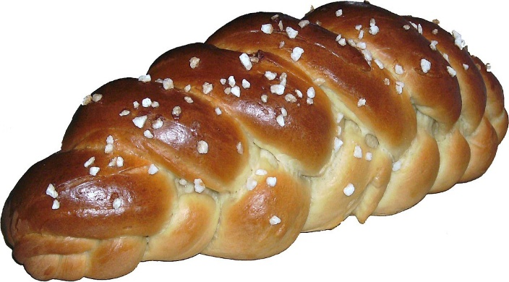
But not everybody celebrates Halloween in Austria. Originally, we celebrate All Saints Day. For All Saints Day people go to the cemetery to visit the dead and many families eat traditional “Allerheiligen Striezel” – that is a delicious braided sweet bread on that day.

