Where can you buy sports equipment in the center of Graz?
What can you do at Kastner and Öhler if you do NOT want to go shopping?

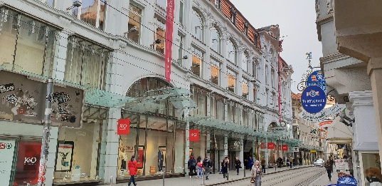
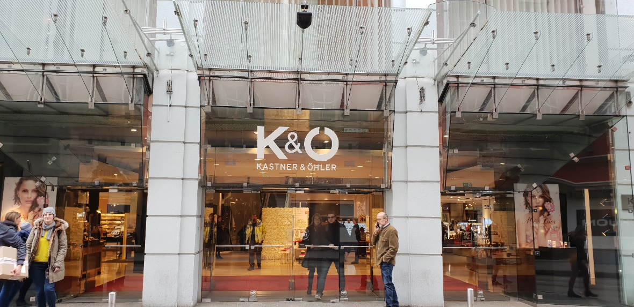
Kastner & Öhler

Kastner and Öhler is a beautiful old department store in Graz.
On the ground floor there is a perfume section and a make-up section, and they are really expensive. Two floors are for women’s clothes and on one floor they sell clothes for men. They also have a toys department on the top floor.
At Kastner and Öhler you can buy exquisite things. They also have their own Kastner and Öhler home store and a really big sports store called Gigasport.
At the top there is a very tasty restaurant where it is not easy to get a seat. In summer the roof terrace is very sunny, and you have a beautiful view over the roofs of Graz.
Kastner and Öhler is a lovely store in every season. Even if you do not want to buy anything, you should go in and see the beautiful building from the escalator.

