What type of meat is used for Wiener Schnitzel?
Where does Wiener Schnitzel originally come from?

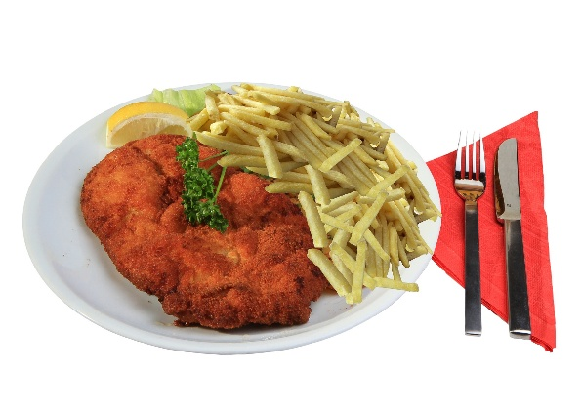
Wiener Schnitzel

Wiener Schnitzel is Austria’s best food and it is very popular
in Austria. Originally, Wiener Schnitzel comes from Milano in Italy, but it was brought to Vienna and became so popular there that we now call it “Wiener Schnitzel”.
You can find Wiener Schnitzel in every traditional restauant in Austria.
The traditional Wiener Schnitzel is made of veal and it’s breaded but today most people make it with turkey or pork. In Austria we like to eat it with potato salad or fries.

