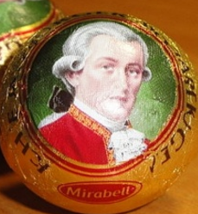
Who is a man with white hair that you can see on the famous Austrian chocolate balls?

Wolfgang Amadeus Mozart

The name of the man is Wolfgang Amadeus Mozart. He is a famous Austrian musician and composer. He was born in Salzburg in 1756 and he died in Vienna in 1791.
Mozart was a miracle child.
At the age of 9 he composed his first opera „Apollo and Hyacinthus“. After that he composed many songs and operas in his life.
His most famous opera is certainly “The Magic Flute”.
This is the most famous Austrian chocolate. The name is Mozartkugel – or Mozart balls.

This is a piano. You need it to compose music.

