What can you do on the Murinsel?
Name 3 things.

The Island in the river Mur
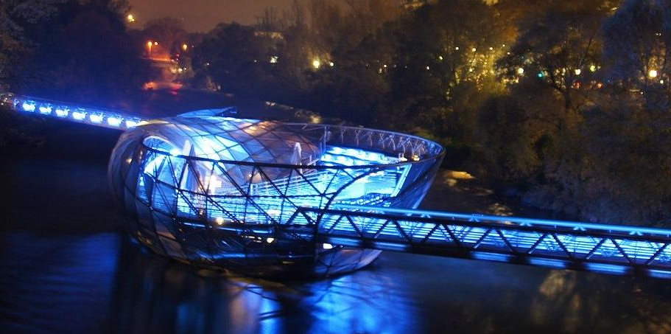
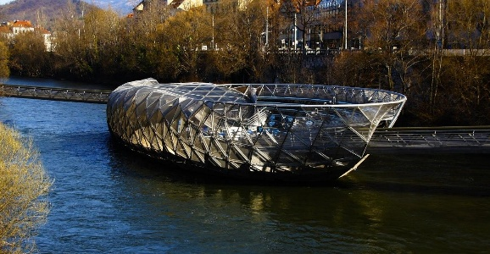
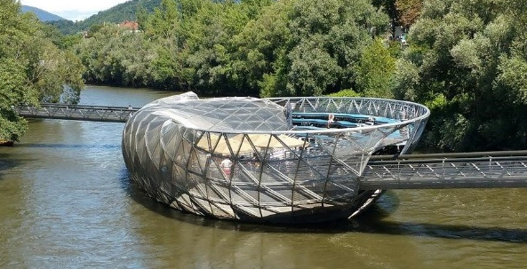
In the year 2003 was Graz the European Capital of Culture. For this occasion, an artificial island was built in the river Mur. On this island, there is a small restaurant. In summer, many events take place on the Murinsel. Sometimes you can watch movies there. It is also like a bridge- you can walk from one side of the river Mur to the other side. In the night, the Murinsel lights up.

