What are children afraid of on December 5th?
Why do so many children put their shoes in front of the front door on December 5th?

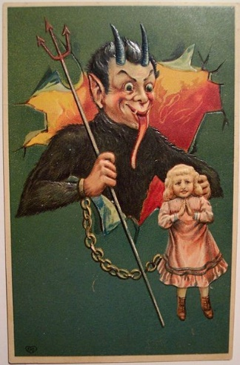
On the 5th of December we celebrate Krampus day. Krampus is a very scary figure. He wears a furry costume with dangerous horns and he always carries a whip. All children are scared of him.

Fortunately, Krampus usually walks with St. Nicholas, – and that makes him less dangerous. St. Nicholas looks like Santa Claus and he comes to kids’ homes to bring little presents.

In the evening children put their boots in front of the door because in the night of December 5th St Nicholas comes and puts tangerines, nuts and sweets in their shoes. On the morning of the 6th, kids are happy because they find the sweets in their shoes.

