What can you see along the Apple Road?
When are the best times to visit the Styrian Apple Road?

Styrian Apple Road
The Styrian apple road is very beautiful and there you walk through large areas full of apple trees. When you go hiking there in May, the trees are in bloom and it is so beautiful, you feel like in paradise and you feel so free.
If you go there in September, you see the really delicious apples.
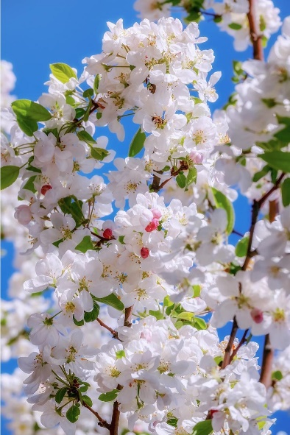
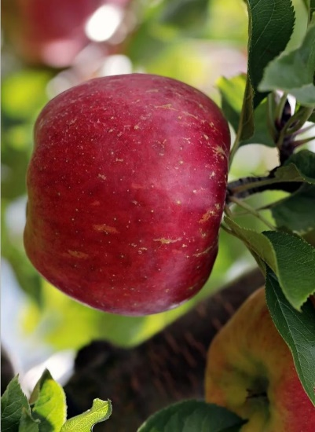
In 1986 about 40 farmers joined forces and founded the association “Styrian Apple Road” The Apple Road is 25 kilometers long so you can walk for a long time. The Apple Road is in a small town called “Puch bei Weiz”. It is easy to reach by car and by bicycle.

