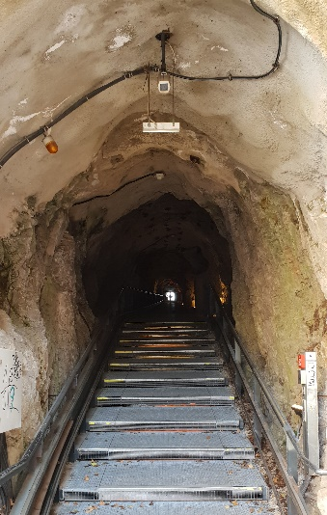
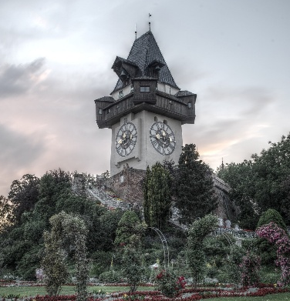
The Schlossberg is our castle hill in the center of Graz. It is a tourist attraction and from the top you have a beautiful view of the whole city.
What is inside the Schloßberg?
But here, we are not going to tell you about the top of Schlossberg, but we will tell you what’s inside it.
Inside the Schlossberg there is a fairy-tale-train. You can ride this train and see lots of scenes from well-known fairytales. This is very popular with children.
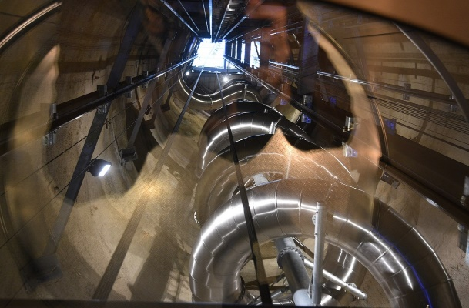
Another cool thing inside the Schlossberg is the lift. You walk inside an old tunnel from the 2nd world war and in the center of the hill you will find a lift that takes you up to the top.
The tunnel goes all the way through the Schlossberg – you can walk in on the northern side and come out in the south close to the river Mur.
This tunnel also leads to an underground concert hall – it is called “Dom im Berg”. It is used for all kinds of music performances.
The coolest thing inside the Schlossberg is the new slide. It is a spiral slide and it winds around the lift. You have to buy a ticket and you can slide down and go round and round and round and round the lift until you reach the bottom.
It’s super cool.
There are more tunnels inside the Schlossberg. They were used to hide from bombings during the war. Now these tunnels are closed.
Just a little tip: Inside the Schloßberg it is very cold. Bring a sweater, even in the summer.

