Advent Calendars
What makes the time shorter when you are waiting for Christmas ???

In Austria children usually get an Advent calendar.
They can open a door in the advent calendar every day.
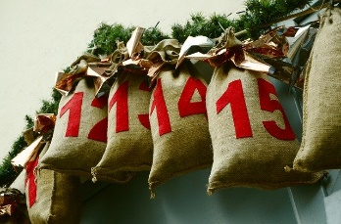
Advent calendars come in all sizes: very small calendars the size of a postcard, and really big ones that you can hang on the wall. You open a door everyday, and you find a picture. Some advent calendars even have a piece of chocolate inside for each day.
The last door is the biggest one, because on this day Jesus was born.
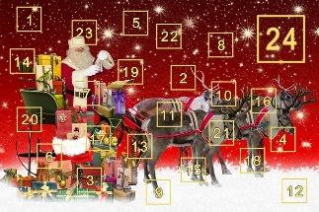
In our class we also have an advent calendar with little bags for each day. Our teachers fill in little treats and every day one of the children can find a little treat.

