Where do the cows live in the summer?
Why are people hearing bells on a hiking trip?

Hiking in the mountains

Austria is a country with lots of mountains. In the Alps you can go hiking in the summer. The farmers keep their cows up on the mountains in the summer. There they can eat fresh grass and produce good milk and cheese. The cows walk around, and you can hear their bells from far away.
In the winter the cows are in the barn in the village.
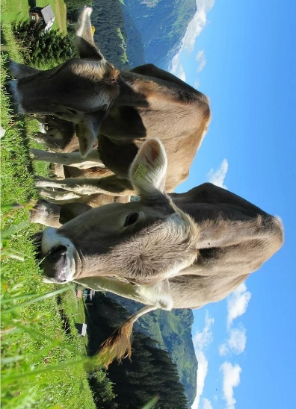
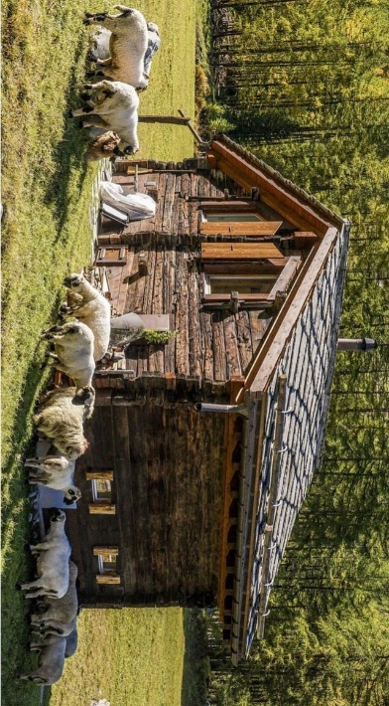
On many mountains there are huts where you can eat and spend the night. Often, there is also a lake where you can go pedal boating and swimming, but the water in these lakes is usually VERY cold. On most hikes you will also cross many little streams. Children like to play there and build dams or wade in the cold water.

