APRIL FOOLS
WHY is there toothpaste in Valentin’s Oreos?

In our school April 1st is always a fun day. We play lots of pranks on our teachers and classmates.

The first time April fools was mentioned in a document was in 1618 in Bavaria/Germany. To this day it is unclear, what started this tradition. On this day most people play pranks on other people.
When the prank is played you scream at the end „April, April!“

PRANK IDEAS:
Toothpaste in Oreos, salt on the toothbrush,
cling film on the toilet
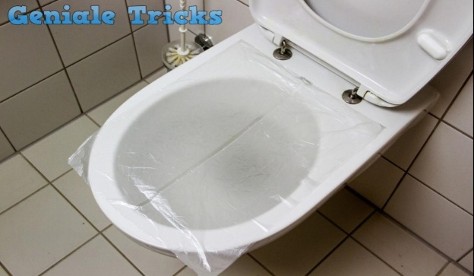
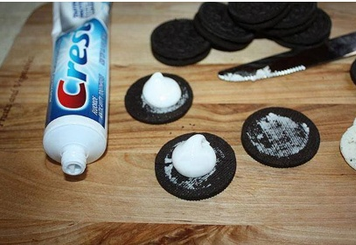
In our school we sometimes agree to dress up in a certain way on April 1st. One year we all brought beach towels, sun lotion and sunglasses and we lay down on the floor when our teachers came in. This was a lot of fun. Some teachers even lay down with us.

