What is a “Buschenschank” in Styria?

Buschenschank
A Buschenschank is a little bit like a farm restaurant. It is very typical of Styria. Styria is one of the 9 provinces of Austria and Graz is its capital.
In a Buschenschank you can usually eat cold things like ham, sausages, cheese platters and salads with pumpkin seed oil. There are often homemade spreads and fresh rye bread They also have delicious home-made desserts.
When you are in a Buschenschank you can drink some grape juice, apple juice and local wine.
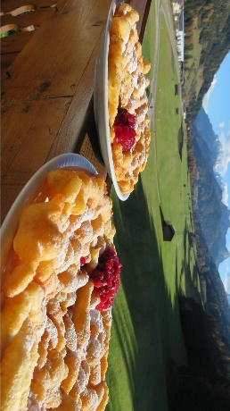

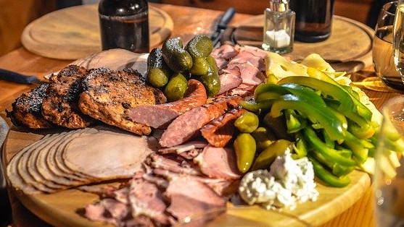
All the things must be grown and produced by the farmers themselves. A Buschenschank is only open on certain days.

