Our school cafeteria
Where do the children in the Praxis NMS get their lunch?
What do they get for lunch?

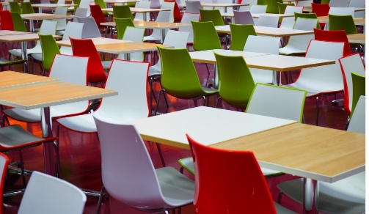
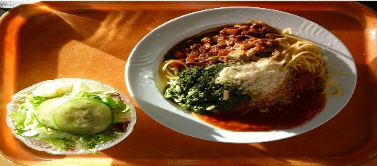

School lasts the whole day from 7:40a.m. till 4.05p.m. and therefore the children have to eat in school. That’s the reason why they go to the cafeteria at about 1 o’clock. The whole class goes together with their teacher.
Some children do not want to eat in the cafeteria. They can also bring food from home. When they don’t eat in the cafeteria, they meet up in a classroom to eat their lunch.
In the cafeteria the children get a 3-course meal, with soup, a main course with salad and a dessert. It costs 5, 40€.
After lunch the children have free-time, and they can play in the yard.
You can also go to the cafeteria in our morning break, if you didn’t bring a snack or sandwich for break time or if you need breakfast.

