What is the best street food when it is really cold in the winter?

Roasted Chestnuts
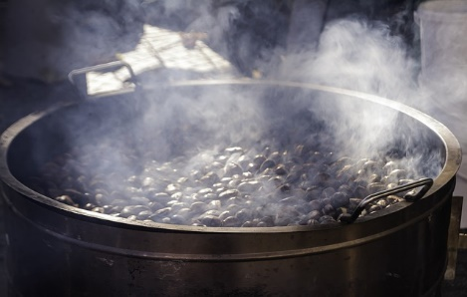
Every winter there are stalls that sell roasted chestnuts for Christmas. They are really delicious.
Usually, you get the hot chestnuts wrapped in newspaper. You have to peel the chestnuts to eat them. The people who sell the chestnuts roast them on a kind of big charcoal grill in the streets.
When it is cold in the winter and your hands are freezing, it is really great to buy roasted chestnuts. They make your hands warm and also warm you inside.
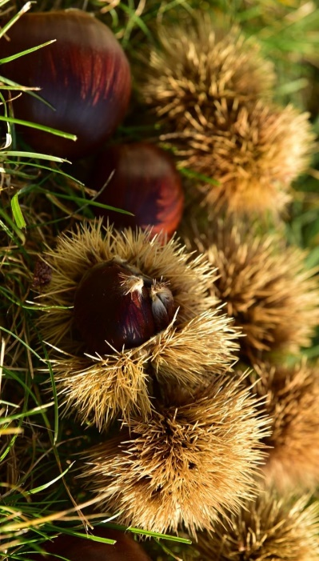
Sometimes the chestnuts are so hot that your hands hurt after you peel the chestnuts.
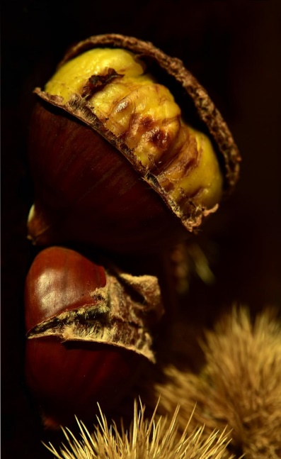
Chestnuts are very popular, and we often eat them in the winter. You can’t eat the chestnuts raw.

