SKIING
What is the most important equipment for skiing. Name 4 things.

Skiing is a very popular sport and a lot of people like it. In Austria we have a lot of mountains, so we have really good skiers.
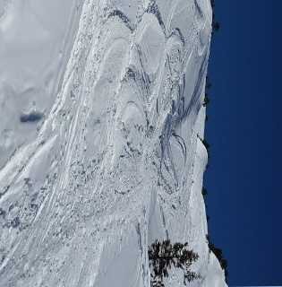
Every winter in Austria we have a lot of ski races where very good skiers participate. Ski racing is their job. Ski races are very exciting for the people that are watching the ski race but of course also for the skiers. There are different types of ski races: downhill races, slalom races and others.
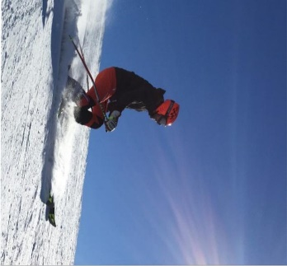
For skiing you need some equipment. You need first some warm clothes that you put on under your ski suit and your ski jacket. You also need ski boots and skis. These things are not very cheap. You must wear a helmet that protects your head. The helmet is very important because if you don’t wear a helmet you can have some really dangerous injuries. You also need ski poles but when you are a beginner you don’t need the ski poles a lot.

