How much is a ticket for the Schlossbergbahn?
How can you go to the top of Schlossberg?
There are 3 ways to do this.

The Schlossbergbahn

The Schlossbergbahn is an old funicular which runs up and down the Schlossberg (castle hill) in Graz. It was built in 1894. It’s red with black stripes and it has big windows, so the people have a beautiful view of Graz when they go up and down.
A ride in the Schlossbergbahn costs 1,30€ for kids and 2,50€ for adults.
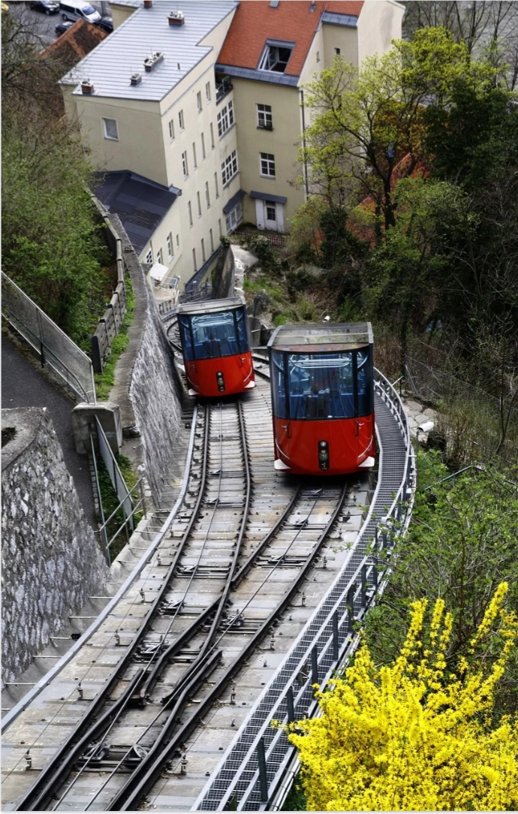
When you come to Graz you MUST go up the Schlossberg. The view is amazing and there are very old cannons, a famous clock tower and some nice restaurants on top of the hill. Many people go up with the Schlossbergbahn and then walk down the stairs.

You can also get to the top of Schlossberg with a lift. It is much faster, but the view is not as good.

