What are they doing?
Two games to practice the present progressive form.

What are these very old people doing?
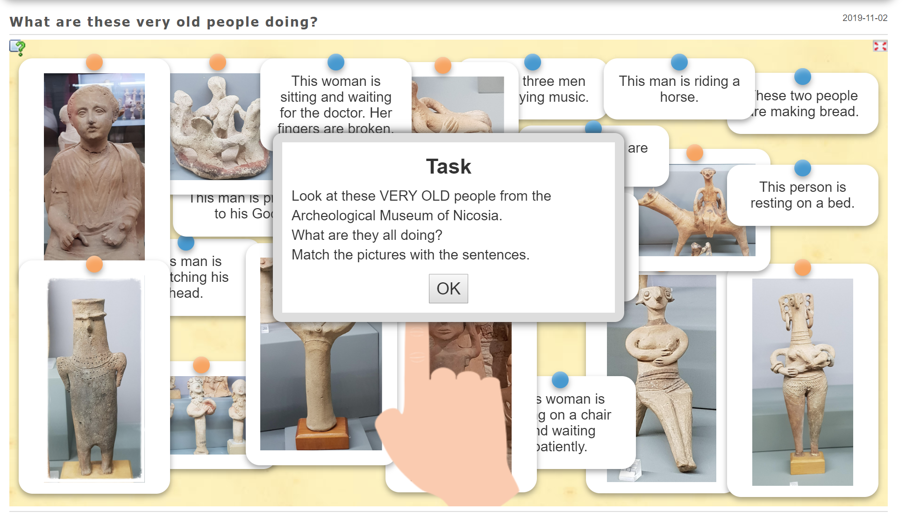

link to the game:
https://learningapps.org/display?v=p6qdhqv5n19
embed code:
<iframe src="https://learningapps.org/watch?v=p6qdhqv5n19" style="border:0px;width:100%;height:500px" webkitallowfullscreen="true" mozallowfullscreen="true"></iframe>

By: Elisabeth Poelzleitner

Listen carefully: What are these very old people doing?


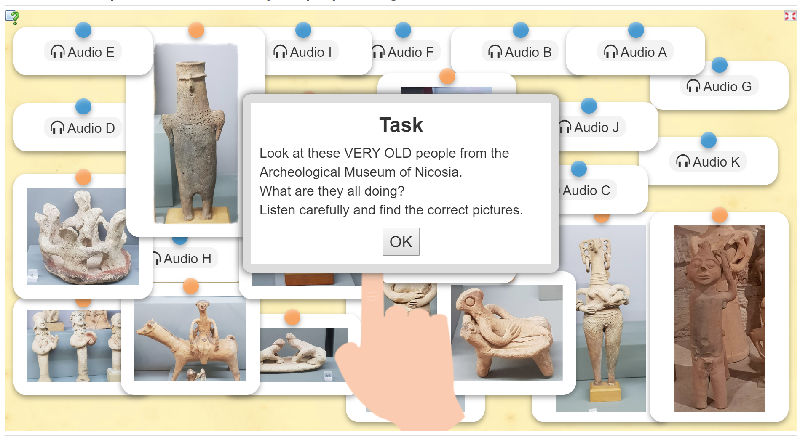
link to the game: https://learningapps.org/display?v=pbx2ga8hk19

embed code: <iframe src="https://learningapps.org/watch?v=pbx2ga8hk19" style="border:0px;width:100%;height:500px" webkitallowfullscreen="true" mozallowfullscreen="true"></iframe>

by: Elisabeth Polzleitner

