START THE GAME!!!! | This is the main symbol of Italy. It was an amphitheater in the ancient and glorious Roman Empire. Rome was called “caput mundi”.  COLOSSEUM

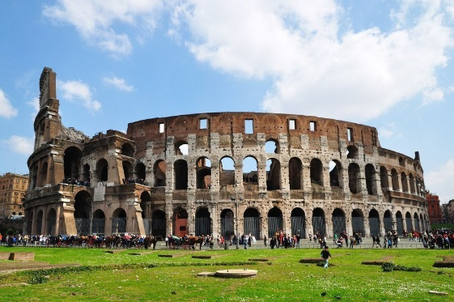 | One of the most important monuments in Italy. It is a bell tower in Pisa (Tuscany) and it is famous for its inclination.  TORRE DI PISA

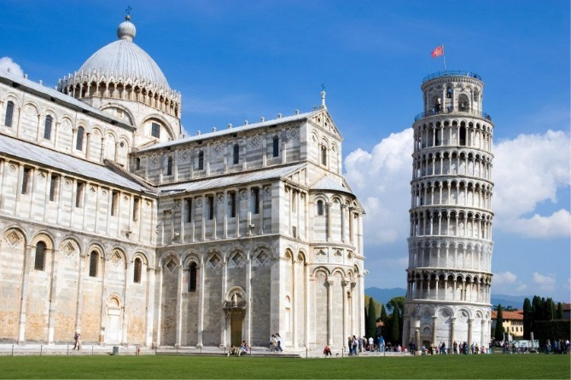  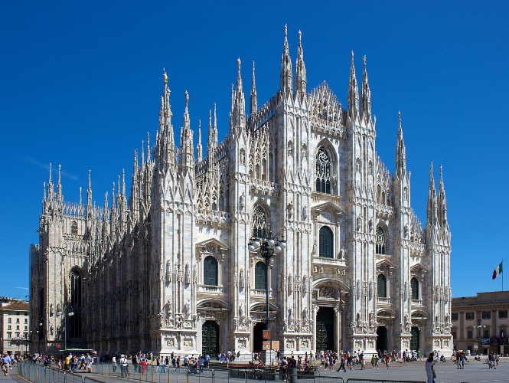 | DUOMO DI  MILANO  (Cathedral)  This is the largest and most complex Gothic building in Italy.
VENICE
This is one of the most attractive towns in Italy. Its buildings are on the water and it is full of little bridges. The GONDOLA is a typical boat to visit the nice town.

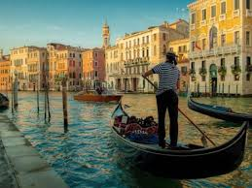 | CATTEDRALE  DI NICOTERA  This is the most important religious place to visit in Nicotera. The Cathedral, dedicated to Our lady of Assumption and built originally in 1785, has a beautiful baroque style of architecture. Inside the Cathedral there are beautiful artworks and ornamental decorations.

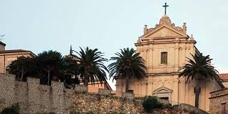 | This is the symbol of the town. Nicotera has Greek and Roman origins. It was a big center near the sea for the production of granitic marble. It was attacked several times by Saracens and destroyed. The new town was built up on the hill.  NICOTERA city emblem

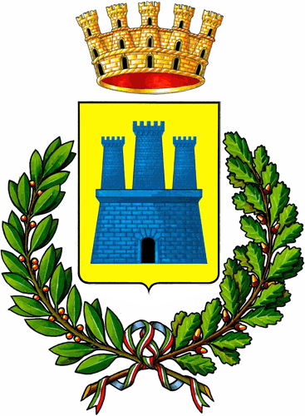 | This is a Norman castle, symbol of Nicotera. It was destroyed and rebuilt several times. It was property of Ruffo Family of Calabria.  Ruffo’s CASTLE

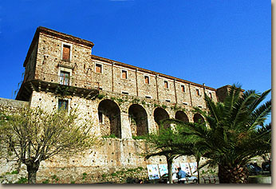 | Mount Etna is a volcano on the East coast of Sicily, part of southern Italy. It is the largest active volcano in Europe. Mount Etna erupts every few years.  ETNA volcano

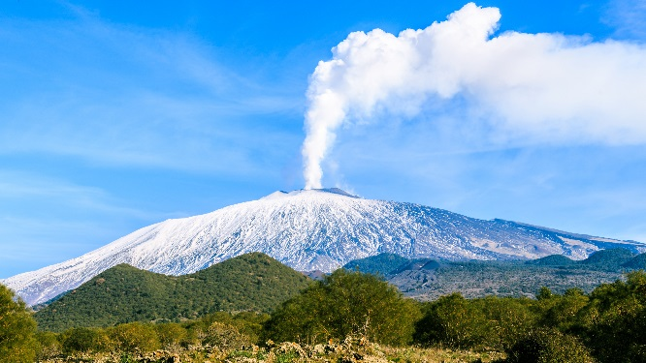  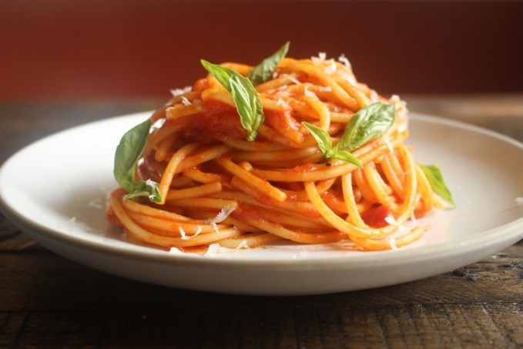  This a typical Calabrian spicy spreadable salame. It is made with parts of the pig, roasted peppers and a mixture of spices.  Nduja | Spaghetti  Spaghetti is a long, string-shaped kind of pasta. It comes from Italian spaghetto, which means "string". Spaghetti is made from wheat and it is boiled in water for a short time. Spaghetti can be served as a main dish with different kinds of sauce.

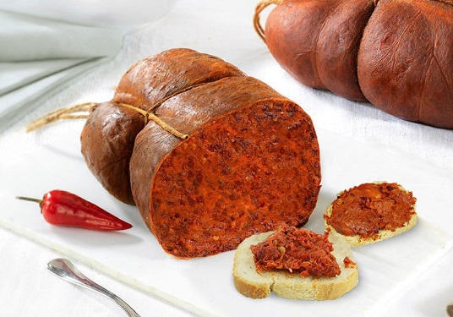 | This is a luxury sport Italian cars brand. The company has been noted for its continued participation in racing, especially in Formula One where it is the oldest and most successful racing team.  FERRARI

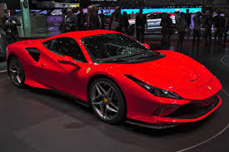 | TORTELLINI  Tortellini are ring-shaped pasta originally from the Italian region of Emilia. They are usually stuffed with a mix of meat, Parmigiano Reggiano cheese, egg and nutmeg. They are traditionally served in capon broth.

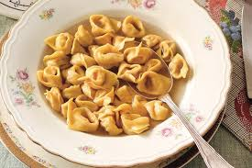 | NICOTERA BEACH  Nicotera Marina has a long sandy beach  and a beautiful sea.  Nicotera is wet by the Tyrrhenean sea.

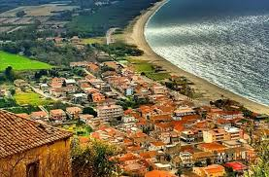 | REGIONS of Italy  Italy is made of 18 Regions in the mainland and 2 big islands called Sicily and Sardinia.

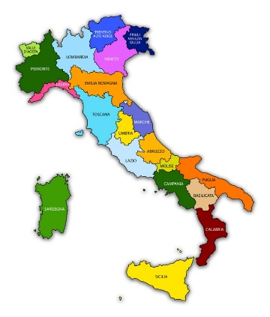 | Panettone and Pandoro  Typical cakes for Christmas.  They are produced in the north of Italy but they are eaten everywhere.

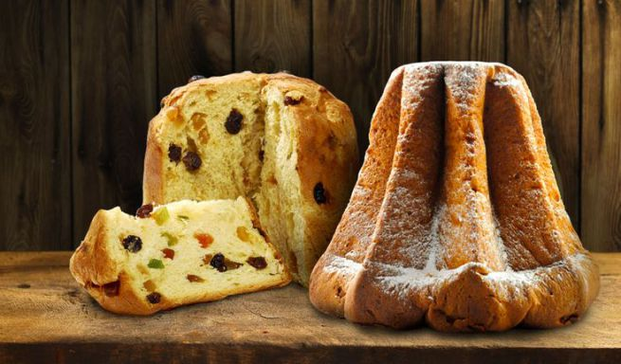 | FIAT 500  This is a typical brand and a famous model of cars made in Italy. The main FIAT factory is in Turin.

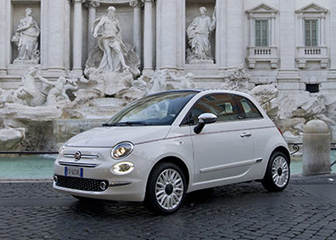 | Tricolore  This is the name for the Italian flag.

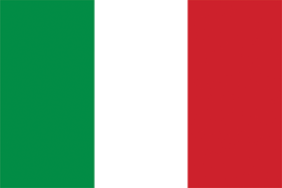 | VESPA  This is a motorbike symbol of the Italian renaissance after the second world war. It is a symbol of the Italian culture and life style.

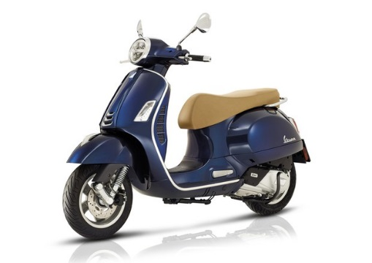 | Laura Pausini  She is one of the best Italian singers known all over the world.

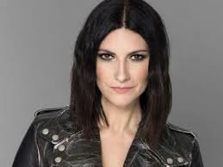 | 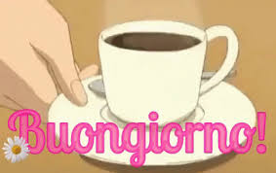

Good morning | Valentino  Armani  Versace  Dolce & Gabbana

ITALIAN fashion | Città del Vaticano SAN PIETRO  Vatican City State is an independent city-state within Rome. The Vatican City is an ecclesiastical state ruled by the Pope.

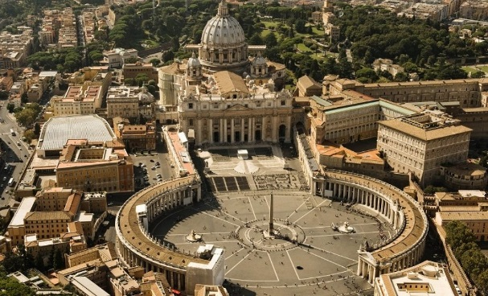 | 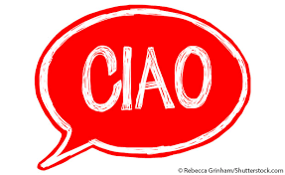

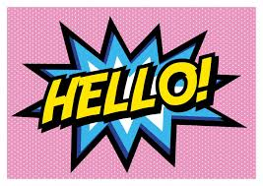 | TOTTI

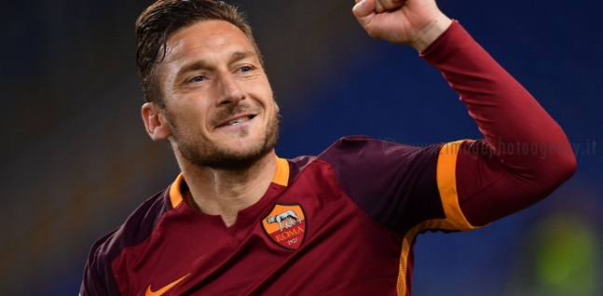 | Pope Francesco I  He is the bishop of Rome and the head of the Roman Catholic Church.

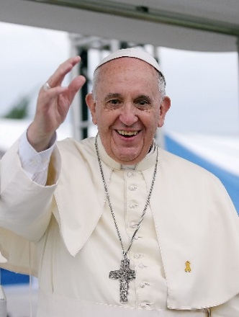 | CALABRIA (Region of Italy)

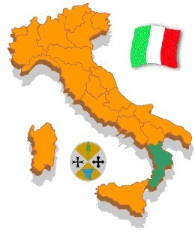 | Enjoy a good PIZZA!!  