How to play Happy Families : 52 cards (13 families)  Play in groups of 3 or 4.  - Hand out all the cards. Do NOT show them to your friends.  - The player with the smallest shoe-size starts.  - Ask: What size of shoes do you wear?  - Answer: I wear size ….. shoes.  - GOAL of the GAME:  Collect as many “families” as possible. 4 cards of the same kind are a “family”.  Ask any player: “Do you have the …?”  - If the player answers: “Yes, I do.” you get the card.  - Keep asking for more cards until a player says: “No, I don’t have the ….”  - The player who says: “No, I don’t have the…” asks the next question.  - The player who has most “families” wins the game. |  | 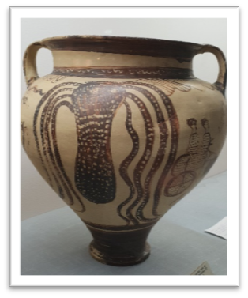  Archeological treasures  - big pot with an octopus  - ceramic man with a beard  - cauldron with animal heads  - copper man with horns
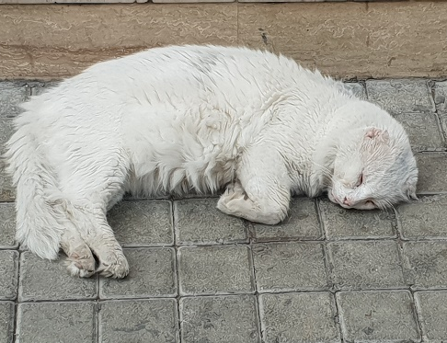Street Cats  - a cat sleeping in the street  - a cat washing itself  - black and white cats  - a gray cat | 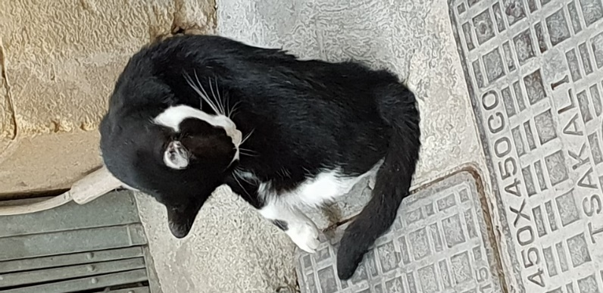  Street Cats  - a cat washing itself  - a cat sleeping in the street  - black and white cats  - a gray cat | 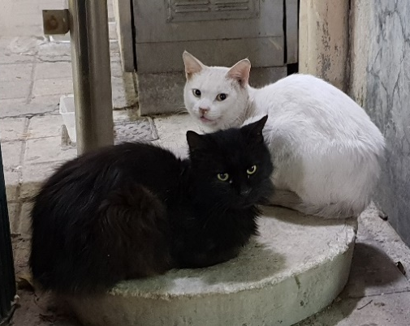  Street Cats  - black and white cats  - a cat washing itself  - a cat sleeping in the street  - a gray cat
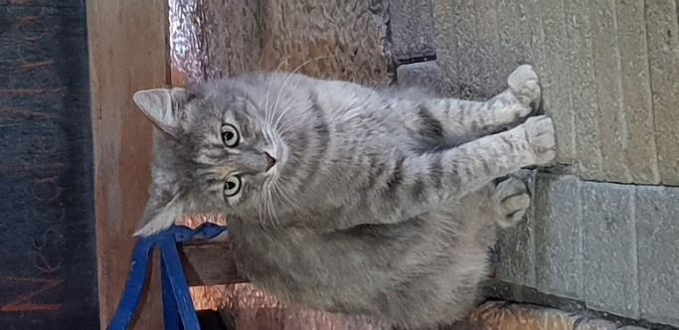  Street Cats  - a gray cat  - a cat washing itself  - a cat sleeping in the street  - black and white cats | 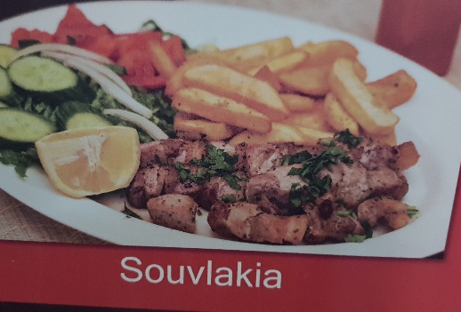  Food  - Souvlakia  - Village Salad  - Mousakka  - Fresh fish | 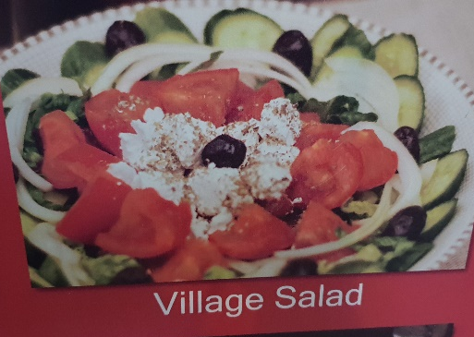  Food  - Village Salad  - Mousakka  - Fresh fish  - Souvlakia
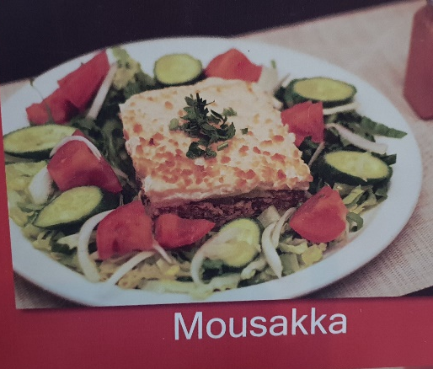  Food  - Mousakka  - Village Salad  - Fresh fish  - Souvlakia | 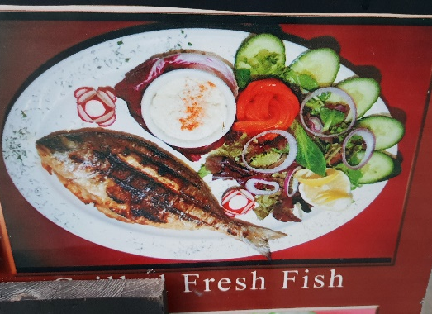  Food  - Fresh fish  - Village Salad  - Mousakka  - Souvlakia | 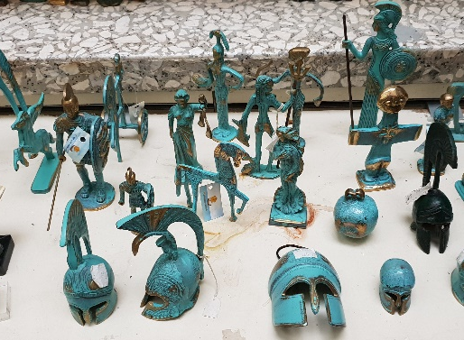  Small souvenirs  - copper figurines  - bottlecaps art  - thimbles  - soap
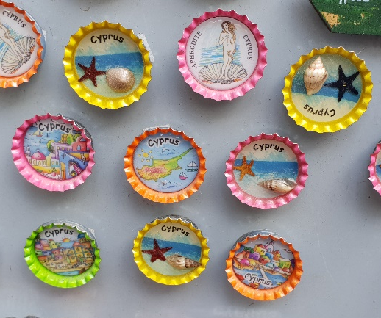  Small souvenirs  - bottlecaps art  - copper figurines  - thimbles  - soap | 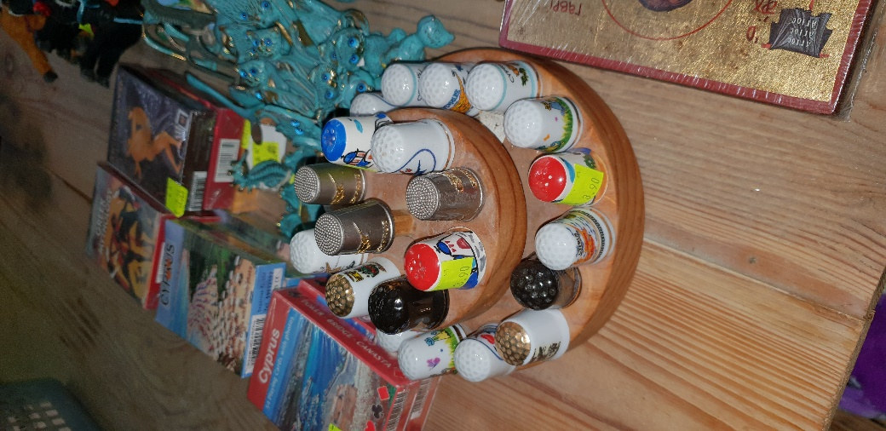  Small souvenirs  - thimbles  - copper figurines  - bottlecaps art  - soap | 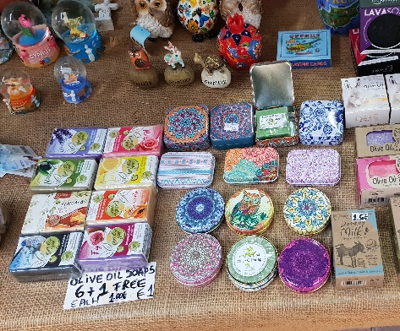Small souvenirs  - soap  - thimbles  - bottlecaps art  - copper figurines
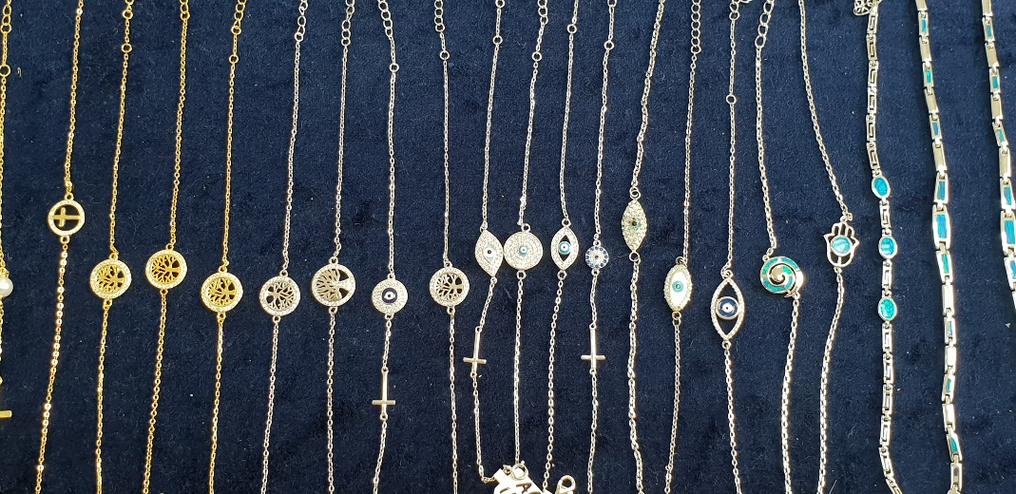  Jewelry  - bracelets  - silver earrings  - blue earrings  - mixed silver jewelry | 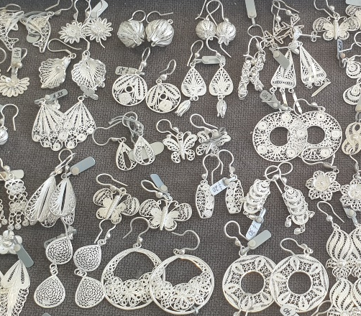  Jewelry  - silver earrings  - blue earrings  - mixed silver jewelry  - bracelets | 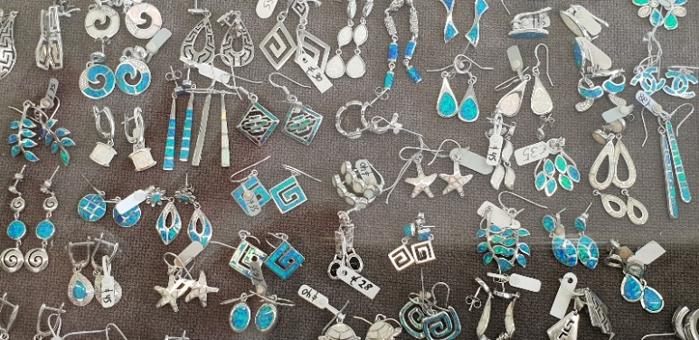  Jewelry  - blue earrings  - mixed silver jewelry  - silver rings  - bracelets
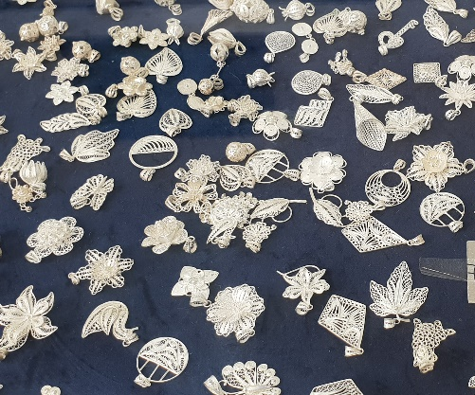  - Jewelry  - mixed silver jewelry  - silver rings  - bracelets  - blue earrings | 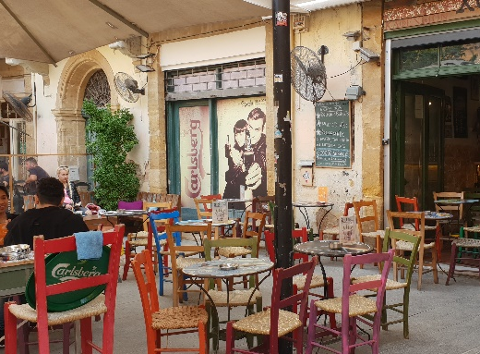  Nice places to sit down  - a colorful taverna  - a coffeshop  - a traditional taverna  - breakfast on the balcony | 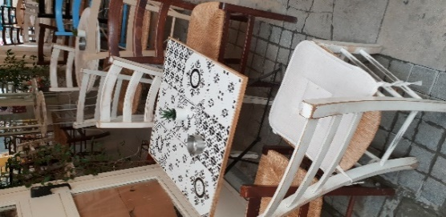  Nice places to sit down  - a coffeshop  - a colorful taverna  - a traditional taverna  - breakfast on the balcony
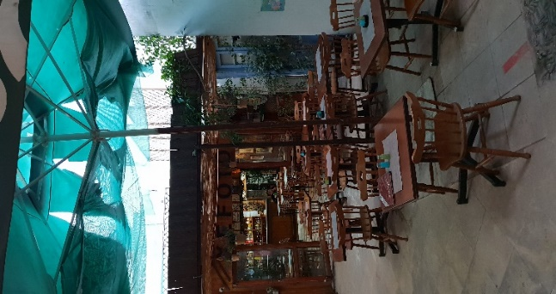  Nice places to sit down  - a traditional taverna  - a coffeshop  - a colorful taverna  - breakfast on the balcony | 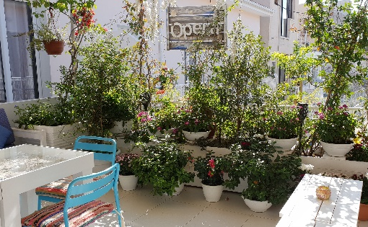  Nice places to sit down  - breakfast on the balcony  - a coffeshop  - a colorful taverna  - a traditional taverna | 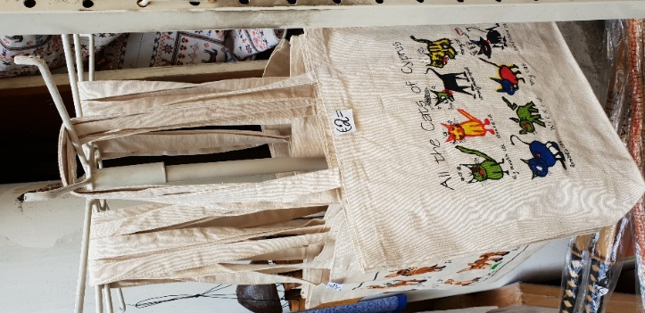  Fun bags  - all the cats of Cyprus  - all kinds of bags  - animals of Cyprus  - small bags and purses
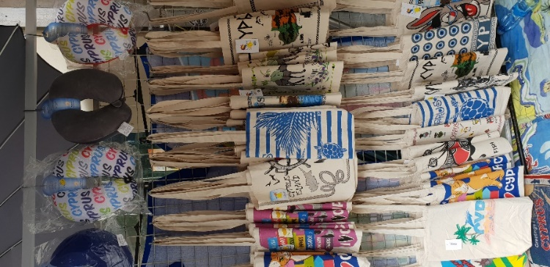  Fun bags  - all kinds of bags  - all the cats of Cyprus  - small bags and purses  - animals of Cyprus | 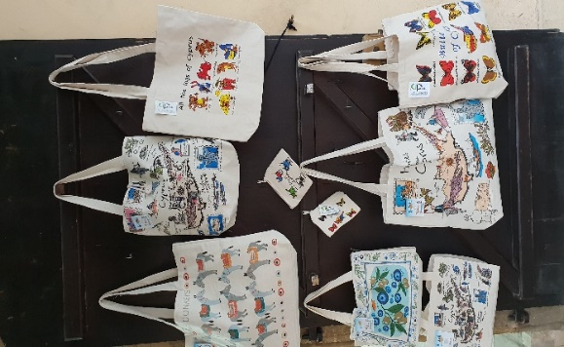  Fun bags  - animals of Cyprus  - all kinds of bags  - all the cats of Cyprus  - small bags and purses | 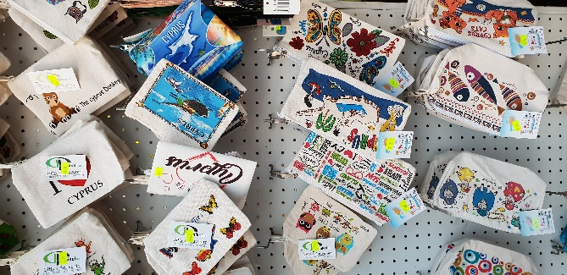  Fun bags  - small bags and purses  - animals of Cyprus  - all kinds of bags  - all the cats of Cyprus
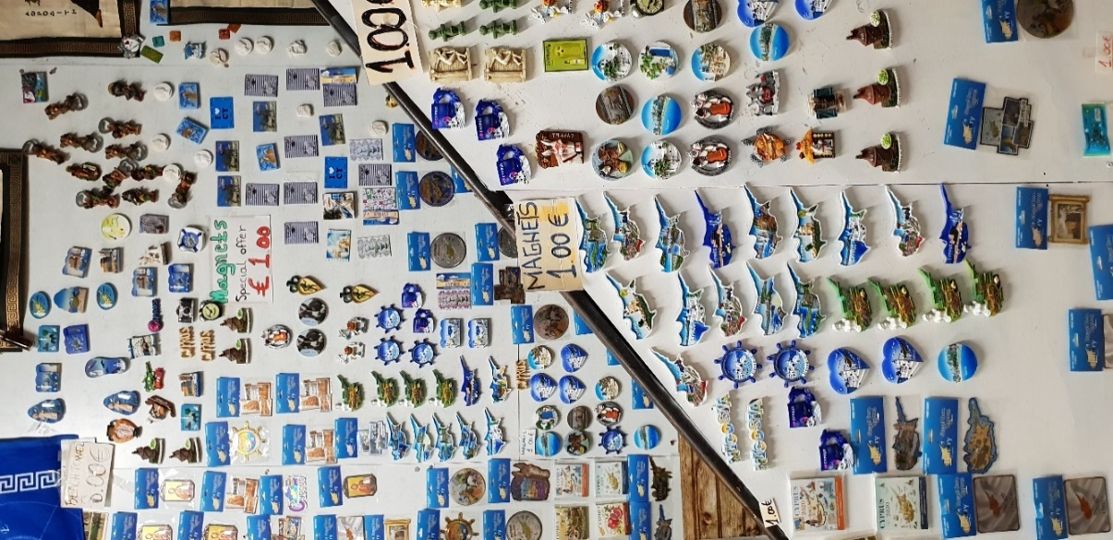  Magnets  - magnets for 1€  - ships and sea motifs  - foto magnets  - all kinds of magnets | 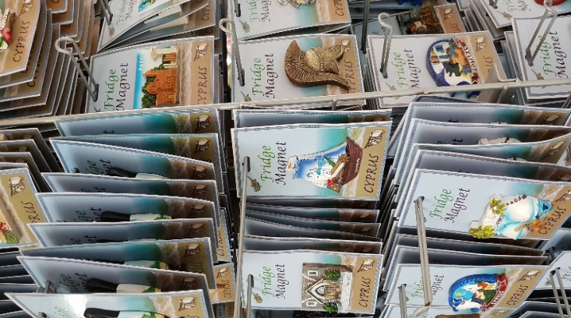  Magnets  - ships and sea motifs  - magnets for 1€  - foto magnets  - all kinds of magnets | 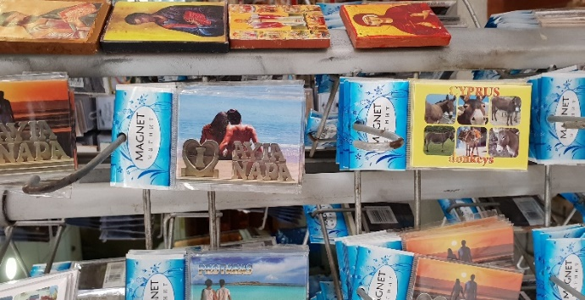  Magnets  - foto magnets  - ships and sea motifs  - magnets for 1€  - all kinds of magnets
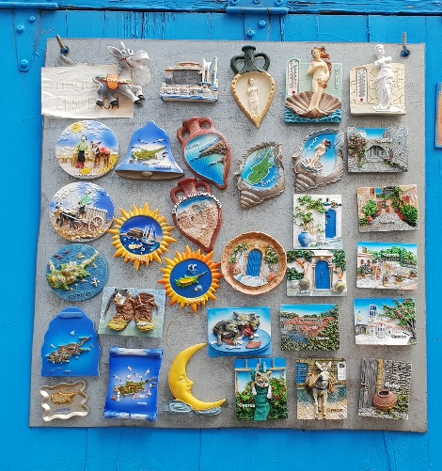  Magnets  - all kinds of magnets  - ships and sea motifs  - magnets for 1€  - foto magnets | 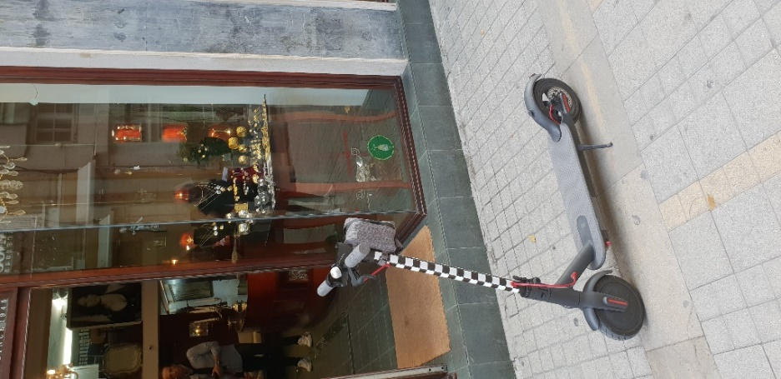  Moving around  - cool scooters everywhere  - cars: they drive on the left  - a traditional bike  - bikes for rent | 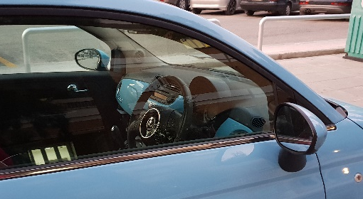  Moving around  - cars: Notice that they drive on the left side of the street.  - a traditional bike  - bikes for rent  - cool scooters everywhere
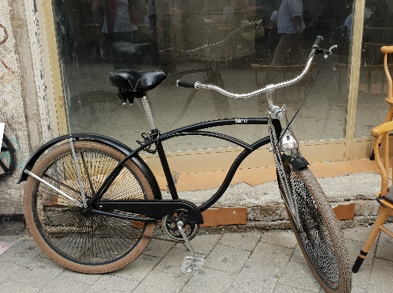  Moving around  - a traditional bike  - cool scooters everywhere  - cars: they drive on the left  - bikes for rent | 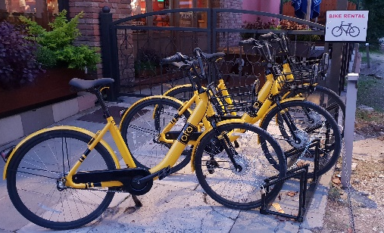  Moving around  - bikes for rent  - cool scooters everywhere  - cars: they drive on the left  - a traditional bike | 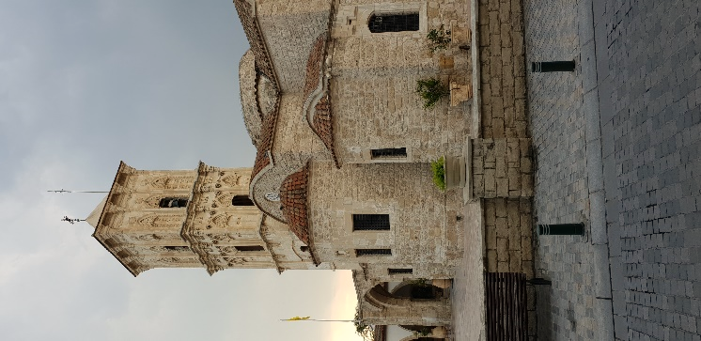  Churches and Mosques  - St. Lazaros Church, Larnaca  - Hala Sultan Tekke, Larnaca  - Faneromenis Church, Nicosia  - Kabir Buyuk Mosque in Larnaca
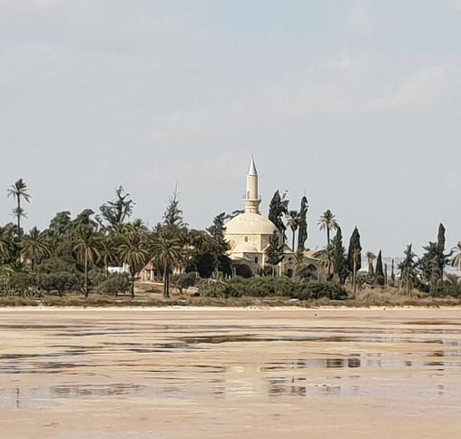  Churches and Mosques  - Hala Sultan Tekke, Larnaca  - St. Lazaros Church, Larnaca  - Faneromenis Church, Nicosia  - Kabir Buyuk Mosque in Larnaca | 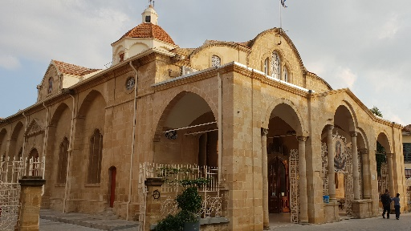Churches and Mosques  - Faneromenis Church, Nicosia  - Hala Sultan Tekke, Larnaca  - St. Lazaros Church, Larnaca  - Kabir Buyuk Mosque in Larnaca | 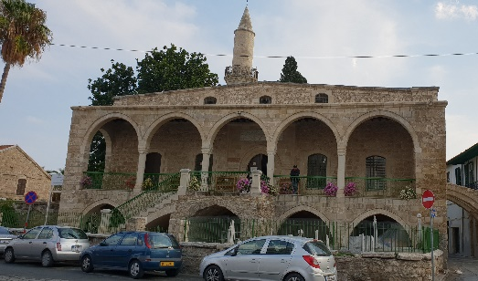  Churches and Mosques  - Kabir Buyuk Mosque in Larnaca  - Hala Sultan Tekke, Larnaca  - St. Lazaros Church, Larnaca  - Faneromenis Church, Nicosia
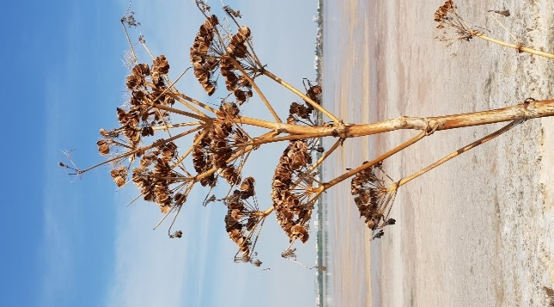  Beautiful Nature  - Salt Lake, Larnaca  - pink Bougainvillea  - Bird of Paradise flower  - lots of flowerpots | 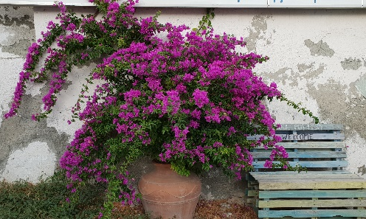Beautiful Nature  - pink Bougainvillea  - Bird of Paradise flower  - lots of flowerpots  - Salt Lake, Larnaca | 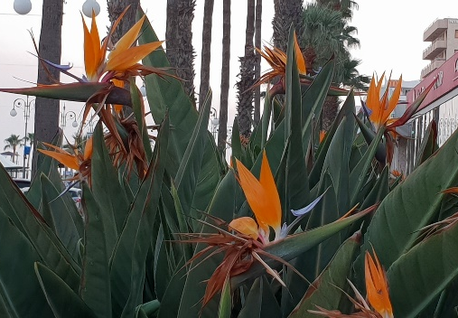  Beautiful Nature  - Bird of Paradise flower  - Salt Lake, Larnaca  - pink Bougainvillea  - lots of flowerpots
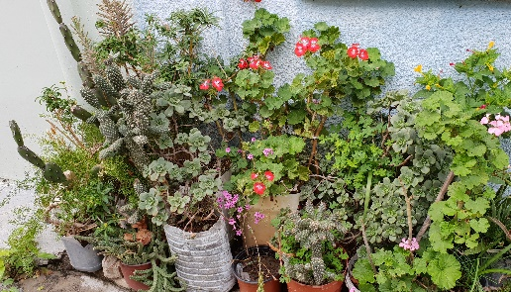  Beautiful Nature  - lots of flowerpots  - Bird of Paradise flower  - Salt Lake, Larnaca  - pink Bougainvillea | 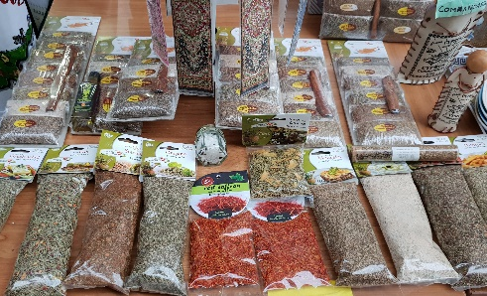  Delicious foods  - spices  - honey with nuts  - candied fruit  - olives | 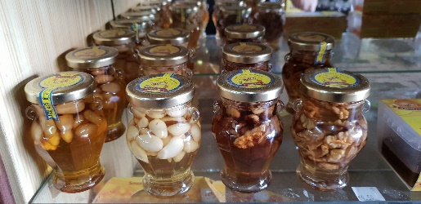  Delicious foods  - honey with nuts  - spices  - candied fruit  - olives
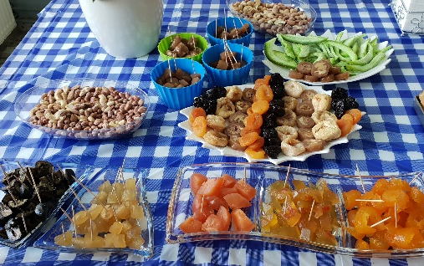  Delicious foods  - candied fruit  - spices  - olives  - honey with nuts | 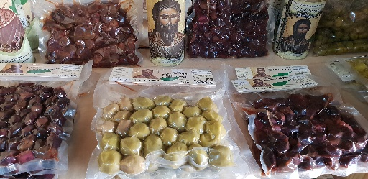Delicious foods  - olives  - honey with nuts  - spices  - candied fruit | 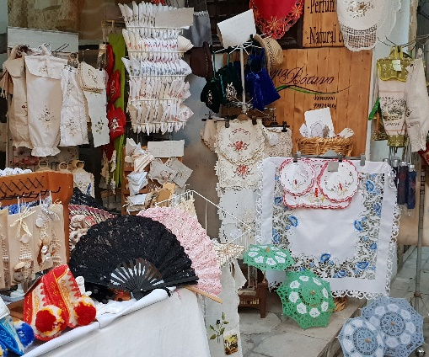Lace  - a lace store in Nicosia  - woman working in the street  - a lace cushion  - lace store in a village
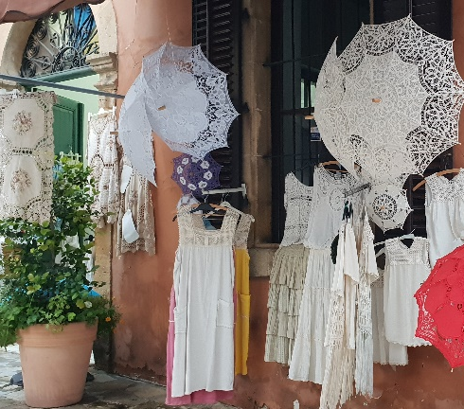  Lace  - lace umbrellas and dresses  - a lace store in Nicosia  - a lace cushion  - lace curtains | 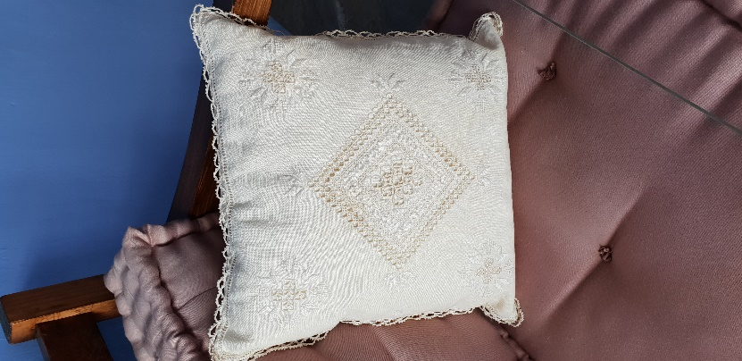  Lace  - a lace cushion  - lace curtains  - lace umbrellas and dresses  - a lace store in Nicosia | 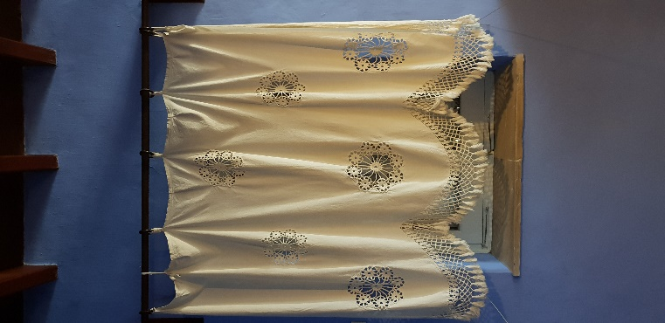  Lace  - lace curtains  - a lace cushion  - lace umbrellas and dresses  - a lace store in Nicosia
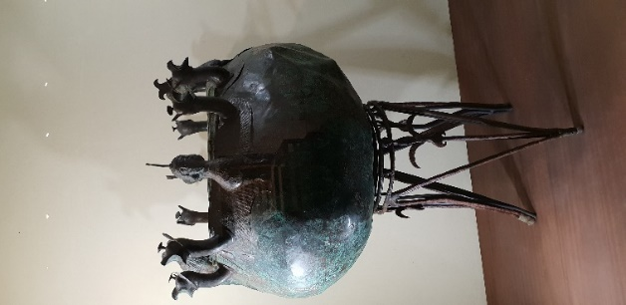  Archeological treasures  - cauldron with animal heads  - copper man with horns  - ceramic man with a beard  - big pot with an octopus | 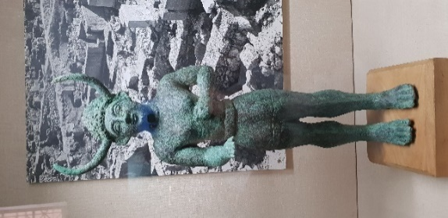Archeological treasures  - copper man with horns  - ceramic man with a beard  - big pot with an octopus  - cauldron with animal heads | 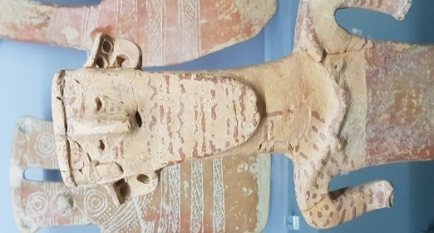Archeological treasures  - ceramic man with a beard  - cauldron with animal heads  - copper man with horns  - big pot with an octopus

