 | 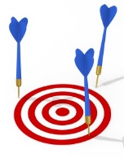 |  | 
I can read the letters GOAL clearly.
The logo shows the idea of playing GAMES.
The logo shows the idea of making international friends very well.
The logo is creative, and I like the style and colors.
The logo is designed carefully.

