Travelling across Europe

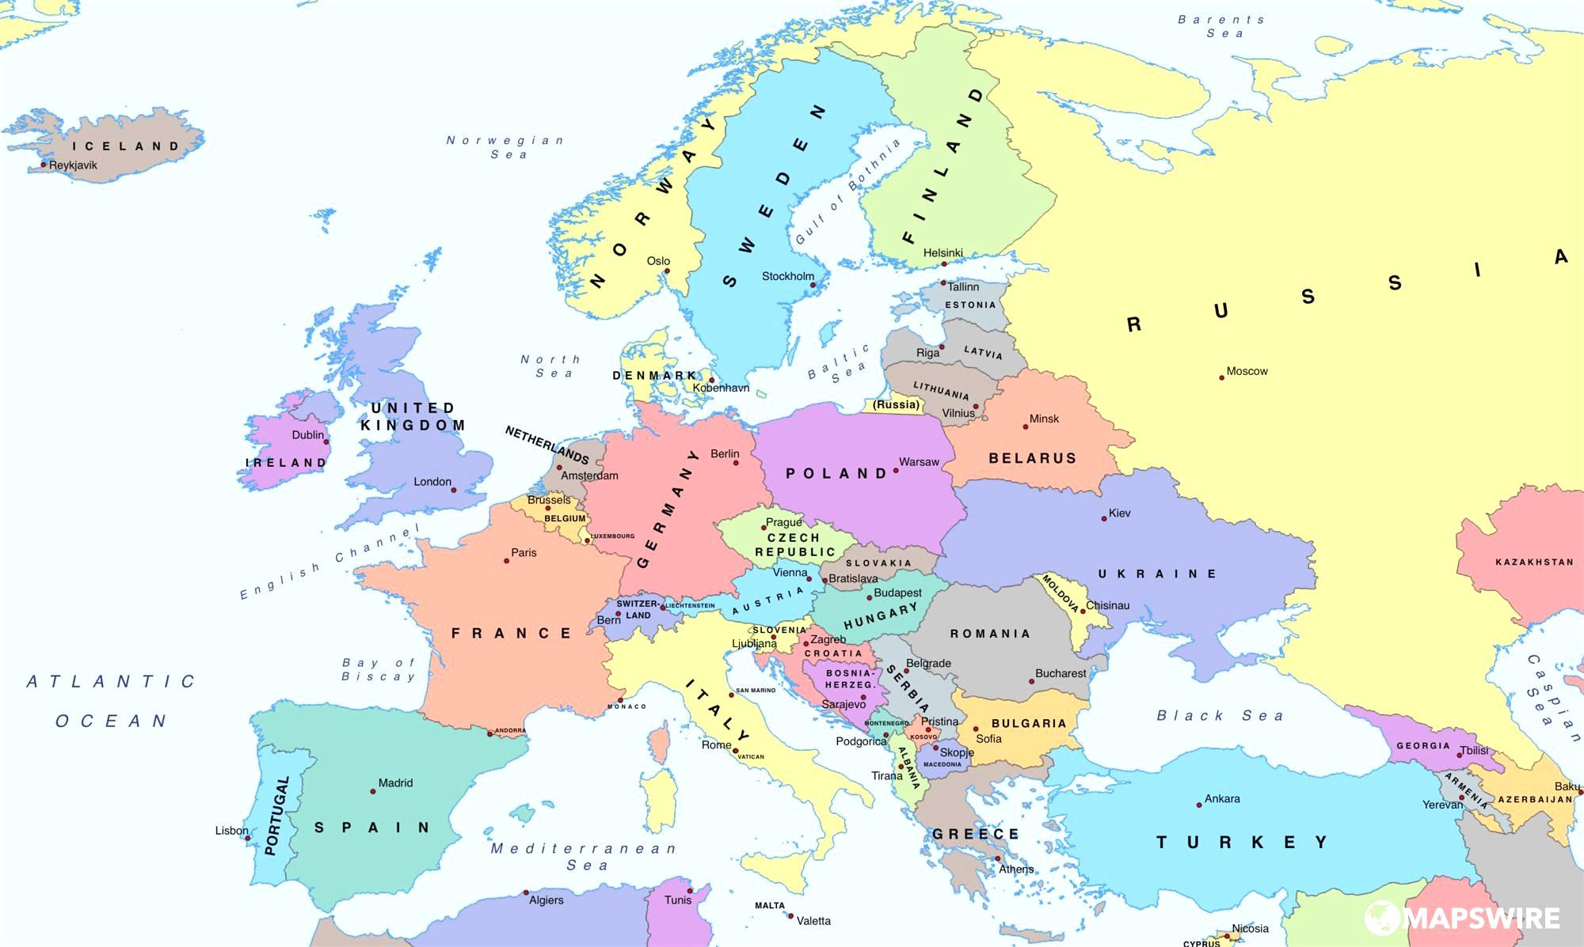

Travelling across Europe
Before your start
1. Each player needs a counter, a sheet of paper and a pencil to write down all the countries that they have visited.
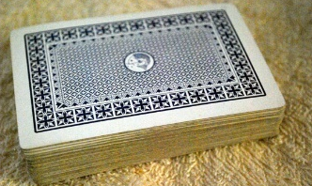
The player who has visited most countries, wins the game.
2. Put all the question cards face down on your desk.

3. Each player chooses a different country to start the trip. Place your counter in this country.
How to move
1. The youngest player starts. In order to travel to a neighboring country, you need a ticket. Pick up a card and answer the question.
If your answer is correct, you can travel to a neighboring country and pick up another card. You can keep travelling as long as you know the answers.
2. Write the countries that you have visited on your sheet. The player on your left can now start to travel.
Attention:

You can only travel by train.
This means, you can only go to a neighboring country, you cannot fly or jump across countries. Plan your trip carefully, so you can visit as many countries as possible.

