Invitation

The Praxismittelschule der Pädagogischen Hochschule Steiermark has the great pleasure to invite the teachers of our partner schools:
- Dimotiko Scholeio Defteras Pano
  - Andri Petrou

- 39th Primary School of Patra
- Pinelopi Vasileiou

- Istituto Comprensivo Statale “A. Pagano” Nicotera
  - Anna Scarfone

- “ELENA CUZA” NATIONAL COLLEGE, Bukarest
  - Nicoleta Ciobanu

to the final project management meeting in Graz that will be held on June 22nd and June 23rd 2022. (Travelling dates: June 21st – June 24th).
The meeting will be held in hybrid format to make sure that the representatives of each country can participate.
Please find the detailed agenda of the meetings on the following page.
We are looking forward to working together in Graz.
Sincerely yours,
The Headmistress
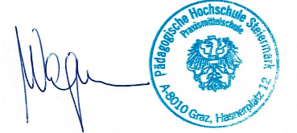
Mag. Andrea Wagner

Program for the final management meeting in Graz, Austria
June 22nd and 23rd 2022

Date | Agenda
Tuesday,  June 21st | Arrival of participants in Graz
Wednesday, June 22nd | 9.00 – 9:30: Welcome at our school.  9.30 – 13.00: Collecting and organizing all project products and results  Lunchbreak  14.30 – 18.00: Organizing the products, final work on the website, e-twinning page and Moodle course.
Thursday,  June 23rd | 9.00 – 13.00: Writing the final report  Lunchbreak  14.30 – 18.00: Finalizing the report, website, e-twinning page and Moodle course.  Good-bye dinner
Friday,  June 24th | Departures

