
Recommendations for restaurants, coffee and drinks
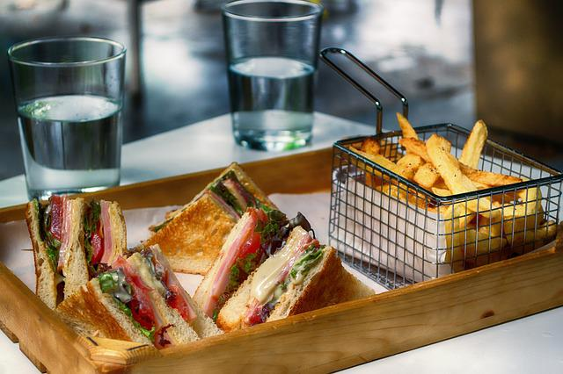


Easy to reach from school if you don’t have a lot of time:
Zapo
Hasnerplatz 1n,
Mo-Thu 9:15-15:30, Fri 9:15-14:30
€
Always 2 menus for lunch; employ people with special needs, good for coffee
Next to the flowershop on Hasnerplatz, walk out of the school and turn left, walk past the bicycles, turn right, go straight ahead until you get to a flower shop, Zapo is on your right (2 minutes walk)
Wokano
Theodor Körner Straße 40, 8010
€€
Mo-Su 11:00-21:00
Asian fusion, big portions, you can put together your own bowl; right next to the school (walk past the bicycles and turn left, cross the street, it’s in front of you, 30 seconds walk)
Auer
Körösistraße 64, 8010 Graz
Mo-Fri 6:30-19:00, Sa&Su 7:00-18:00
€€
A bakery, good for coffee, tea and light lunches, sandwiches, quiche, breakfast; sweets
5 minute walk; walk out of the school, walk past the bicycles, turn right, cross the street at the traffic light, turn right and take the first left (Eichendorffstraße), walk until you get to a dead end (lots of parking cars), turn right, Auer is in front of you

If you have a little more time, also easy to reach from school:
La Place
Gigasport Graz, Sackgasse 7, 3rd floor
Food Mo thru Sat, 11:00-17:30
€€
Nice view over Graz, all kinds bowls (pasta, rice, salad), soups and juices
in the section of “Gigasport”
Tagescafé Freiblick
Sackstraße 7, on the rooftop of Kastner & Öhler
Open Mo-Sat 9:30-19:00
€€€
Nice view over Graz, good for breakfast, coffee or other drinks
How to get there from school: take the tram 3 or 5 and get off at “Schlossbergplatz”, it’s inside of Kastner&Öhler, go up to the rooftop
Die Scherbe
Stockergasse 2, 8010 Graz
Open Mo-Sun, 9:00-1:00 (a.m.)
€€
All kinds of different dishes from different countries all over the world; breakfast, lunch and dinner; nice garden to sit outside, also good for drinks or coffee (night and day), they often have concerts or other events there
How to get there: walk for around 15 minutes (from school), 4 minutes from your hotel
Austrian/Styrian Food
Lendplatzl
Lendplatz 11 (close to your hotel)
Mo-Sat 9-00:00, Su 21:00, lunch menu Mo-Fr 11:00-14:30
€€
If you like fried chicken, try a “Backhendl” with potato salad! You can also get the Austrian Wiener Schnitzel with rice or fries- if you like meat filled with ham and cheese, then try a “Cordon Bleu”. They also have fish and salads on the menu. 5 minute walk from your hotel
Glöckl Bräu
Glockenspielpl. 2-3, 8010
Mo-Su kitchen from 9:00-21:00
€€
Traditional Austrian food- beer, Schnitzel, grilled chicken (Grillhendl), sausages, Cordon bleu, Styrian bowl, Gulasch,… in the city center. Desserts like applepie or “Kaiserschmarren”. 10 min walk from your hotel

Other nice places close to your hotel
Kunsthauscafé
Südtirolerplatz 2, 8020 Graz
Mo-Sun 9:00-0:00
€€(€)
Modern café and restaurant, nice for breakfast, lunch, dinner, drinks or coffee; dishes from all over the world including vegan burgers; suck in the atmosphere of Graz; 1 minute from your hotel
Schwalbennest
Franziskanerplatz 1, 8010 Graz
Tu-Fr, 9:00-19:00; Sa&Sun 12:00-19:00
€€
Good place for Austrian cakes, coffee, hot chocolate in all variations (from Zotter!) and tea; there is a cosy little balcony on the first floor, good for observing the people of Graz; 3 min walk from your hotel

