Welcome to the Mittelschule der Pädagogischen Hochschule, GRAZ
GOAL project meeting: May 11th to 15th

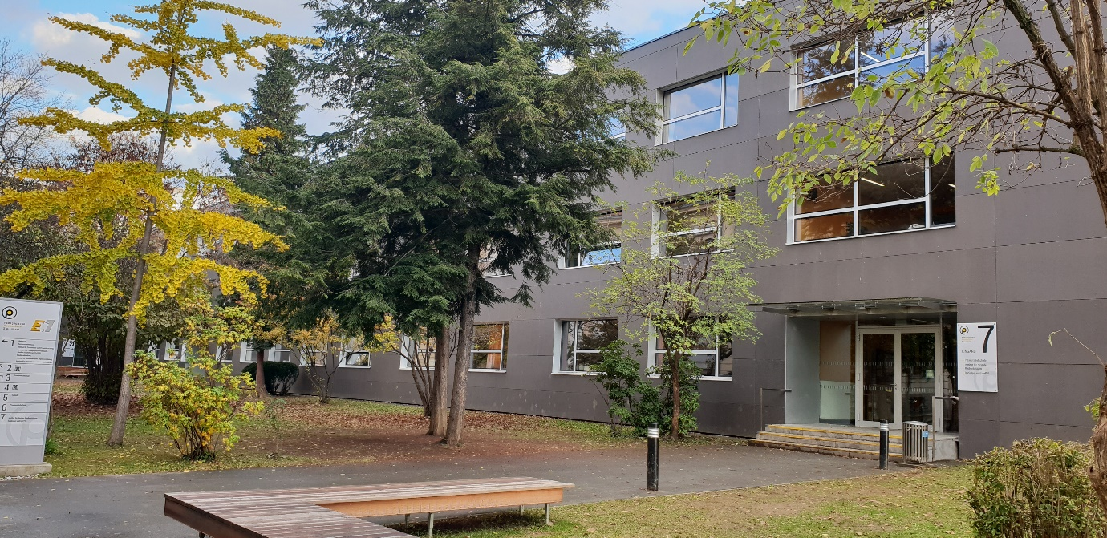

Date | Agenda
Wednesday, 11th | Arrival of participants in Graz,
Thursday 12th | 9.00 Welcome at our school. Meeting with our head-teacher Mag. Andrea Wagner.
9.40 - 11.20
GAMES Session with the kids of 1f and 2f
- Games: Traveling across Europe
- Happy families of Cyprus
- Happy families of Graz
- GOAL online games

11.20 Leave school to go to the Rathaus, (City Hall)

12:00: Welcome reception by the Mayor with a small buffet.
Tip: Wear comfortable shoes for walking about 6 km.
Afternoon | 14:00  Actionbound Graz  Digital treasure hunt in the town center.  “Exploring Graz through a magnifying lens”
Free evening:

Dinner in town
Our tip: You will find lots of nice places for dinner around Lendplatz, Franziskanerplatz and the Bermuda Triangle.
Check the map and the restaurant tips in this info package.

Friday, 13th | 8:00 to 12:00  IGEL TV Studio  Planning session for the TV program “Exploring Graz through a magnifying lense”  Recording the TV show in the studio
10:00: coffee break in the 1st floor study area
Styrian Harmonica – played by Leo
 | Igel TV workshop continued
12:30- 14.00
Light lunch in town. Do NOT eat too much – you will be eating lots of chocolate this afternoon and we will have a Styrian dinner at a traditional “Buschenschank” in the evening. Please be back at the school at 13.50.
Places we recommend: (Find more info about these places in the following pages)
- Auer
- La Place (K&Ö Terrasse)
- Kunsthaus Café (longer wait)
- Mangolds
- Zapo
Afternoon | 13.50: board the coach for our afternoon tour out into the countryside.  On the way: Visiting the typical apple farm “Obstbau Gsöls”  16:00 Tour at Zotter factory + exploring the “edible zoo”  Reservierungsnummer: 0022022051300016
Evening | 18:30: Dinner at a typical “Buschenschank” Bernhart: Hofberg 61
Saturday, 14th  Morning | 8.20 meet at the hotel lobby and take the tram to Eggenberg castle  9h Guided tour of the castle and walk around the park.
Lunch | Back to the town center  12:30 Lunch at “Die Scherbe”
Afternoon | Your choice: Suggested activities:  Zeughaus (Tour with audio guide)  Joanneum Museum  Kunsthaus
Evening | Dinner in town
Sunday 15th | Departures  We wish you a safe trip home.

How to get to our school and back to your hotel
The best option: Walk along the green line on this plan. You’ll walk along the river on a mixed path for pedestrians and bicycles. Please do not block the path for cyclists.
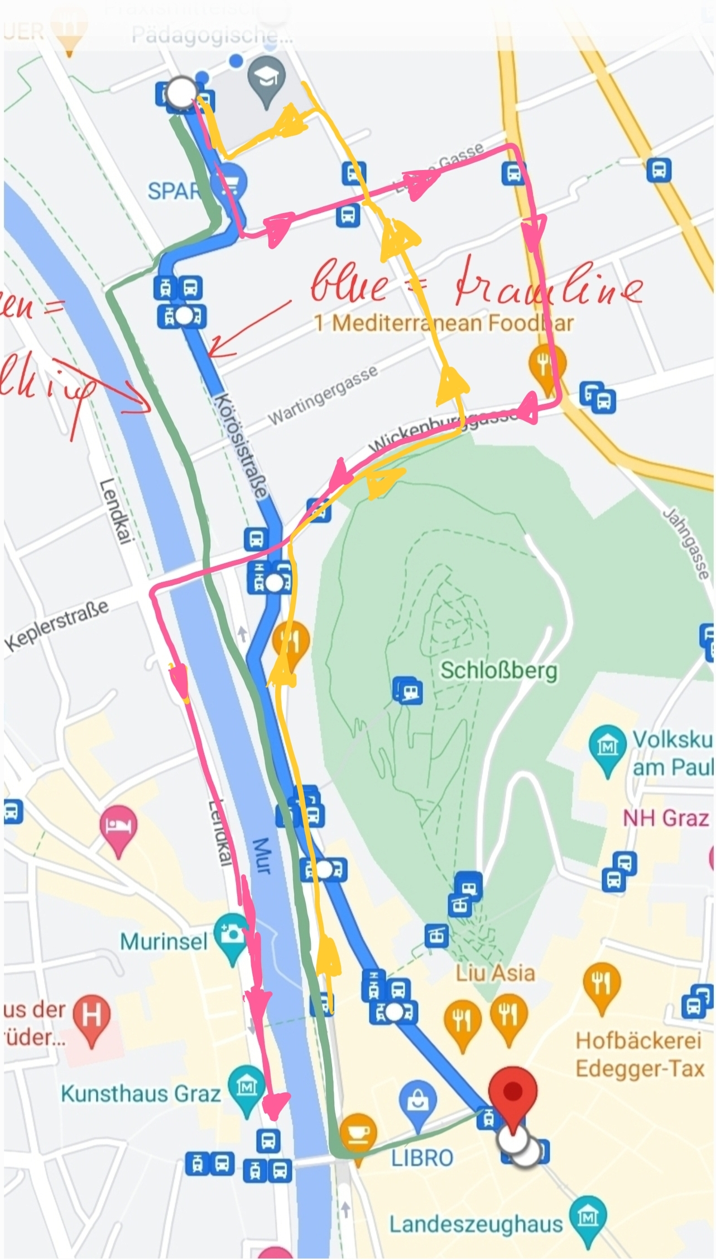
Option: if you do not want to walk
Due to roadworks, there won’t be any trams along line 5.
Take the bus 3/5 if you do not want to walk.
From our school into the town center: pink line
Stops:
Theodor-Körner-Straße –
Lange Gasse –
Grabenstraße –
Wickenburggasse –
Keplerbrücke –
Lendkai -
-----------------------------
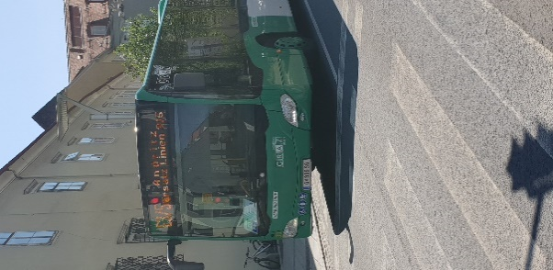
From town center to our school: yellow line.
Take the little footbridge across the river and cross the street. The bus 3/5 will stop right here and take you to our school.
Stops:
Kaiser-Franz-Josef-Kai - Keplerbrücke - Wickenburggasse - Laimburggasse - Theodor-Körner-Straße

Exploring Graz with a magnifying lens
On Thursday afternoon you will be exploring Graz in small groups. Ideally, you will form international groups – but we leave it to you to form small groups yourself.
You have two main tasks to complete:
  - Follow the instructions of the Actionbound quest. This treasure hunt will guide you through the town center and point out some of the most interesting places. If you do not have internet access in Austria, download the bound before leaving the school or your hotel. Keep the bound open until you are back at your hotel in the evening and then upload the results using the WIFI connection at the hotel.

  - Parallel to this walking tour, keep your eyes wide open and notice lots of little details and interesting aspects of our town and our school. Take photos of these things. We will need these pictures for our TV production on Friday. Here, we are interested in everyday things that may be different from your country.
    - What do you notice?
    - What questions come up during your visit?
    - What is different from your country?
    - What is the same?
    - What can you learn from us and what can we learn from you?

- Download the app Actionbound on your phone.
- Scan the QR code on this page.
Enter your (group-)name and follow the step-by-step instructions.
For extra help, you will find a map of your path on the following page.
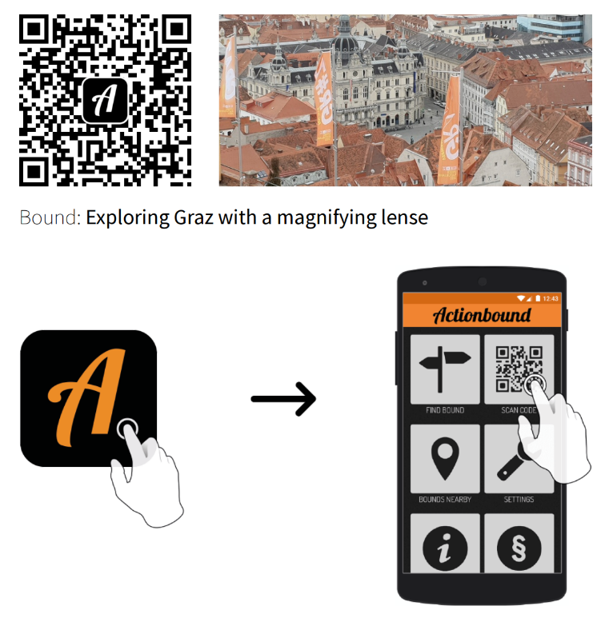

Map of the inner city:
Pink line: your path for the Action Bound treasure hunt
Blue lines and markings: good places to find nice restaurants

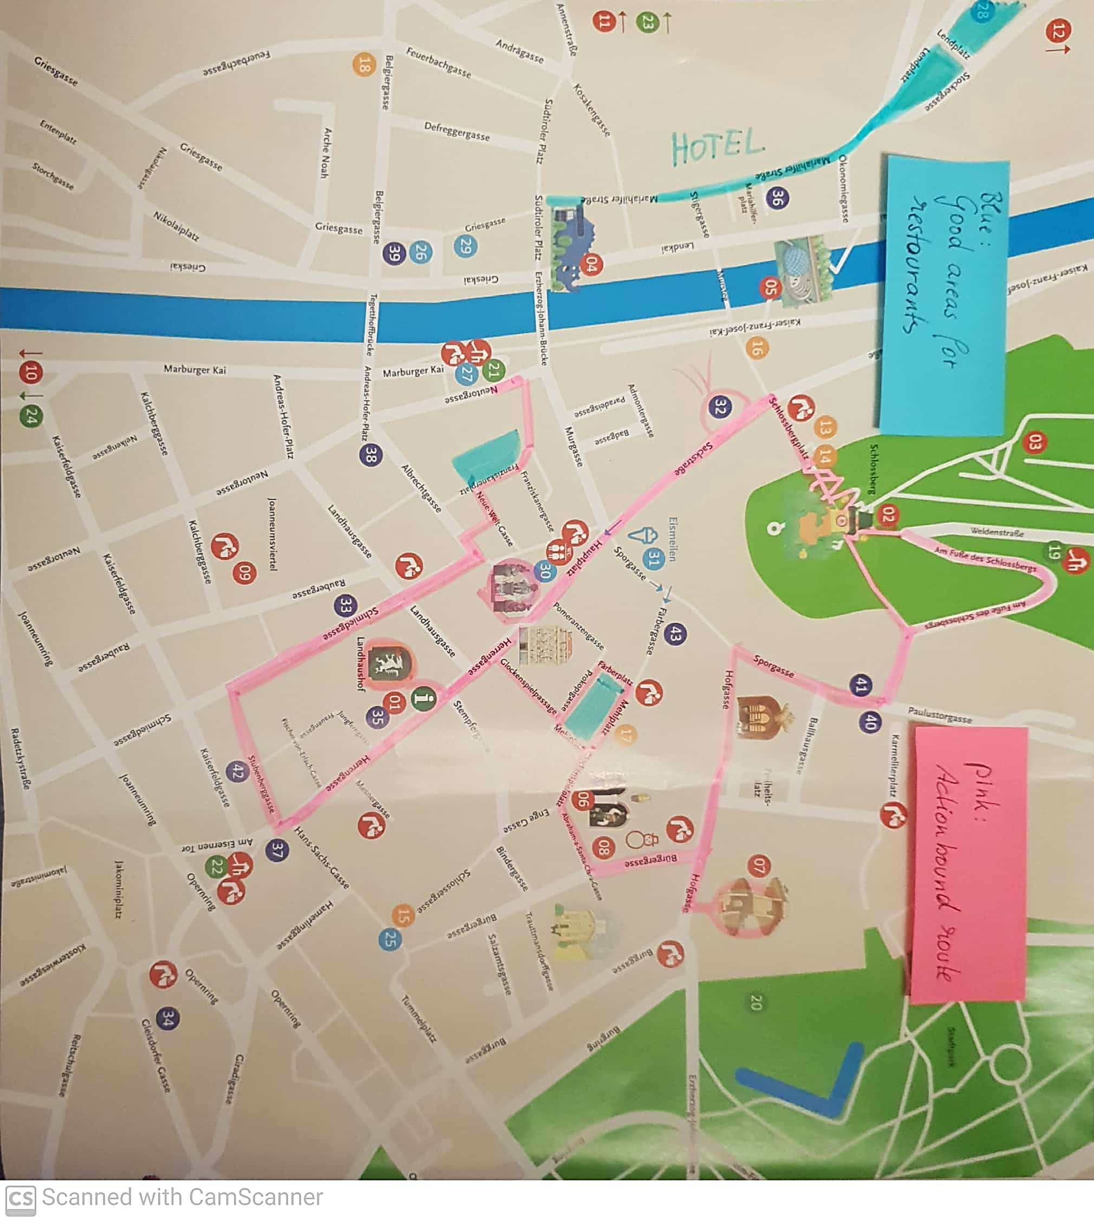
Blue highlights show good areas for eating out.
Pink highlights show the path of our Action bound treasure hunt.

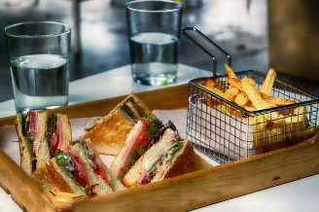

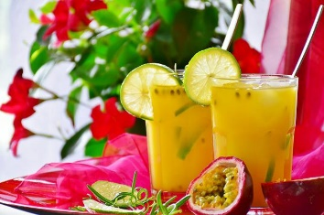
Recommendations for restaurants, coffee and drinks

Easy to reach from school if you don’t have a lot of time:
Zapo €
Hasnerplatz 1n, : Mo-Thu 9:15-15:30, Fri 9:15-14:30
Always 2 menus for lunch; employ people with special needs, good for coffee
Next to the flowershop on Hasnerplatz, walk out of the school and turn left, walk past the bicycles, turn right, go straight ahead until you get to a flower shop, Zapo is on your right (2 minutes walk)
Wokano €€
Theodor Körner Straße 40, 8010: Mo-Su 11:00-21:00
Asian fusion, big portions, you can put together your own bowl; right next to the school (walk past the bicycles and turn left, cross the street, it’s in front of you, 30 seconds walk)
Auer €€
Körösistraße 64, 8010 Graz: Mo-Fri 6:30-19:00, Sa&Su 7:00-18:00
A bakery, good for coffee, tea and light lunches, sandwiches, quiche, breakfast; sweets. A 5 minute walk from school. Walk out of the school, walk past the bicycles, turn right, cross the street at the traffic light, turn right and take the first left (Eichendorffstraße), walk until you get to a dead end (lots of parking cars), turn right, Auer is in front of you.
If you have a little more time, also easy to reach from school:
La Place €€
Gigasport Graz, Sackgasse 7, 3rd floor: Food Mo thru Sat, 11:00-17:30
Nice view over Graz, all kinds bowls (pasta, rice, salad), soups and juices
in the section of “Gigasport”
Tagescafé Freiblick €€€
Sackstraße 7, on the rooftop of Kastner & Öhler: Open Mo-Sat 9:30-19:00
Nice view over Graz, good for breakfast, coffee or other drinks
How to get there from school: take the tram 3 or 5 and get off at “Schlossbergplatz”, it’s inside of Kastner&Öhler, go up to the rooftop
Die Scherbe €€
Stockergasse 2, 8010 Graz: Open Mo-Sun, 9:00-1:00 (a.m.)
All kinds of different dishes from different countries all over the world; breakfast, lunch and dinner; nice garden to sit outside, also good for drinks or coffee (night and day), they often have concerts or other events there
How to get there: walk for around 15 minutes (from school), 4 minutes from your hotel
Austrian/Styrian Food
Lendplatzl €€
Lendplatz 11 (close to your hotel): Mo-Sat 9-00:00, Su 21:00, lunch menu Mo-Fr 11:00-14:30
If you like fried chicken, try a “Backhendl” with potato salad! You can also get the Austrian Wiener Schnitzel with rice or fries- if you like meat filled with ham and cheese, then try a “Cordon Bleu”. They also have fish and salads on the menu. 5 minute walk from your hotel
Glöckl Bräu €€
Glockenspielpl. 2-3, 8010: Mo-Su kitchen from 9:00-21:00
Traditional Austrian food- beer, Schnitzel, grilled chicken (Grillhendl), sausages, Cordon bleu, Styrian bowl, Gulasch,… in the city center. Desserts like applepie or “Kaiserschmarren”. 10 min walk from your hotel.

Other nice places close to your hotel
Kunsthauscafé €€(€)
Südtirolerplatz 2, 8020 Graz: Mo-Sun 9:00-0:00
Modern café and restaurant, nice for breakfast, lunch, dinner, drinks or coffee; dishes from all over the world including vegan burgers; suck in the atmosphere of Graz; 1 minute from your hotel – but you need a bit more time to wait for the food.
Schwalbennest €€
Franziskanerplatz 1, 8010 Graz: Tu-Fr, 9:00-19:00; Sa&Sun 12:00-19:00
Good place for Austrian cakes, coffee, hot chocolate in all variations (from Zotter!) and tea; there is a cosy little balcony on the first floor, good for observing the people of Graz; 3 min walk from your hotel

Nice places for dinner within walking distance of your hotel

Lendplatz and Mariahilferstrasse:
Exit your hotel and walk along Mariahilferstrasse (to the left). In this street and around Lendplatz you will find lots of nice little places that invite you to sit down and enjoy.

The Bermuda Triangle:
In the area called the Bermuda Triangle (Färberplatz, Mehlplatz, Glockenspielplatz) you will find all kinds of good foods, including a Greek restaurant and a very nice Italian place.

Franziskanerplatz:
This is another hotspot of nice restaurants, all within easy walking distance of your hote.

