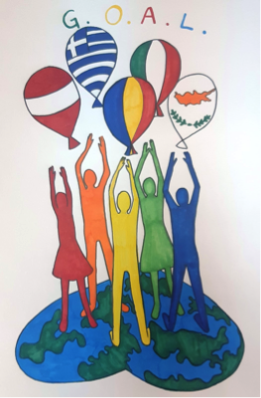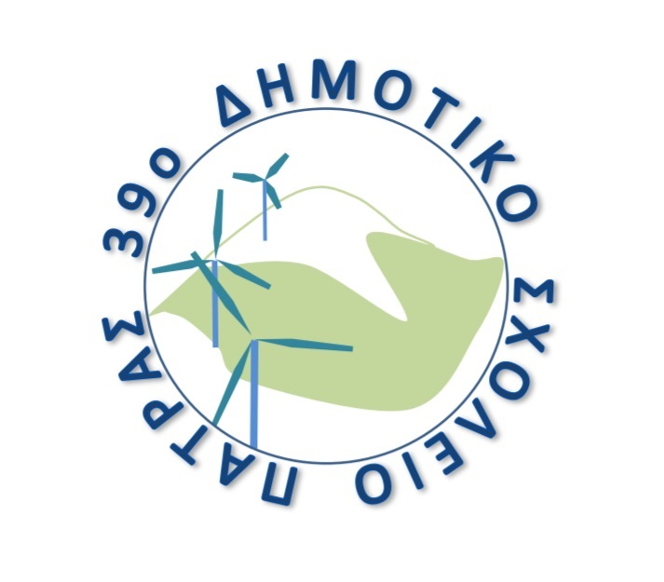
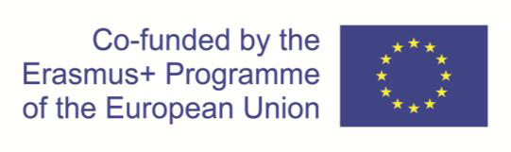
39th Primary School of Patra
Panachaikou terma - Neo Souli
26500 - Patra
Tel / fax: +302610640147
Email: mail@39dim-patras.ach.sch.gr

KA229 - School Exchange Partnerships (Call 2019 Round 1 KA2)
Agreement number: 2019-1-RO01-KA229-063665_2

AGENDA

08/06/2022 | Arrival in Patra
09/06/2022 | 9:00: Welcome ceremony at the school  10:30: Coffee break  11:00 - 13:00: "HOW WE PLAY" Games and activities  THE CHILDREN MAY NEED A CAP AND AN EXTRA T-SHIRT. THEY WILL DANCE AND PLAY OUTDOOR GAMES, RUNNING IS INVOLVED. WE ARE NOT GOING TO RETURN TO THE HOTEL AFTER SCHOOL.  13:30: Lunch  17:00: Visit to Rio-Antirrio bridge  Free evening
10/06/2022 | 9:00 - 12:30: "HOW WE LEARN" activities at school  10:30: Coffee break  13:30: Visit to the Archaeological museum of Patra  https://youtu.be/cMJ0oX7Ykl0  https://youtu.be/8iPTBZD5U7E  15:00: Lunch  17:00: Tour of the city  Free evening
11/06/2022 | Visit to Ancient Olympia  SWIMMING AND LUNCH AFTERWARDS. A SWIMSUIT, A CAP AND A BEACH TOWEL WILL BE NECESSARY. THE RESTAURANT IS AT THE BEACH, SO THOSE OF YOU WHO DON'T WANT TO SWIM CAN RELAX IN THE SHADE AND WATCH THE SWIMMERS!
12/06/2022 | Departure

Lunch Thursday 9/6/2022

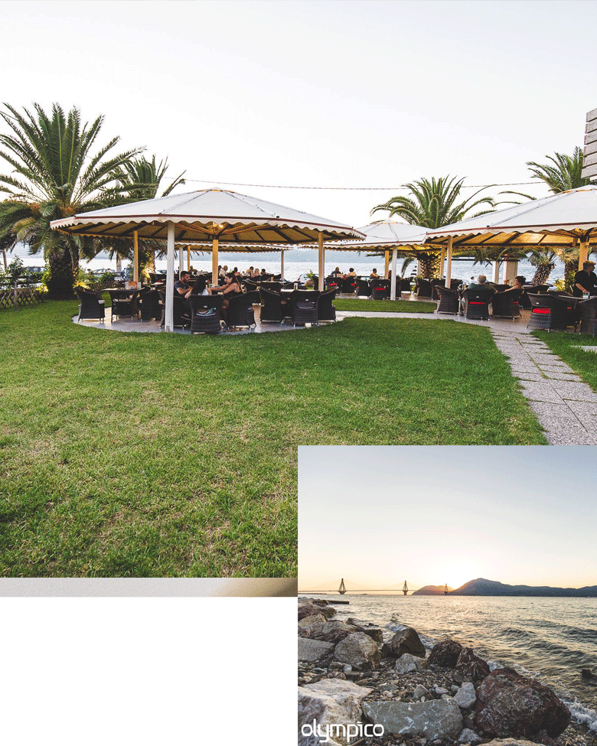
Pl
PlPlaePPlea
Please choose one of the following per person:

Main course:

1. Pork fillet with mavrodaphe sauce (Mavrodaphne is a local wine with very special flavour)
2.Chicken roll with parmesan sauce
3.Grilled burger (the meat ball only, not the bread)
4. Spaghetti al pesto (vegetarian dish)
5. Spaghetti with vegetables (vegetarian dish)
6. Risotto with wild mushrooms (vegetarian dish)

All the dishes are served with : rice, chips or grilled vegetables with haloumi cheese.
Please choose one of these too.

Lunch Friday 10/6/2022

Please use the QRcode below to access the menu. The English version will be available soon (as far as I know....)

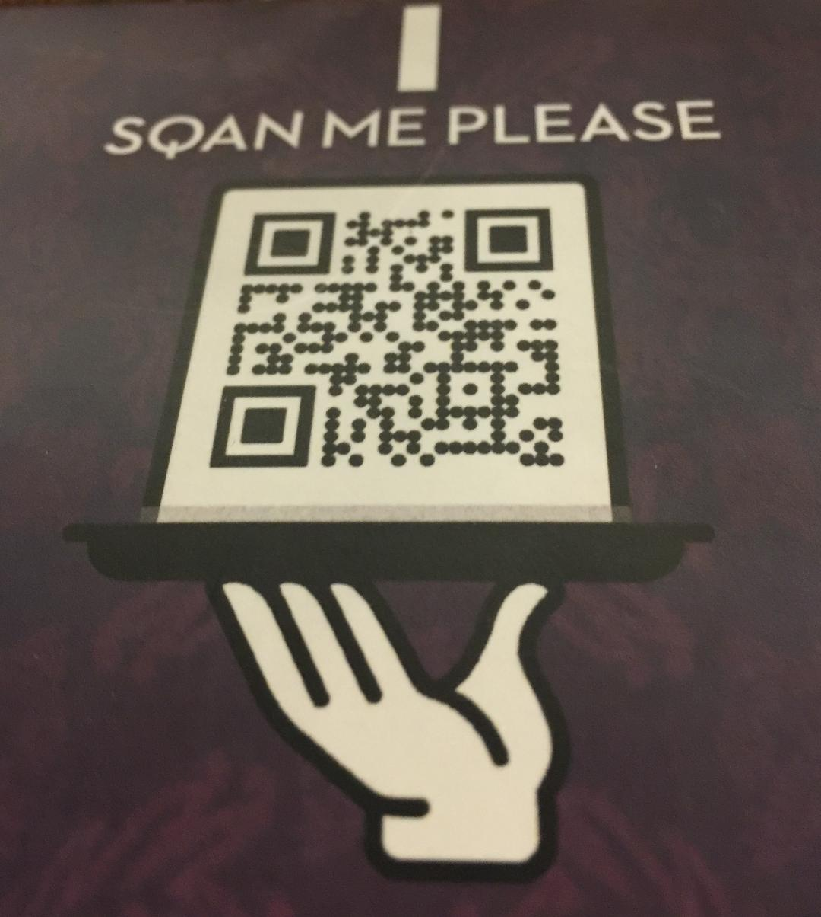

Lunch Saturday11/6/2022

THIS IS THE MENU. YOU CAN CHOOSE WHATEVER YOU LIKE.

