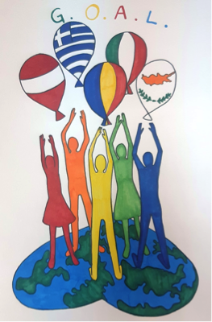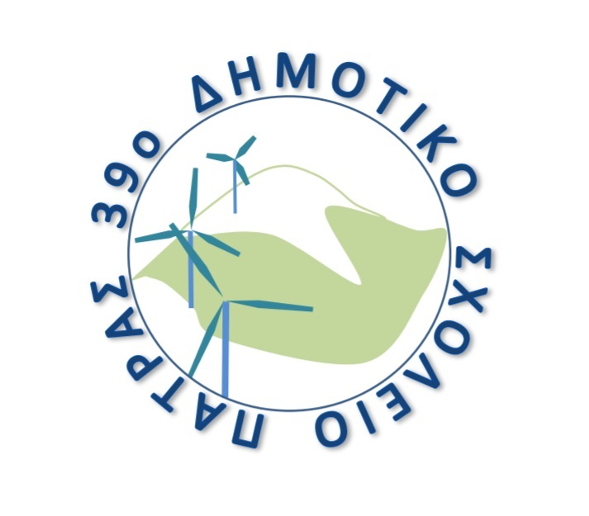
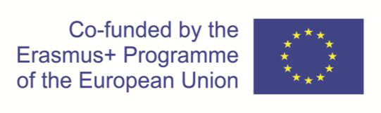
39th Primary School of Patra
Panachaikou terma - Neo Souli
26500 - Patra
Tel / fax: +302610640147
Email: mail@39dim-patras.ach.sch.gr

KA229 - School Exchange Partnerships (Call 2019 Round 1 KA2)
Agreement number: 2019-1-RO01-KA229-063665_2

AGENDA

08/06/2022 | Arrival in Patra
09/06/2022 | 9:00: Welcome ceremony at the school  10:30: Coffee break  11:00 - 13:00: "HOW WE PLAY" Games and activities  13:30: Lunch  17:00: Visit to Rio-Antirrio bridge  Free evening
10/06/2022 | 9:00 - 12:30: "HOW WE LEARN" activities at school  10:30: Coffee break  13:30: Visit to the Archaeological museum of Patra  15:00: Lunch  17:00: Tour of the city  Free evening
11/06/2022 | Visit to Ancient Olympia
12/06/2022 | Departure

