39th Primary School of Patra  Panachaikou terma Neo Souli  26500 - Patra  Tel / fax: +302610640147  email: mail@39dim-patras.ach.sch.gr | 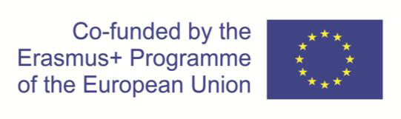  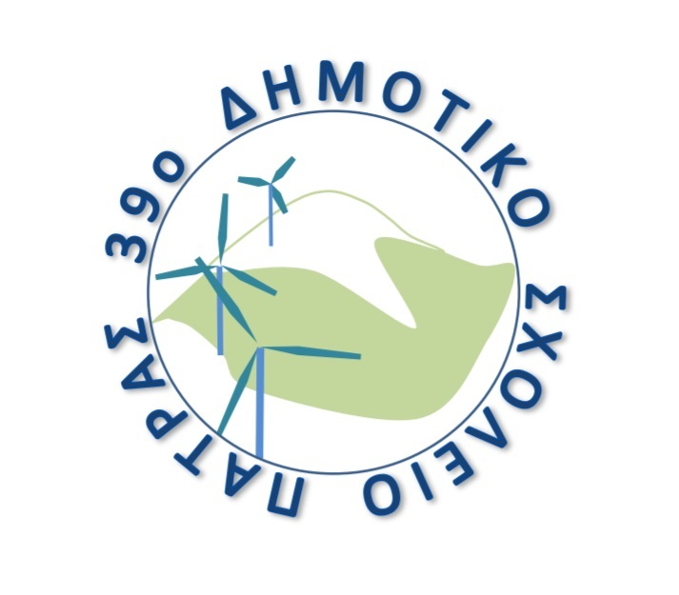

KA229 - School Exchange Partnerships (Call 2019 Round 1 KA2)
Agreement number: 2019-1-RO01-KA229-063665_2

INVITATION

The 39th Primary School of Patra has the great pleasure to invite the teachers and pupils of the partner schools

Colegiul National Elena Cuza, Romania
Neue Mittelschule der Pädagogischen Hochschule Steiermark, Austria
Dimotiko Scholeio Defteras Pano, Cyprus
Istituto Comprensivo Statale "A. PAGANO"

to the final Learning Teaching and Training activity of the Erasmus+ Project “GAMES FOR ACTIVE LEARNING [G.O.A.L.]” (Agreement Number: 2019-1-RO01-KA229-063665_2).

The meeting will take place in Patra, Greece, between 8th and 12th June 2022.
Teachers and pupils from Romania, Austria and Cyprus will visit our school in order to participate in the "Europe for all" workshop. The main topics of of this workshop will be traditional games and the place where we live and learn. The pupils and teachers from Italy will be able to participate online.

The target language of the meeting and the project is English.
Please find enclosed the agenda of the visit.
We are looking forward to welcoming you to our school.

Sincerely yours

The Headmistress

Angeliki Zervi

