Certificate of attendance

Learning/teaching/training activities

I undersigned Mag. Andrea Wagner
Position: School Headmistress
representing the host organization/school: Praxismittelschule der Pädagogischen Hochschule Steiermark
address: Hasnerplatz 12, 8010 Graz, Austria
certify that the following persons
Staff:
Constantina Stephanou Andri Charalambous Chrystalla Charalambous Koliou
Andri Petrou Christina Kazafa Nikoletta Nikolaidou

Students:
Therapon Agapiou Stephanie Al Khoury Giorgos Antreou
Olga Bowen Demetra Charalambous Aristos Christodoulou
Alexandros Eracleous Panagiotis Evangelides Panayiota Fotiou
Ismini Gavrielidou Rodothea Georgiadi Rea Ierodiakonou
Maria Ioannide Michaelangelos Iordanou Ioanna Kalias
Giannis Karamallis Nearchos Nearchou Nikol Elizabeth Nikolaou
Eleni Paschali Rafail Spyrou Ioanna Stavrou
Ioannis Stylianou
Mariam Amer Andreas Constantinou Marilia Erotokritou
Maria Evangelia Koumi Andreas Maifoshis Chara Pavlou
Michael Theodosiou Andri Thoma Sophia Tikka
representing the sending organization/school:
complete name: Dimotiko Scholeio Defteras Pano
address: 21, Archipishop Makarios G Avenue, Nicosia, Cyprus
attended virtual learning/teaching/training activities organized by the Praxismittelschule der PH Steiermark in Graz and were present online on May 19th to 21st 2021.

Short term joint staff training events
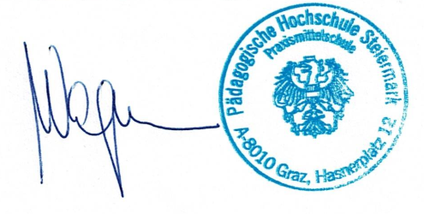
Short term exchange of groups of pupils
Blended mobility
Intensive study programme
Accompanying persons
Place: Graz, date: June 16th, 2021
The host organization/school:
(signature of the legal representative&stamp)

