Certificate of attendance

Learning/teaching/training activities
I undersigned Mag. Andrea Wagner
Position: School Headmistress
representing the host organization/school: Praxismittelschule der Pädagogischen Hochschule Steiermark
address: Hasnerplatz 12, 8010 Graz, Austria
Staff: 7
Pinelopi Vasileiou, Maria Petropoulou, Pinelopi Panitsa, Dimitra Papanikolaou, Ourania Sfika, Christina Koutsospyrou, Georgia Panagopoulou

certify that the following persons
Students: 42
Vassilis Sougleris, Irene Athanasopoulou, Anastasia Apostolopoulou, Ioanna Alexandri, Nicky Kaiafa, Gerasimos Mellas, Gerasimos Kandiliotis, Constantina Arvanitidou, Andrianna Christopoulou, Maria-Elli Gasparinatou, Sophia Diamantopoulou, George Constantinou, Theodora Zafeiropoulou, Athanasia Petroutsou, Georgia Christopoulou, Anastasia Mparouni, Anna-Marina Loui,Theodora Kotsopoulou, Evina Tavoulari, Ioannis Xypolias, Alexandros Fragoulis, Evelina Lazana, Marilena Kostin,Vassiliki Kotsopoulou, Andriana Kolelou, Maria Katrivesi, Andreas Georgopoulos,Penelope Georgopoulou, Christina Karkoulia, Despoina Pentoti,Vassilis Aggelopoulos, Myrsini Xypolia, Malevi Solomou, Ariadne Kotsopoulou, Georgia Petta, Panagiotis Harmantas, Heracles Christopoulos, Harris Haralampakis, Gerasimos Moshos, Panagiotis Papadopoulos, Constantina Kalisperaki, Constantinos Panoutsakopoulos

representing the sending organization/school:
complete name: 39th Primary School of Patra
address: Panachaikou terma Neo Souli, 26500 Patra, Greece
attended virtual learning/teaching/training activities organized by the Praxismittelschule der PH Steiermark in Graz and were present online on May 19⁻21st 2021.

Short term joint staff training events
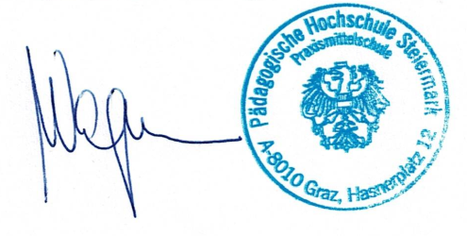
Short term exchange of groups of pupils
Blended mobility
Intensive study programme
Accompanying persons
Place: Graz, date: June 16th, 2021
The host organization/school:
(signature of the legal representative&stamp)

