Certificate of attendance

Learning/teaching/training activities

I undersigned Mag. Andrea Wagner
Position: School Headmistress
representing the host organization/school: Praxismittelschule der Pädagogischen Hochschule Steiermark
address: Hasnerplatz 12, 8010 Graz, Austria
certify that the following persons
Staff:
Scarfone Anna and Ferrazzo Maria
Students:
Nicotera Primary School Grade 4 (Teacher Anna Scarfone)
Calandruccio Gabriele, Cupoto Francesco, Ferraro Emma, Ferragina Jennifer, La Rosa Raffaellla, La Torre Walter, Mercuri Stefano, Moise Giacomo
Nicotera Primary School, Grade 5, (Teacher A. Scarfone)
Aiello Francesco Pio, Campisi Antonio, Fama Davide, Gallone M. Fatima, Leone Antonio, Loiacono Guiseppe, Marra Giovanni, Pagano Emma, Rao Ilenia, Taccone Marika, Tailli Angelica, Varde Geivanna, Vizzone Sergio
Nicotera Marina Primary School, (Teacher Maria Ferazzo)
Arcuri Sharon, Barbieri Myriam, Iannizzi Gabriele, Pagano Giuseppe, Paradiso Aurora, Polimeni Carmelo, Sbaglia Matilde, Sbano Michael
representing the sending organization/school:
complete name: Istituto Comprensivo Statale “A. Pagano” Nicotera
address: Corso Umberto I – n.75 Nicotera, Italy
attended virtual learning/teaching/training activities organized by the Praxismittelschule der PH Steiermark in Graz and were present online on May 19th to 21st 2021.

Short term joint staff training events
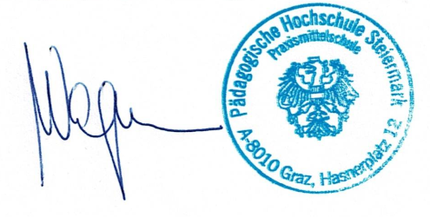
Short term exchange of groups of pupils
Blended mobility
Intensive study programme
Accompanying persons
Place: Graz, date: June 16th, 2021
The host organization/school:
(signature of the legal representative&stamp)

