Certificate of attendance

Learning/teaching/training activities

I undersigned Mag. Andrea Wagner
Position: School Headmistress
representing the host organization/school: PRAXISMITTELSCHULE DER PÄDAGOGISCHEN HOCHSCHULE STEIERMARK
address: Hasnerplatz 12, 8010 Graz, Austria
certify that the following persons
Staff:
Nicoleta Ciobanu, Carmen Tică, Gabriela Mirea, Irina Terecoasă, Carmen Bucur, Laura Anton, Caterina German , Mihaela Avram

Students:
Burlan Irina, Calinovschi Eliza, Lazar Andrei, Paraschiv Ilinca, Nen Ioana , Talpalariu Mara, Stoican Ilinca, Tudor Maria, Enache Lena, Nedelea Melissa, Bucur Ianis, Păsăilă Matei, Lache Diana, Ana Radu, Ania Cismaru, Alexia Petrescu, Alexandra Stolnicu, Maya Zamfir, Sultana Sandra, Popovici Maria, Marica David Ștefan, Cojocaru-Sasha Petrila Nicolas, Vasile Maria Gabriela, Sebastian Ciomag, Ștefan Niță, Radu Constantin, Miruna Soare, Arina Saceanu, Iris Saproni, Carina Caragea, Ștefan Radu, Matei Mitulescu, Alexandra Siriteanu, Daria Florea, Anamaria Tiugă, Anna Grigore, Catinca Draghiescu, Rebecka Willie, Andrei Dumitrașcu, Edward Ene, Bogdan Roman, Damian Rotaru, Brianna Neacu, Iulia Constantinescu, Denisa Isopencu, Ilinca Borcea, Oana Ciupercă, Iulia Antoniu, Mihai Paicu, Daria Iancu, Dragoș Hera, Andrei Anghel, Petru Cristel, Filip Iliescu, Isabelle Ulrich, Annabella Dunăreanu, Matilde Vasile, Ștefania Peptan, David Bîrlă, Mario Udrea, Radu Olteanu, Leonard Maxim, Mara Mija, Iarina Neacșu, Carina Lungu, Isabela Pintilei, Elisa Dumitru, Mihnea Arsenescu, Cătălina Grigore,Ana Martin, Daria Georgescu, Cruceanu Catinca, Damian Daria Maria, Chiran Delia, Mihalcea Anastasia, Enăchescu David, Zobi Yara Bursuc, Petrica Teodora, Ilieș Sara, Burlan Sonia, Nica Denisa, Ganciu Iasmine
representing the sending organization/school:
complete name: “ELENA CUZA” NATIONAL COLLEGE
address: number 1, Peștera Scărișoara Street, Bucharest, Romania
attended virtual learning/teaching/training activities organized by the Praxismittelschule der PH Steiermark in Graz and were present online on May 19-21st 2021.
Short term joint staff training events
Short term exchange of groups of pupils
Blended mobility
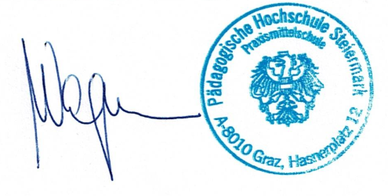
Intensive study programme
Accompanying persons
Place: Graz, date: June 16th, 2021
The host organization/school:
(signature of the legal representative&stamp)

