Invitation

The Praxismittelschule der Pädagogischen Hochschule Steiermark has the great pleasure to invite the teachers and students of our partner schools
- Dimotiko Scholeio Defteras Pano
- 39th Primary School of Patra
- Istituto Comprensivo Statale “A. Pagano” Nicotera
- “ELENA CUZA” NATIONAL COLLEGE, Bukarest

to a 3-day virtual workshop held on Zoom. The workshop meetings will be held on May 19th to 21st 2021 from 8.00 to 13.00 (Time in Austria and Italy), or 9.00 to 14.00 (Cyprus, Greece, Romania).
Please find the detailed agenda of the meetings below.

We are looking forward to working together online.
Sincerely yours,
The Headmistress


Mag. Andrea Wagner

GOAL – Online Workshop: Superheroes of our World
Day 1: May 19th 2021  Time: 8.00 – 13.00 (Austria, Italy)  9.00 – 14.00 (Cyprus, Greece, Romania) |  |  |  |  |  |  |  |  |  |  | approx. time
Project kickoff on Zoom:  - What is this project about?  - Superheroes? Where can we find them?  - Tips for Writers  - Tips for Illustrators |  |  |  |  |  |  |  |  |  |  | 8.00-8.30  9.00-9.30  main room
Getting to know your team members: Warm-up activity in your team  https://www.polzleitner.com/epep/0-NMS/ErasmusGOALproject/Superheroes/Ice-breaker-in-common.docx |  |  |  |  |  |  |  |  |  |  | 15’ in
Team 1 | Team 2 | Team 3 | Team 4 | Team 5 |  | Team 6 | Team 7 | Team 8 | Team 9 | Team  10 | breakout-rooms
11 | 12 | 13 | 14 | 15 |  | 16 | 17 | 18 | 19 | 20
21 | 22 | 23 | 24 | 25
Come back to the main room: Join your workshop for writers or illustrators. |  |  |  |  |  |  |  |  |  |  | 8.45-9.30  9.45-10.30  2 breakout  rooms
Workshop 2: More tips for writers Who is your hero?  - What superpowers does he/she have?  - Where does your story play?  - What is the problem?  - How will your hero solve it?  Meet the writers in |  |  |  |  | Workshop 2: Tips for Illustrators (all teams)  - Let’s look at some picturebooks and collect ideas  - How to paint story backgrounds  - How to draw or paint the characters / parts of characters / accessories  - Trying out the features of book-creator online |  |  |  |  |  | 8.45-9.30  9.45-10.30  2 breakout  rooms
Break |  |  |  |  |  |  |  |  |  |  | 30’
Let’s meet in the main room again to discuss the next steps |  |  |  |  |  |  |  |  |  |  | 5’
Book Teams (writers and illustrators) meet to discuss first plans and ideas for their book. |  |  |  |  |  |  |  |  |  |  | 10.00 – 10.30  11.00 – 11.30
Team  1  Illustators work offline but keep in touch with their team.  Writing teams: Write your story | Team 2 | Team 3 | Team 4 | Team 5 |  | Team 6 | Team 7 | Team 8 | Team 9 | Team10 | 10.30 – 12.45  11.30 – 13.45  Students from Cyprus will leave at 13.00)
Short plenary: 12.45 – 13.00
13.45 – 14.00
Time for questions and good-bye

Day 2: May 20th, 2021  Time: 8.00 – 13.00 (Austria, Italy)  9.00 – 14.00 (Cyprus, Greece, Romania) |  |  |  |  |  |  |  |  |  | 8.00-13.00  9.00-14.00
Welcome back  - Highlights and good examples  - Some more tips from your teachers  - Plan for the day  - Time for questions |  |  |  |  |  |  |  |  |  | 8.00 – 8.30  9.00 – 9.30
Back to your team  See how far you are?  What needs to be done next?  Back to work… |  |  |  |  |  |  |  |  |  | 8.30-10.00  9.30-11.00
Team1 | Team 2 | Team 3 | Team 4  Writers work in your teams. Get feedback from your teachers. Then polish the text.  Practice recording the text. Read it to a teacher, then record the text in the app. | Team 5 | Team 6 | Team 7 | Team 8  Illustrators add backgrounds and characters to the books. Design all the pages carefully. Then design a cover page.  Delete all the instructions and organize your pages. | Team 9 | Team 10
Break |  |  |  |  |  |  |  |  |  | 10.00-10.30  11.00-11.30
 |  |  |  | Meet in your teams and polish and finalize your books. |  |  |  |  |  | 10.30–11.45  11.30-12.45
  Plenary:  Let’s celebrate:  Read all the books and find out about the superheroes.  Rounding-off the project |  |  |  |  |  |  |  |  |  | 11.45-13.00  12.45-14.00  Cyprus will leave at 13.00

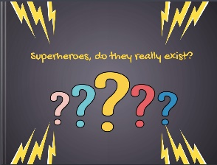
Day 3: May 21st 2021
Let’s celebrate our superhero books
Step 1
Let’s recap and look at some of the amazing superheroes that you have created in this project (teacher’s presentation)
Step 2
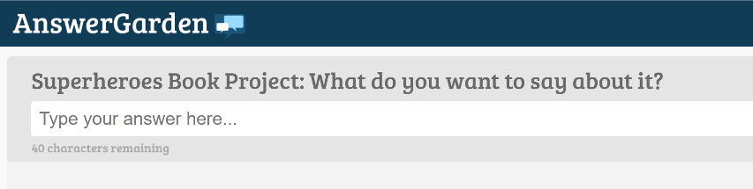
Answer the question in our ANSWERGARDEN

Step 3
Read the books and write short feedback comments for the other teams.
- What do you like about their books?
- What did they do exceptionally well?
- Do you have any tips for them?
- You can also add some to the books that you like a lot.
You will find all the books on this padlet:https://padlet.com/lispolzleitner/w9mboe0h6spz
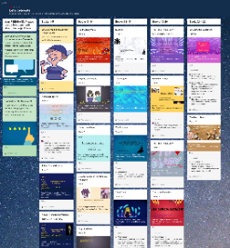

Step 4
Explore the books in detail and answer the quiz. You can win a little prize if you get lots of answers right. You can do this on paper or online.

https://forms.gle/ksHj9H2Es1p2p1fN6
