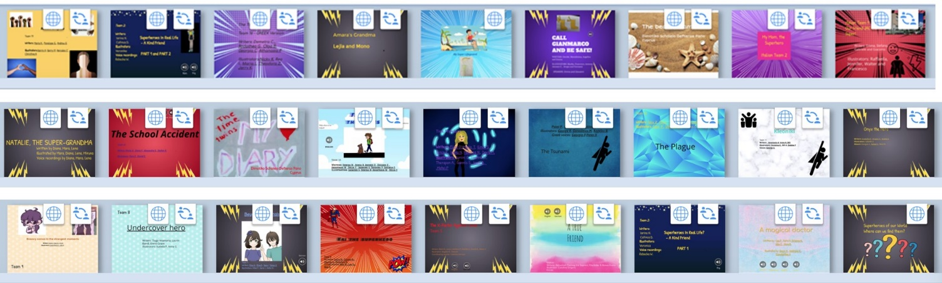
Solutions: Explore the Superhero books and find a hero who…
In which book can you find … | Title of the book | Team  Number
… a hero whose grandma cannot only cook delicious food, but she can defeat a dangerous pollution monster | Natalie,the Super Grandma | 19
… a hero who can listen from a long distance. He can even help people who are far away. | Our friend Jack is super | 20
… a hero who cleans up a beach in Crete | Kleoniki | 11
… a hero who fights against a horde of zombies together with his superhero friends | The Plague | 12
... where a brother and sister travel to ancient Egypt and save their mother from a forced marriage to the King of Egypt. | The Time Twins | 16a
… a hero who is on the beach with friends and saves some tourists from drowning | The Beach Team | 22
…a hero who runs into a burning building to save a friend | Bravery comes in the strangest moments | 9
...where the hero finds his parents in the drawings of her history book and then teleports herself to old Byzantium to save her parents from terrible riots in a Hippodrome. | The Time Twins’ Diary | 16b
… a hero who has saved two people after a bus accident | Onyx the Hero | 10
… a hero who saves a girl’s birthday party with a cake. | My Mom,the Superhero | 21
…a hero who is called HOPE. She can use her powers to change her father’s racist mind. | Racism in Africa | 17
…a hero who can become invisible and pass through walls | The School Accident | 18
… a hero who can read people’s minds | Undercover Hero | 8
… a hero who leads the residents of her village to a high mountain and saves them from drowning | The Tsunami | 13
… a hero who saves a girl from drowning in the sea | My Super Lifeguard | 3
… a hero who suddenly became super strong to save a girl after an earthquake | A true friend | 4
… a hero who saves her brother’s life in the war in Afghanistan | Magical doctor | 1
… a hero who is a crazy, old scientist who saves the world from a dangerous virus | The X Factor against Covid | 5
… a hero whose superpower is kindness and who helps a friend to overcome her shyness | A Kind Friend | 2
… a hero who can make things happen if he thinks about them really hard. He helps people who are being bullied. | Kai the superhero | 6
… a hero who is very clever and saves a group of children with the flashlight of her mobile phone | Time Travel | 14
… a hero who can read minds and souls | Flying Thoughts | 15
… a hero who finds her lost brother after a long search and brings him home safely | Beyond the portals / | 7
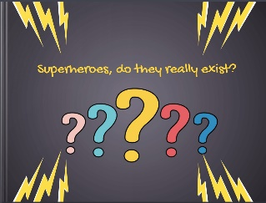
Let’s celebrate our superhero books
Step 1:
Answer the question in our ANSWERGARDEN: https://answergarden.ch/1987592
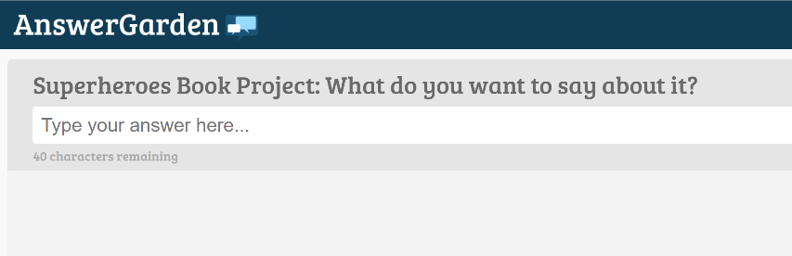

Step 2
Read the books and write short feedback comments for the other teams.
What do you like about their books?
What did they do exceptionally well?
Do you have any tips for them?
You can also add some to the books that you like a lot.
You will find all the books on this padlet:https://padlet.com/lispolzleitner/w9mboe0h6spz
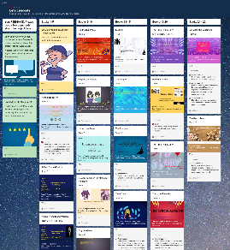

Step 3:
Explore the books in detail and answer the quiz. You can win a little prize if you get lots of answers right. You can do this on paper or online. Ask your teacher for the paper quiz or follow this link.
https://forms.gle/ksHj9H2Es1p2p1fN6
