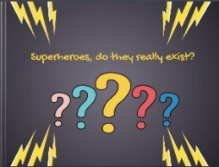
Let’s celebrate our superhero books
Step 1
Let’s recap and look at some of the coolest heroes that you have created in this project. (Teacher’s powerpoint)
Step 2
Answer the question in our ANSWERGARDEN: https://answergarden.ch/1987592
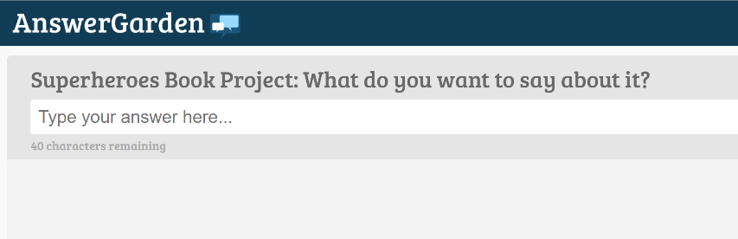

Step 3
Read the books and write short feedback comments for the other teams.
What do you like about their books?
What did they do exceptionally well?
Do you have any tips for them?
You can also add some to the books that you like a lot.
You will find all the books on this padlet:https://padlet.com/lispolzleitner/w9mboe0h6spz
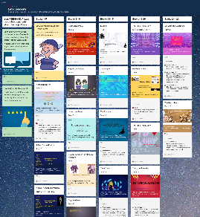

Step 4:
Explore the books in detail and answer the quiz. You can win a little prize if you get lots of answers right. You can do this on paper or online.
https://forms.gle/ksHj9H2Es1p2p1fN6


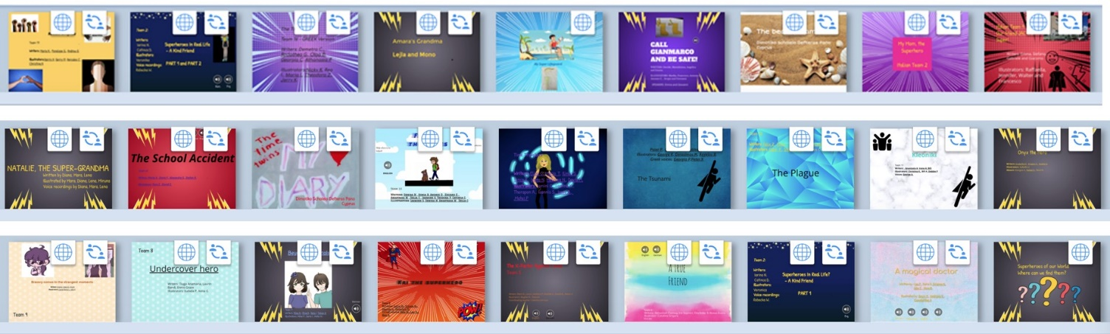
Explore the Superhero books and find a hero who…
In which book can you find … | Title of the book | Team  Number
… a hero whose grandma cannot only cook delicious food, but she can defeat a dangerous pollution monster | Natalie,the Super Grandma | 19
… a hero who can listen from a long distance. He can even help people who are far away.
… a hero who cleans up a beach in Crete
… a hero who fights against a horde of zombies together with his superhero friends
... where a brother and sister travel to ancient Egypt and save their mother from a forced marriage to the King of Egypt.
… a hero who is on the beach with friends and saves some tourists from drowning
...where the hero finds his parents in the drawings of her history book and then teleports herself to old Byzantium to save her parents from terrible riots in a Hippodrome.
…a hero who runs into a burning building to save a friend
… a hero who has saved two people after a bus accident
… a hero who saves a girl’s birthday party with a cake.
…a hero who is called HOPE. She can use her powers to change her father’s racist mind.
…a hero who can become invisible and pass through walls
… a hero who can read people’s minds
… a hero who leads the residents of her village to a high mountain and saves them from drowning
… a hero who saves a girl from drowning in the sea
… a hero who suddenly became super strong to save a girl after an earthquake
… a hero who saves her brother’s life in the war in Afghanistan
… a hero who is a crazy, old scientist who saves the world from a dangerous virus
… a hero whose superpower is kindness and who helps a friend to overcome her shyness
… a hero who can make things happen if he thinks about them really hard. He helps people who are being bullied.
… a hero who is very clever and saves a group of children with the flashlight of her mobile phone
… a hero who can read minds and souls
… a hero who finds her lost brother after a long search and brings him home safely

