
Our Heroes: Storybook project

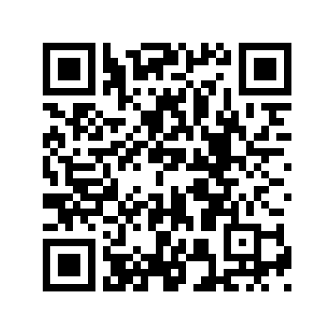

https://tinyurl.com/GOALsuperheroes
What are we going to do in this workshop?

In this workshop you are going to create our own online story-books or cartoon books about cool heroes. You will be working in international groups -- each group will produce their own story-book. We will be using “book creator online” to create our books.

Each book team will need students for the following jobs:

- WRITERS, that is students who like to create and write stories
- ILLUSTRATORS, that is students who like to draw and paint

You will work together as a team and bring in your strengths to create a perfect storybook. Read the following job descriptions and decide what your role could be.

The Writers
With the help of a teacher you will create your own superhero and write a story about one of his/her great deeds. Choose this job if you like to create stories and if you like to write in English. You will need a computer or a tablet or I-pad to write the story online, together with your group.

The Illustrators
This job is for students who like to draw or paint. You will illustrate the story. You can draw, paint or make a cartoon. You will share the work in your group. Some students will draw all the characters, others will paint the background pictures.
You will need a computer or tablet or I-pad to work in this group, and you will need paper and painting materials for the pictures. You will then take a photo of your page or scan it and put the pictures into the storybook.

The project teachers will finally put your storybooks online so all the kids in the GOAL project can read them.
When and Where: The workshop will be held on Zoom.
Wednesday, May 19th: : 8.00 to 13.00 (Austria, Italy) --- 9.00 to 14.00 (Cyprus, Greece, Romania)
Wednesday, May 26th: 8.00 to 13.00 (Austria, Italy) --- 9.00 to 14.00 (Cyprus, Greece, Romania)
Wednesday, June 16th: 8.00 to 13.00 (Austria, Italy) --- 9.00 to 14.00 (Cyprus, Greece, Romania)

